Spec. number: 1
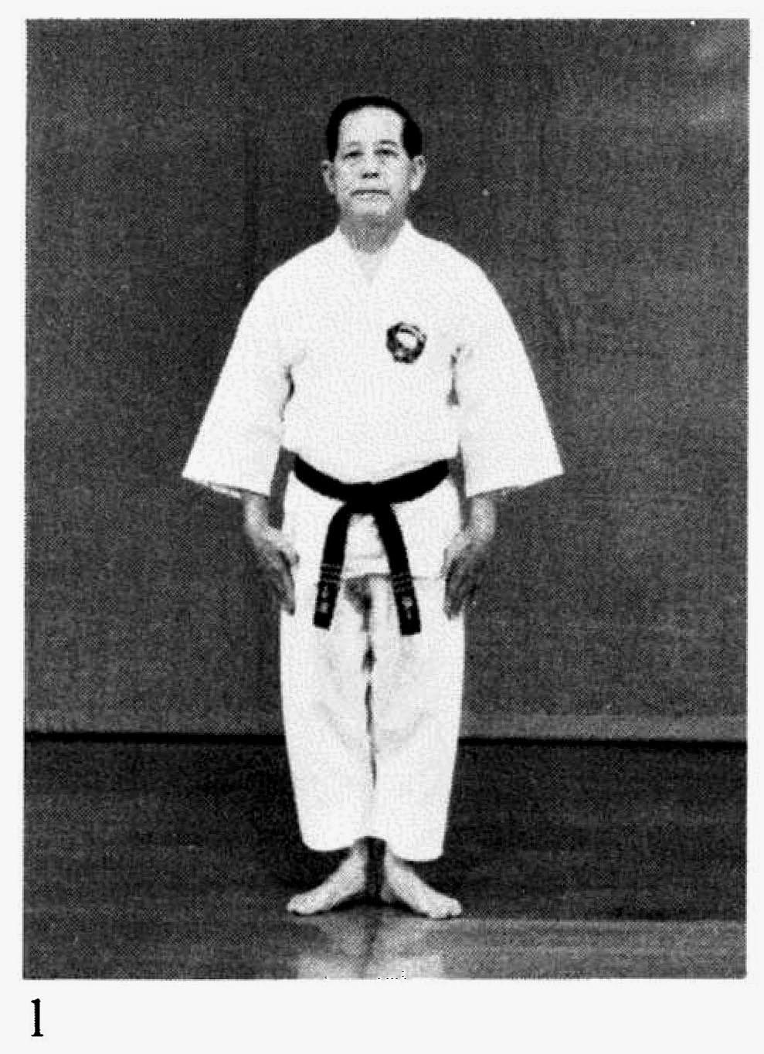
Technique: Formal attention stance (Chokuritsu-fudo-dachi or Kio-tsuke)
and bow (Rei)
Kata: All
Page number: 59 and 104
Description: “The heels are together with the toes pointing out at a 60-degree angle.”
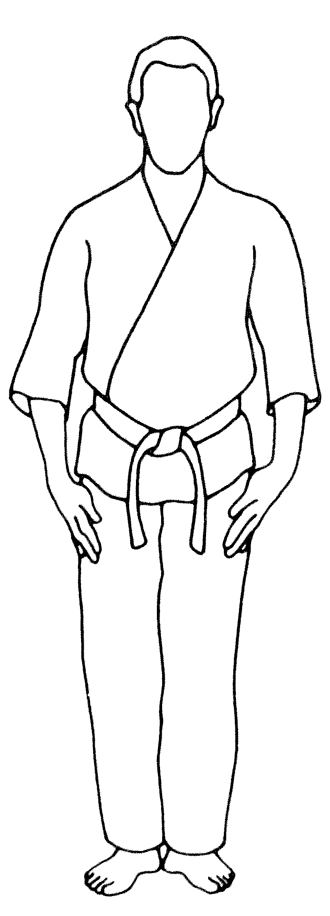
Comments: As Hanshi elaborates, "In kio-tsuke (attention) the fingers are lightly touching the gi and are positioned slightly to the front. They touch each other and the thumb without tension."
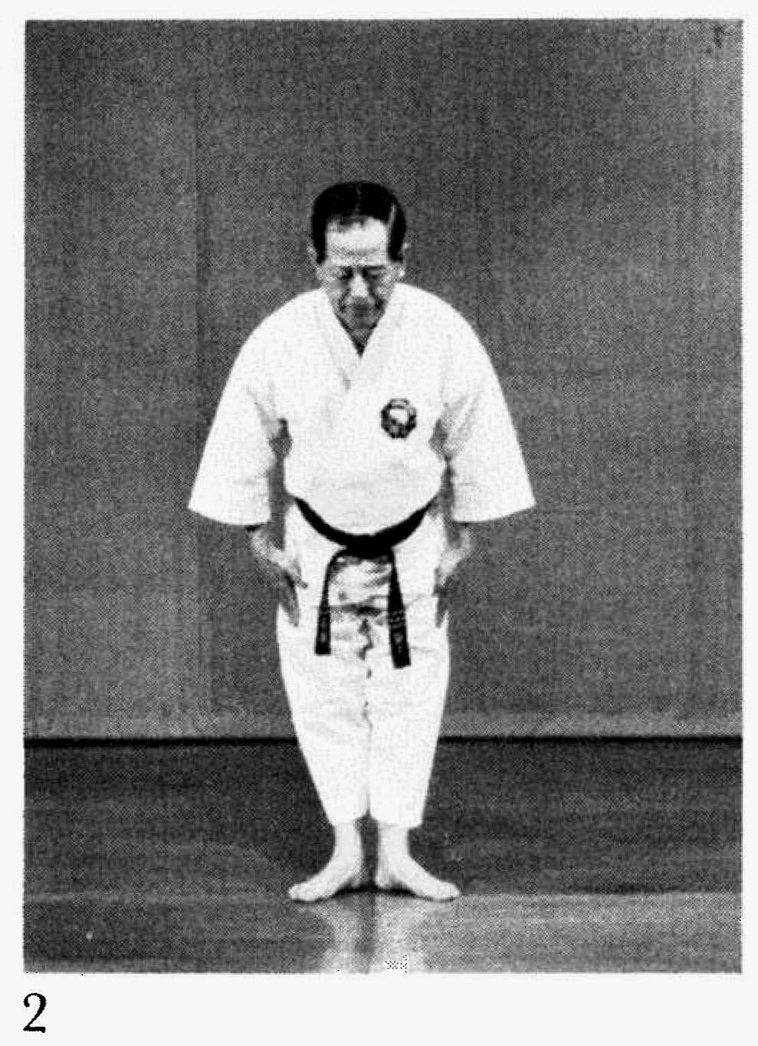
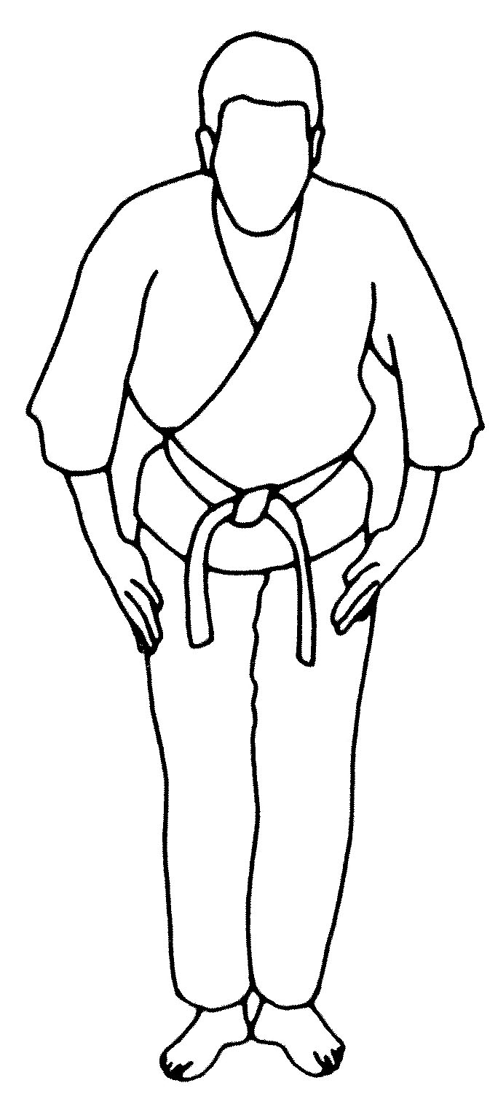
"From the kio-tsuke position the body bends forward at the waist with the eyes, neck and shoulders moving together as one. The fingertips lightly graze the gi as the body moves. The bow should not be made too low."
Do not look down at the floor or up at your imaginary opponent as the head and back are lowered. Rather, the gaze remains fixed as if painted onto the face, making maximum use of peripheral vision.
Photographs: 104(1 and 2)

