Spec. number: 2
Technique: Wide open-leg stance (Jigotai-dachi)
Kata: Fukyugata 2 and many other kata
Page number: 65
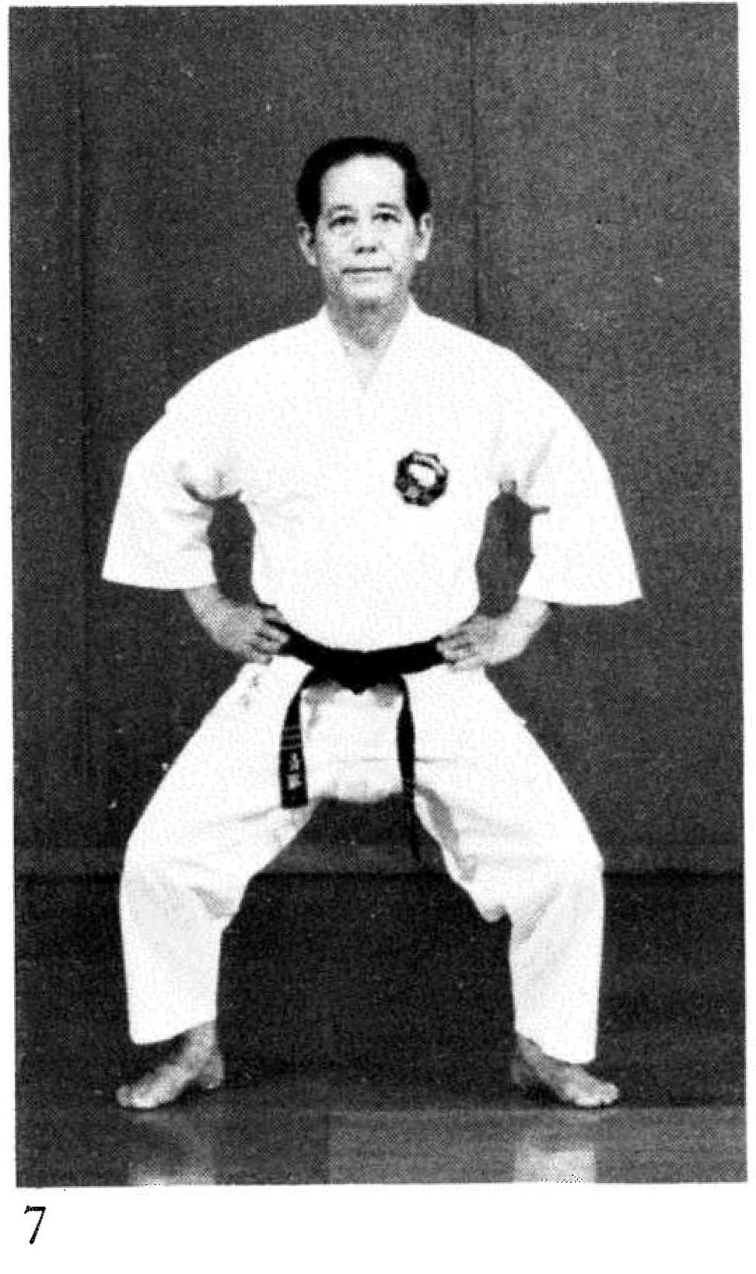
Description: Fig. 7 shows the feet separated the “length of shank + width of fist.” The knees bend at about a 40 degree angle to lower the body.
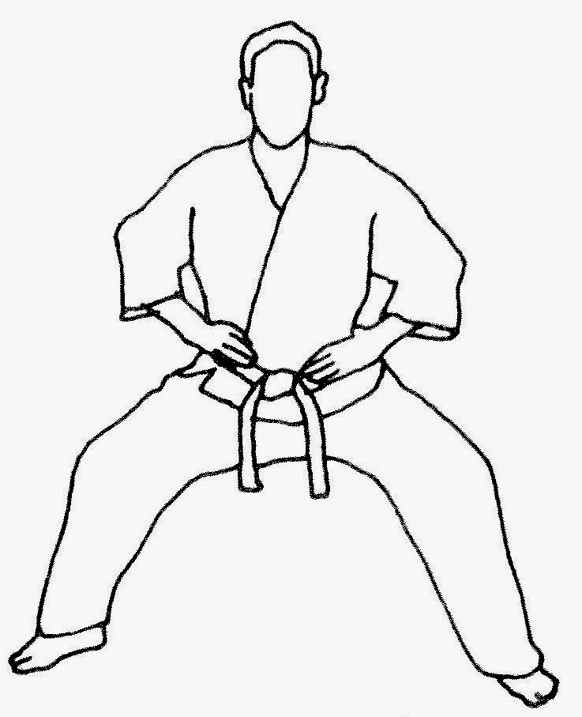
Comments: We bend the knees much farther - as much as 90 degrees - to create a pronounced drop in height. To accommodate the greater bend in the knees and keep the knees over the heels, we must position the feet further apart, typically a shank plus 2 to 3 fists’ width.
Another subtle difference is that while Fig. 7 shows Nagamine Sensei with his knees slightly forward and positioned over the toes, we bring the knees back to be positioned over the heels. See the Kata Reference Guide DVD.
Photographs: 65(7)

