Spec. number: 3
Technique: Front-leg-bent stance (Zenkutsu-dachi)
Kata: Fukyugata 1 and many other kata
Page number: 66
Description: “Formed by stretching the back leg fully straight and by bending the front until its knee makes a vertical line with its toe. The same distance between the feet is taken as explained in jigotai-dachi.”
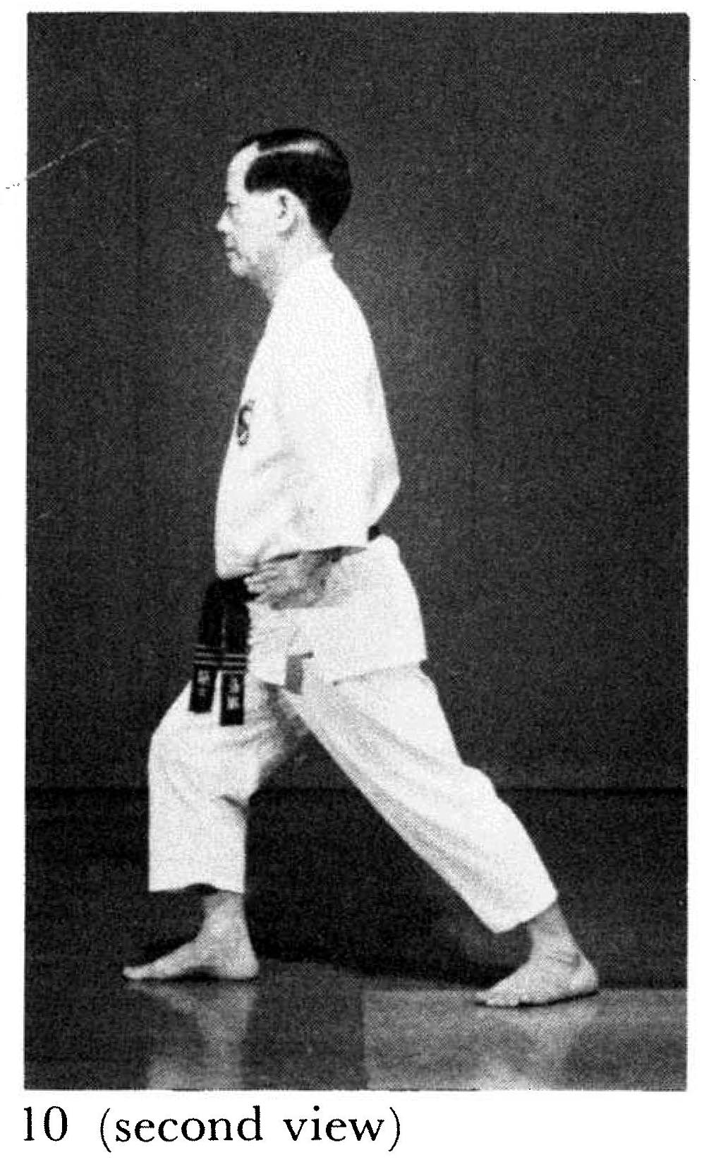
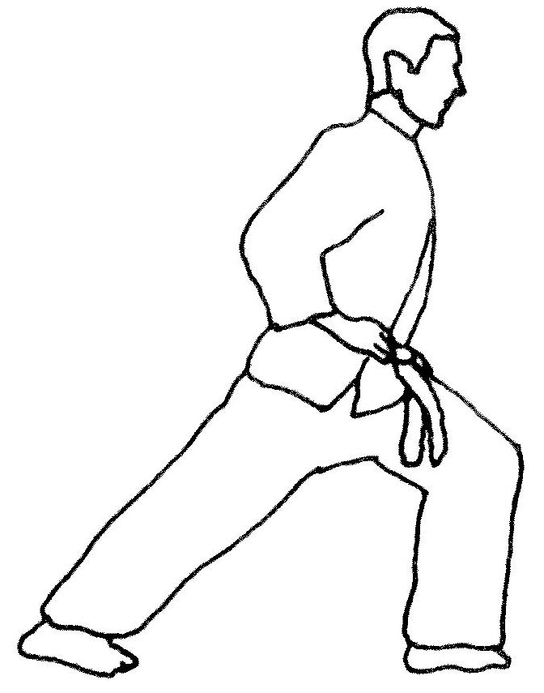
Comments: Fig. 10 shows the forward knee bent about 35 degrees with the knee positioned above the instep, not the toe. We bend the knee much farther – at least 45 degrees - to lengthen the stance and create a pronounced drop in height.
Note that the illus. from the Red Book shows more clearly the knee over the toe, as described by Nagamine Sensei.
Another subtle difference is that Nagamine Sensei leans forward from the waist only 10 degrees. As per the Red Book illustration, we should lean the upper body forward at least 25 degrees. See the Kata Reference Guide DVD.
It is curious that Nagamine Sensei translates “zenkutsu-dachi” as “front-leg-bent” stance while we translate it as “forward-leaning” stance.
Photographs: 66(10)

