Spec. number: 4
Technique: Ready stances (Kamaekata)
Kata: Rohai
Page number: 58
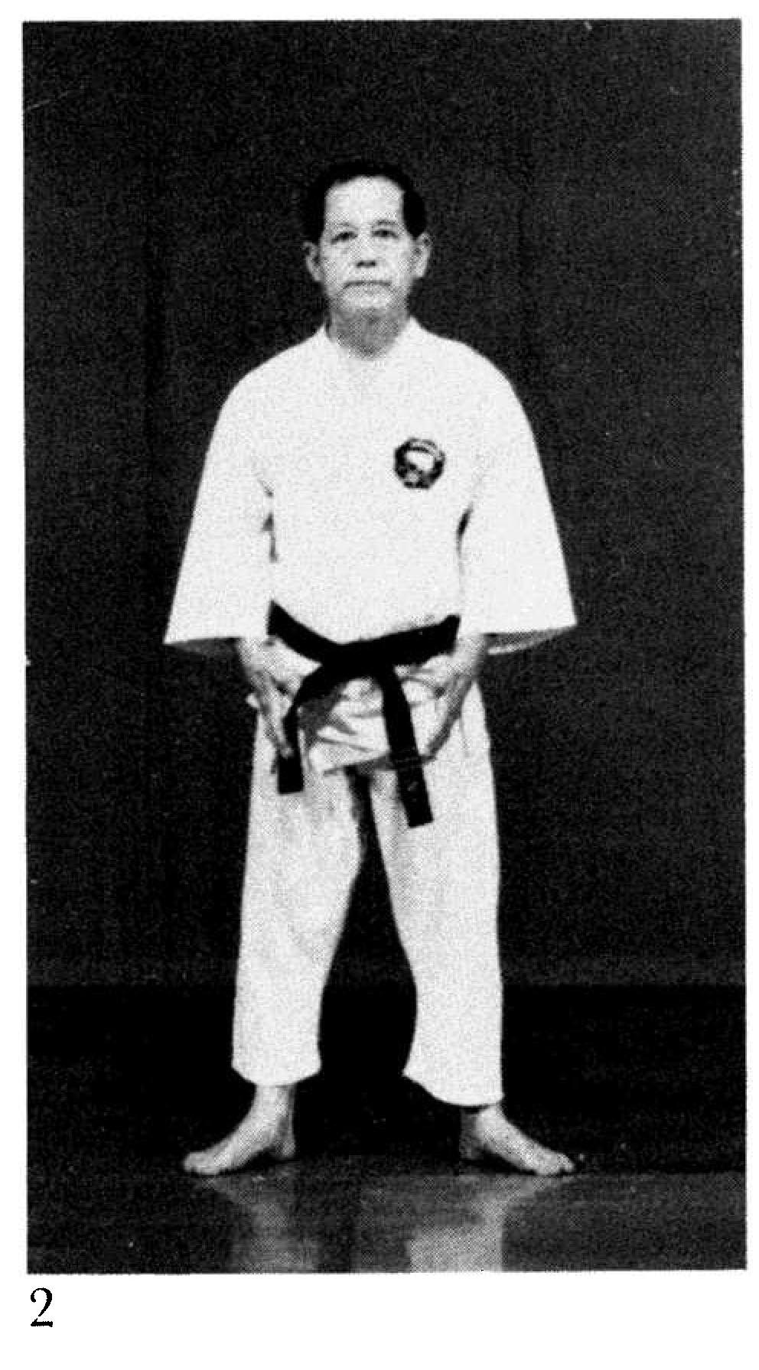
Description: Fig. 2 shows the feet at 45 degree angles for the yoi position.
Comments: For the opening yoi position we have the feet parallel. At the end of the kata they are 45 degrees. See the Kata Reference Guide DVD.
Photographs: 58(2)
Rohai: 180(3, 4), 185(37)

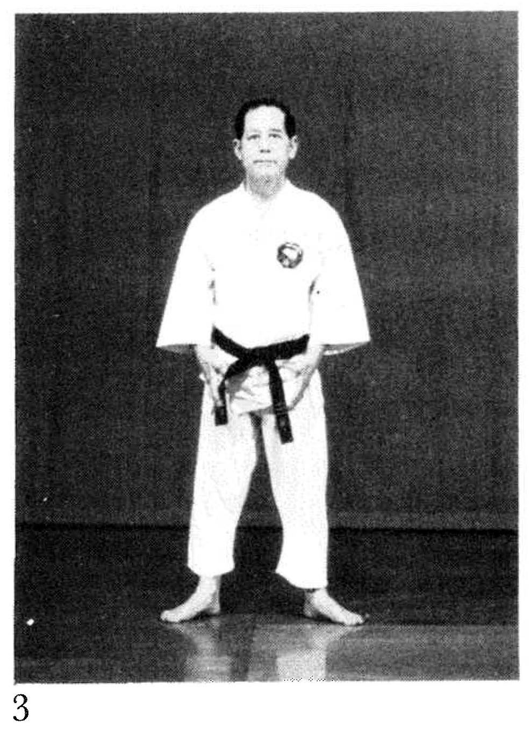 | 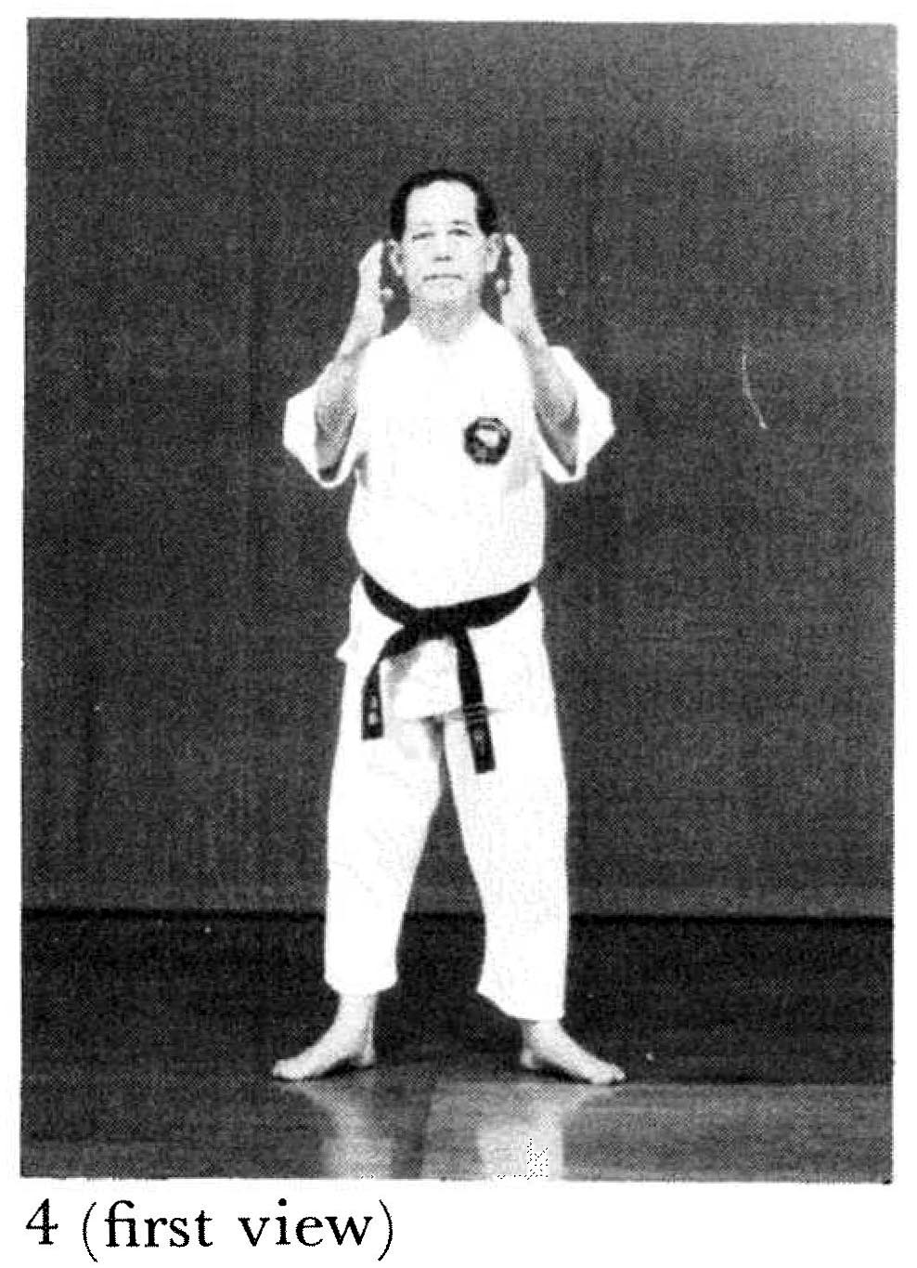
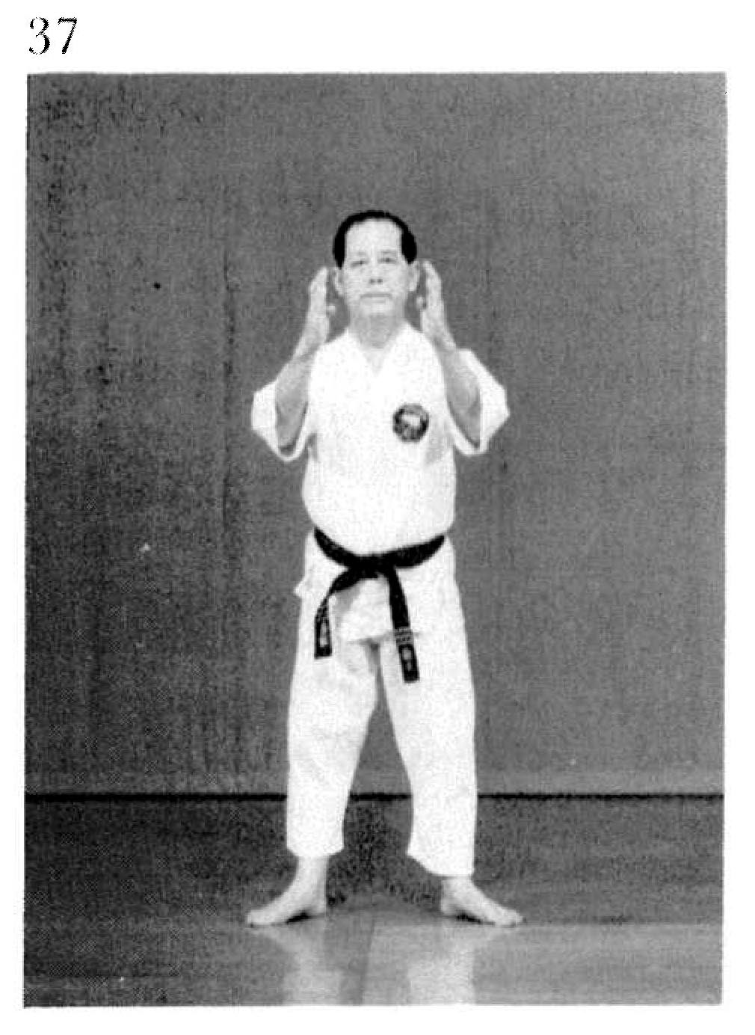 | Fig. 4 and 37 - Here we bend slightly forward in the opening and closing moves (more than shown in the photographs - see Kata DVD)

