Spec. number: 5
Technique: Ready stances (Kamaekata)
Kata: Wankan
Page number: 59
Description: “In Wankan, the right fist is placed on the left palm as in the picture (Fig. 5).”
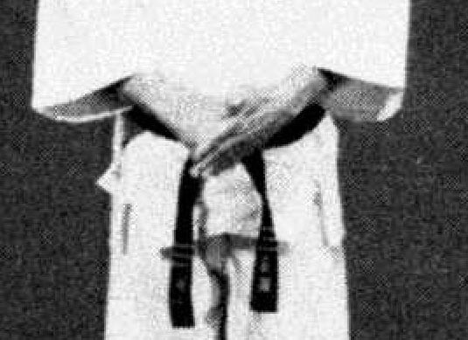
Comments: Fig. 5 shows the right fist forming almost a 90 degree angle with the left palm. We place the left palm at about a 45 degree angle over the fist.
Photographs: 59(5)
Wankan: 172(3), 178(40)

