Spec. number: 6
Technique: Ready stances (Kamaekata)
Kata: Passai
Page number: 60
Description: The yoi position for Passai is described as being the same as for N1 – N3, Ananku and Chinto: “The right fist is covered by the left palm (Fig. 6).”
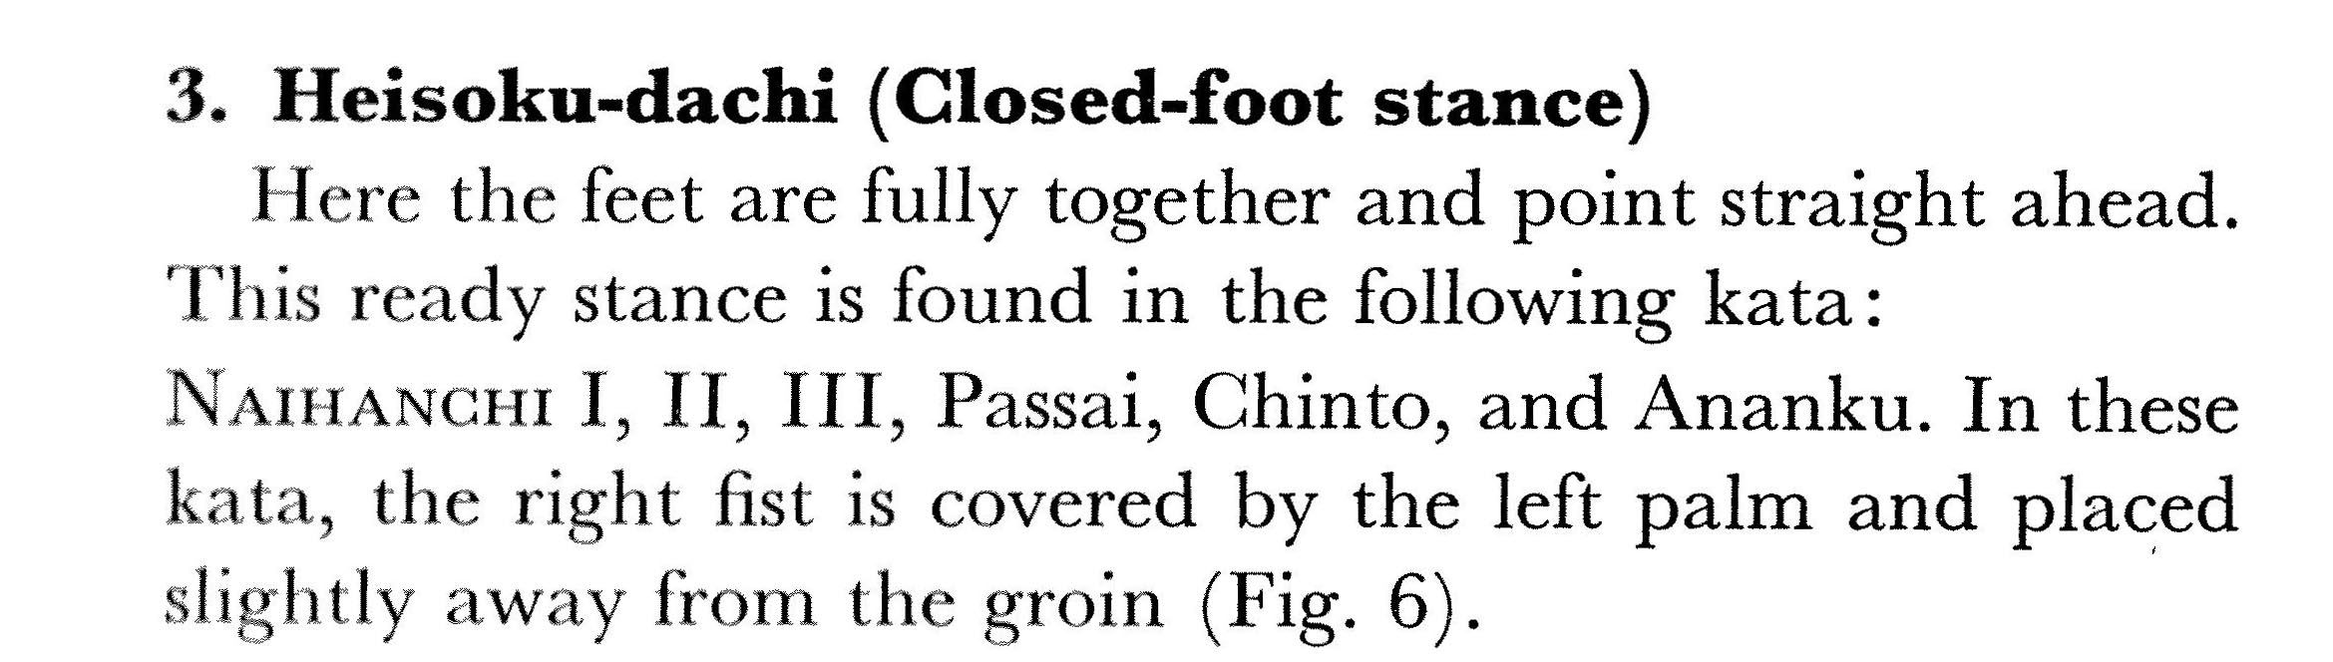
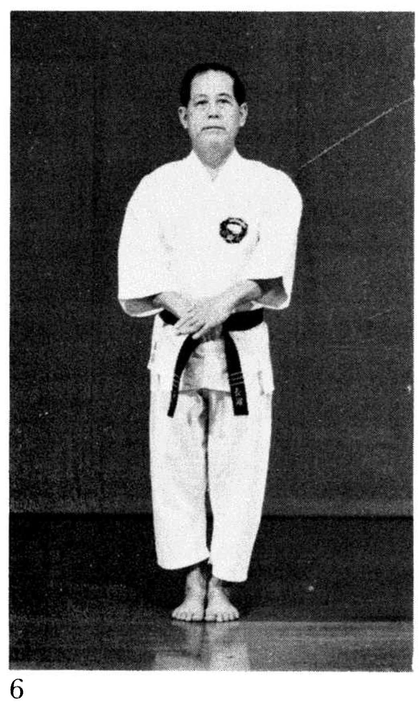
Comments: We cover the fist with “the bent palm and fingers of the left hand” as described in the yoi position for Wanshu, except that the hands are placed slightly forward of the groin, not in line with the solar plexus (see Fig. 7 and the Kata ref DVD).
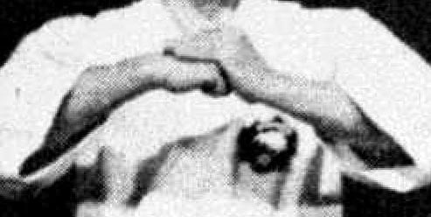

Fig. 60(7) - Wanshu

Photographs: 60(6)
Passai: 196(3, 4), 205(55)
