Spec. number: 7
Technique: One-leg stance (Ippon-ashi-dachi)
Kata: Various black belt kata
Page number: 68
Description: One-leg stance is described as “the thigh and foot parallel to the floor and the body is erect” (Fig. 14).
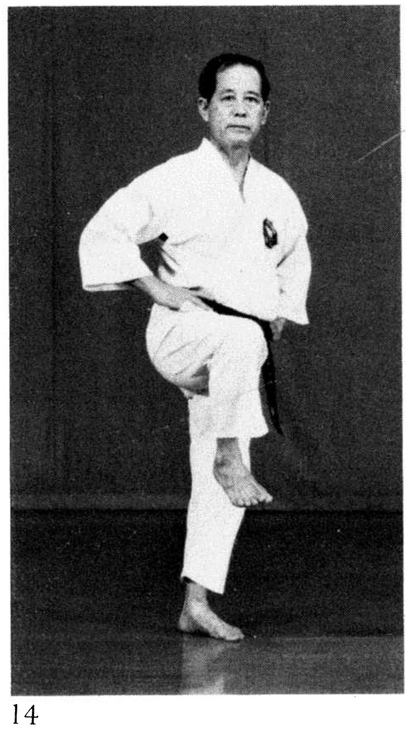
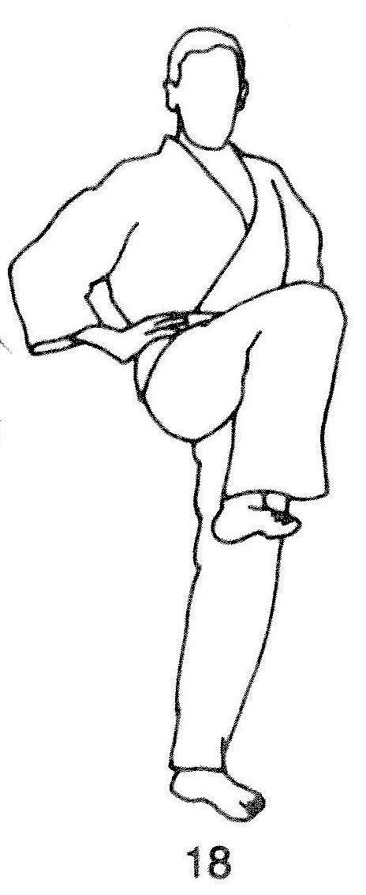
Comments: We bring the thigh and knee higher, as in chambering for a kick, and lean slightly forward. This is consistent with Nagamine Sensei’s notes on Rohai: “The most characteristic technique of the kata is a one-foot standing stance with the other foot drawn to deliver a kick…” (pg. 179).
As Hanshi explains, “In the one- legged stance the knee is high up covering the ribs and solar plexus and the foot is tucked in covering the groin. Offer the sole/knife-edge of the foot to the opponent instead of the top/instep.” See Illus. 18 as well as kata Rohai and Wankan in the Reference DVD.
Photo 68(14)

Pinan yon dan: 140(32)
Wankan: 173(14)
Rohai: 181(11), 182(16)

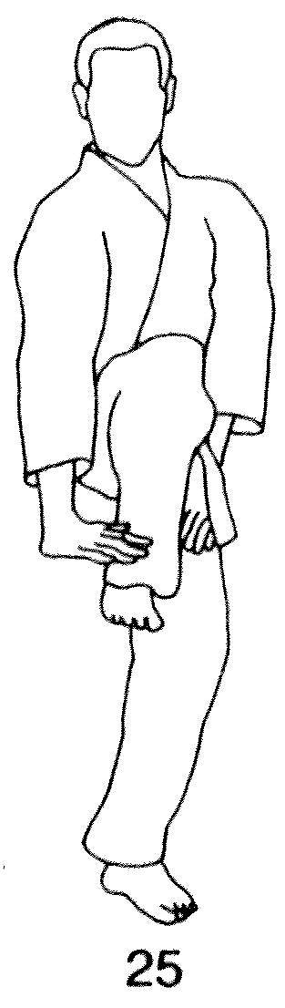  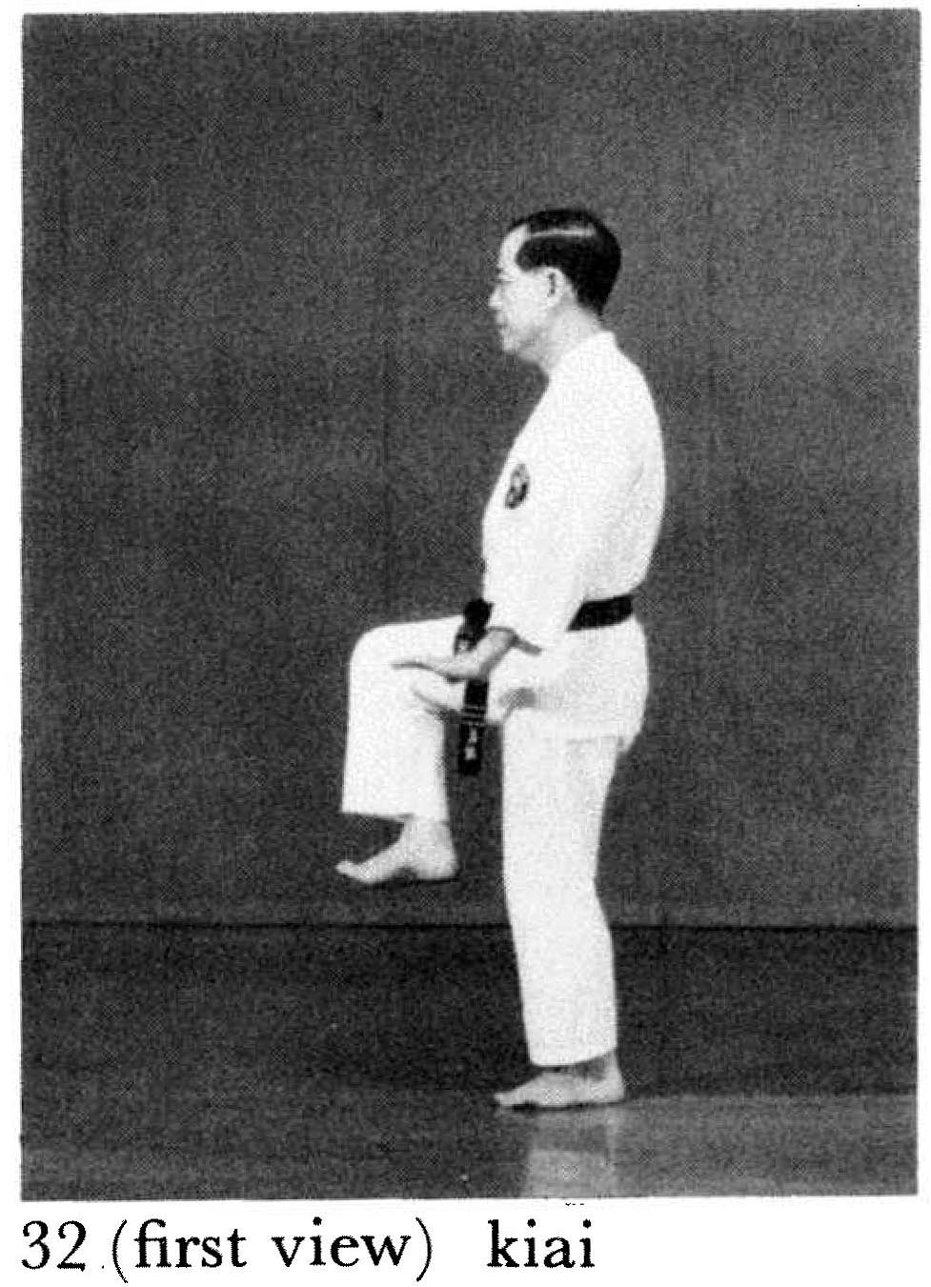 | 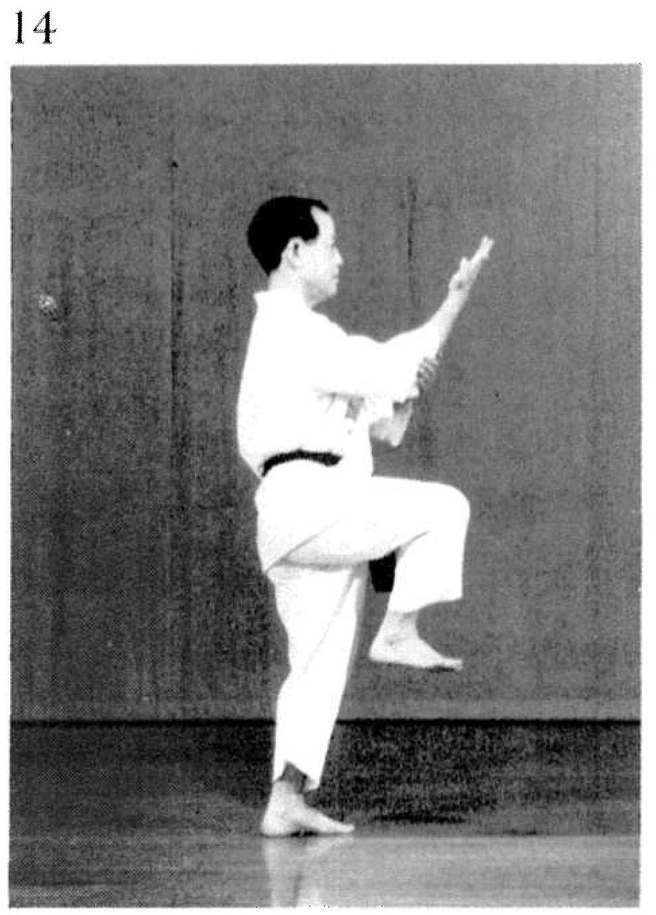
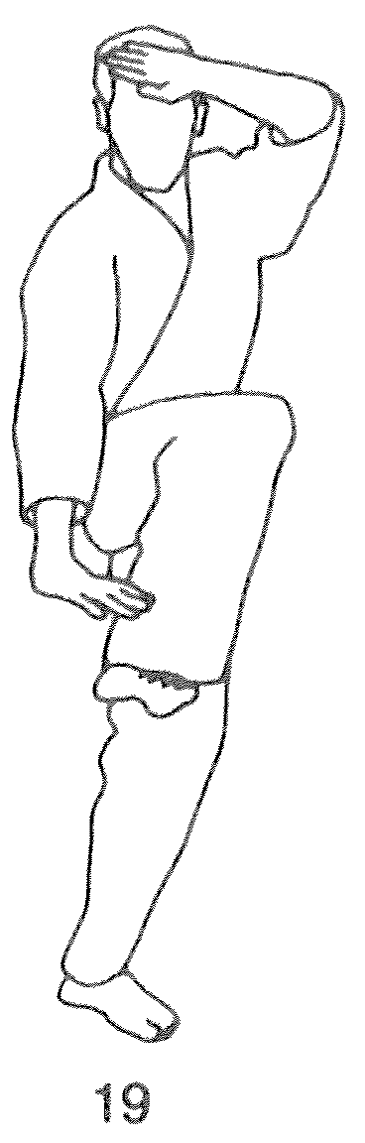  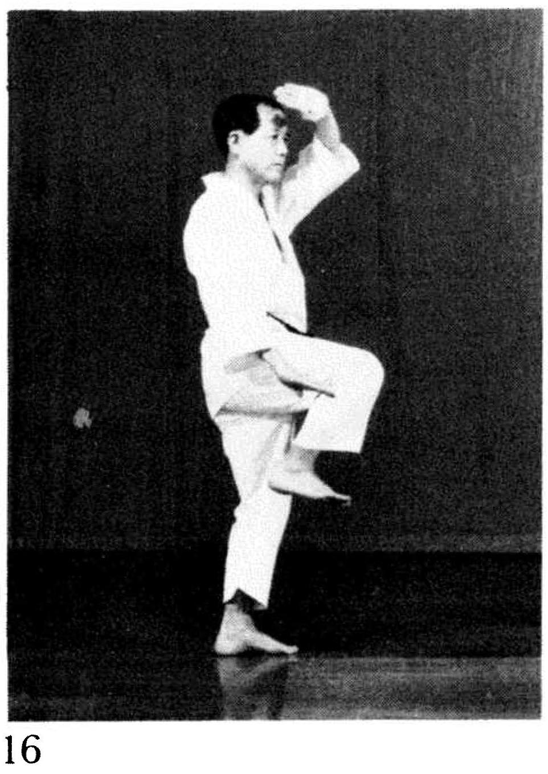 | 