Spec. number: 8
Technique: Lower punch (Gedan-zuke)
Kata: Rohai, Wanshu, Passai and Chinto
Page number: 70, 71
Comments: Lower punch is only found in the above black belt kata, not in P5 or the Nihanchi kata.
Photographs: 71(8), 71(9)
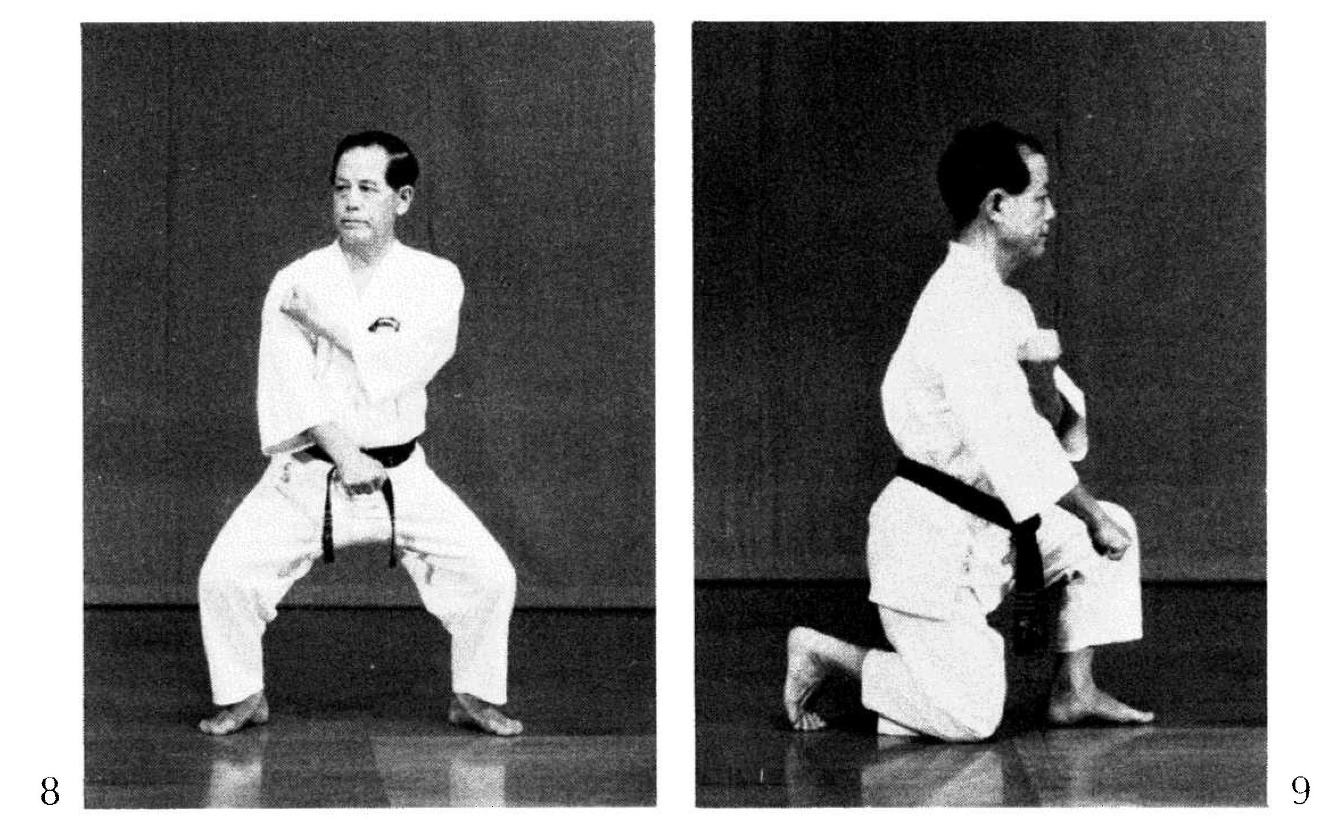

Rohai pg. 182  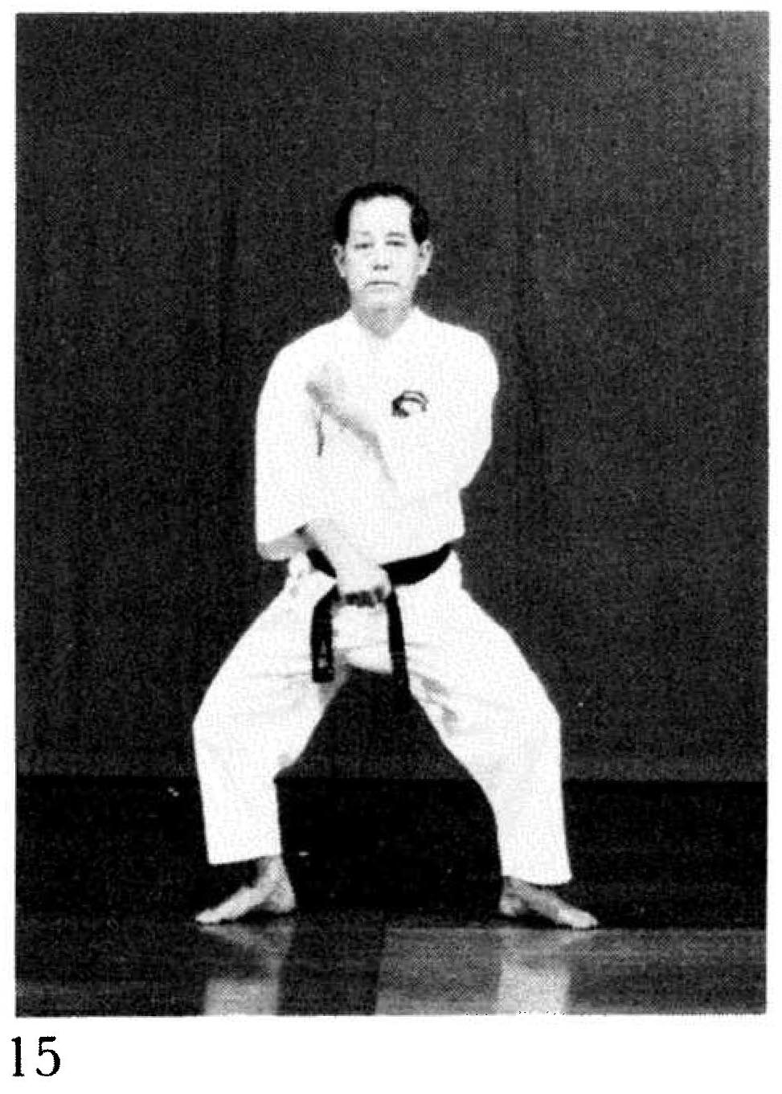 | Wanshu pg. 188  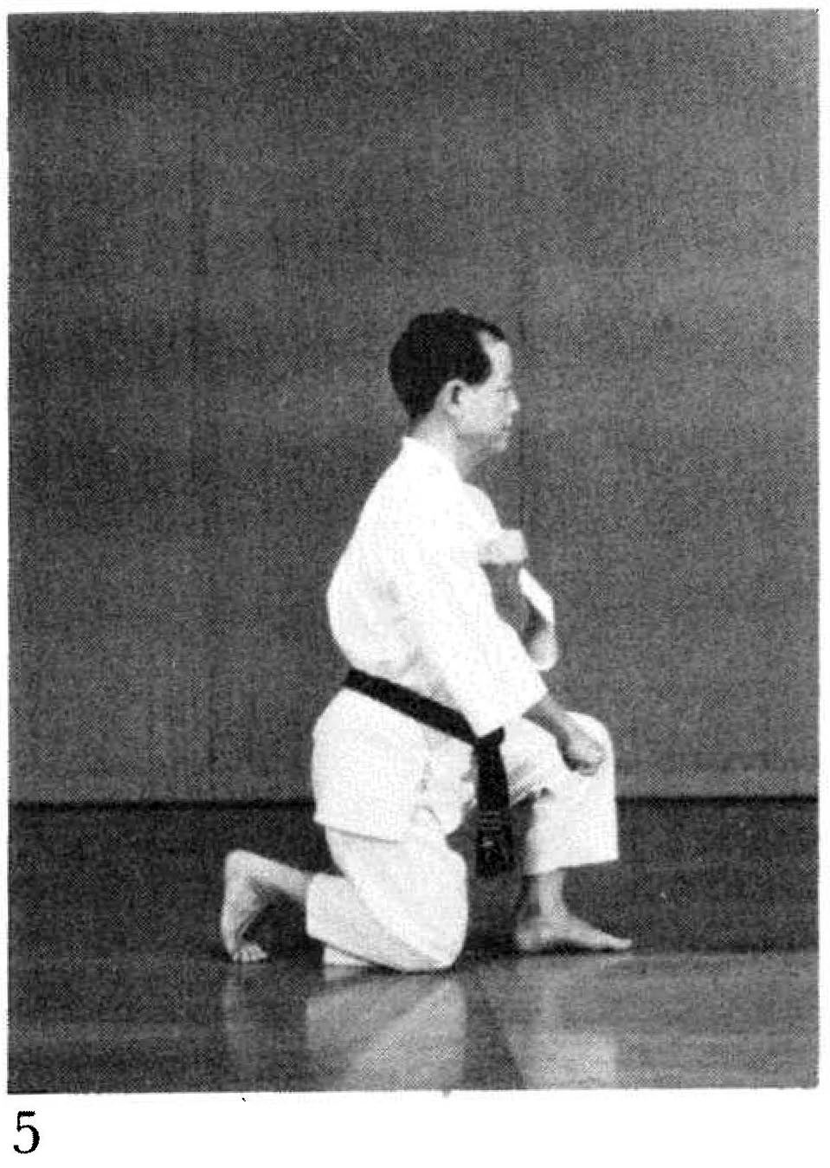
Wanshu pg. 189  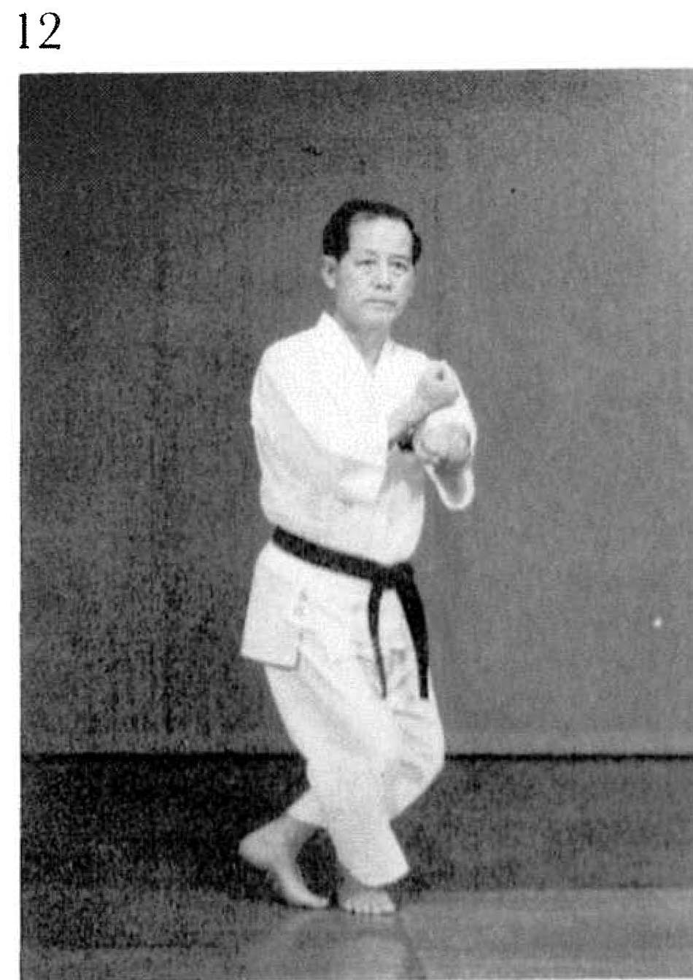 | Wanshu pg. 191  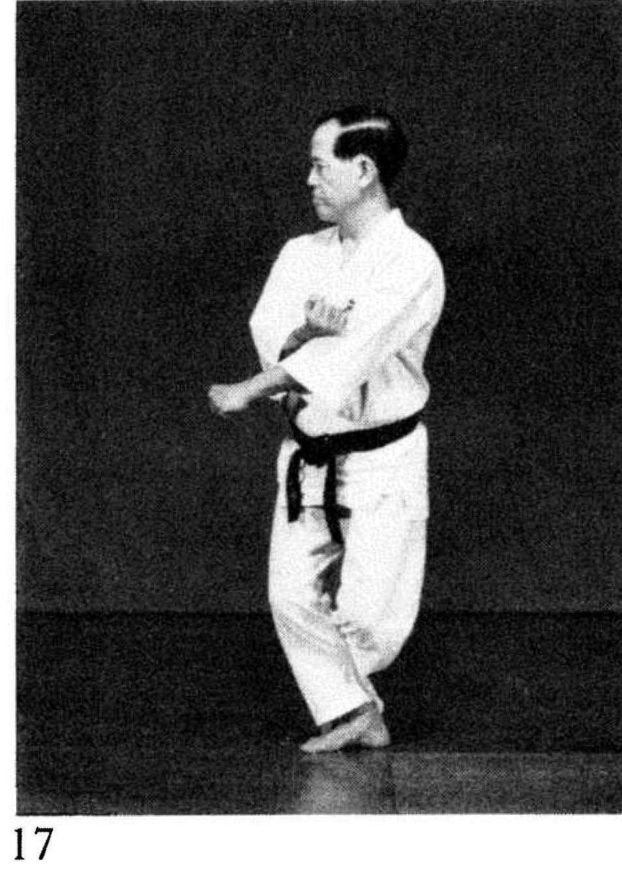

Passai pg. 203 Fig. 39 follows an elbow smash and is often misinterpreted as a low block.  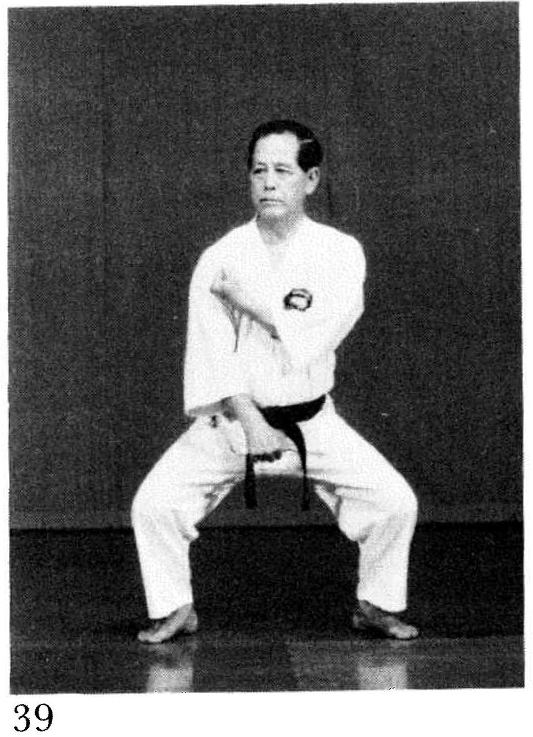 | Passai pg. 202. Fig. 39 and 41 are unusual in that they show Nagamine Sensei looking to the right while punching to the midline.  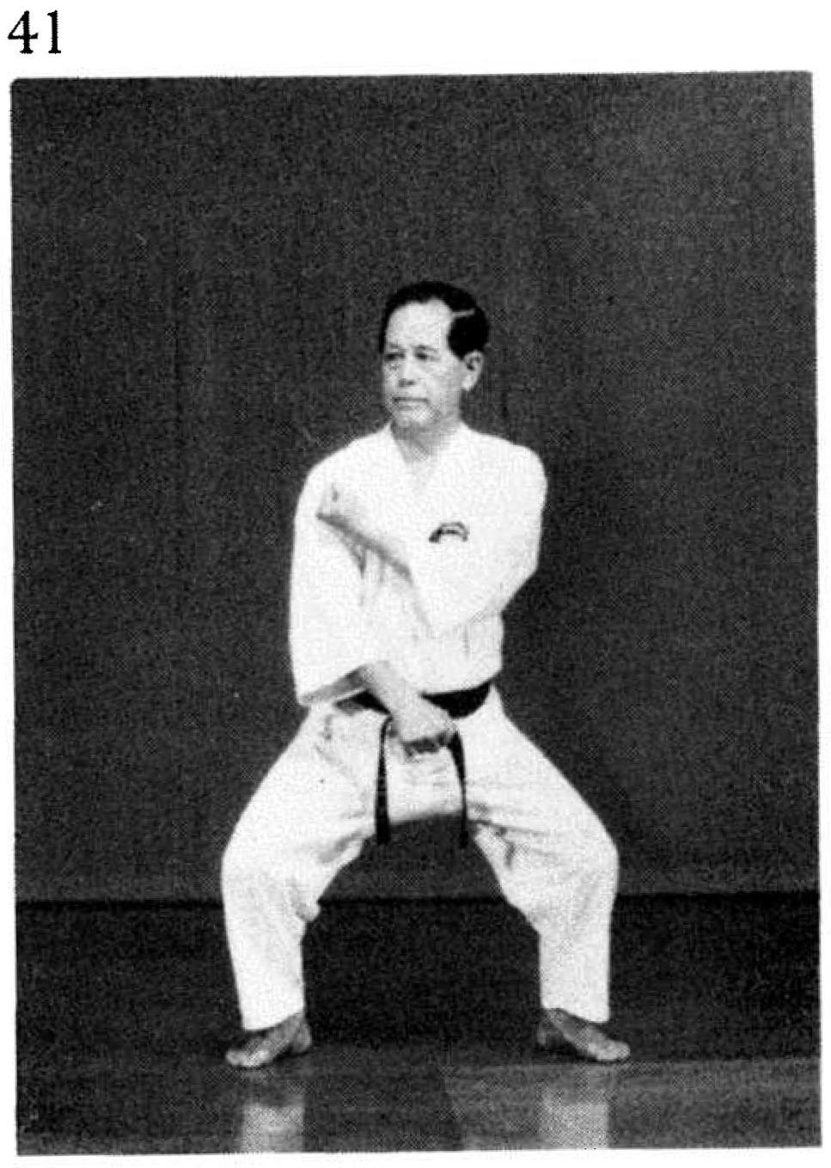

Chinto pg. 229
