Spec. number: 9
Technique: Circular block and punch (Tomoe-zuki)
Kata: F2, Rohai, Passai
Page number: 70
Description: “Used to deliver a blow to the chest and abdomen simultaneously.”
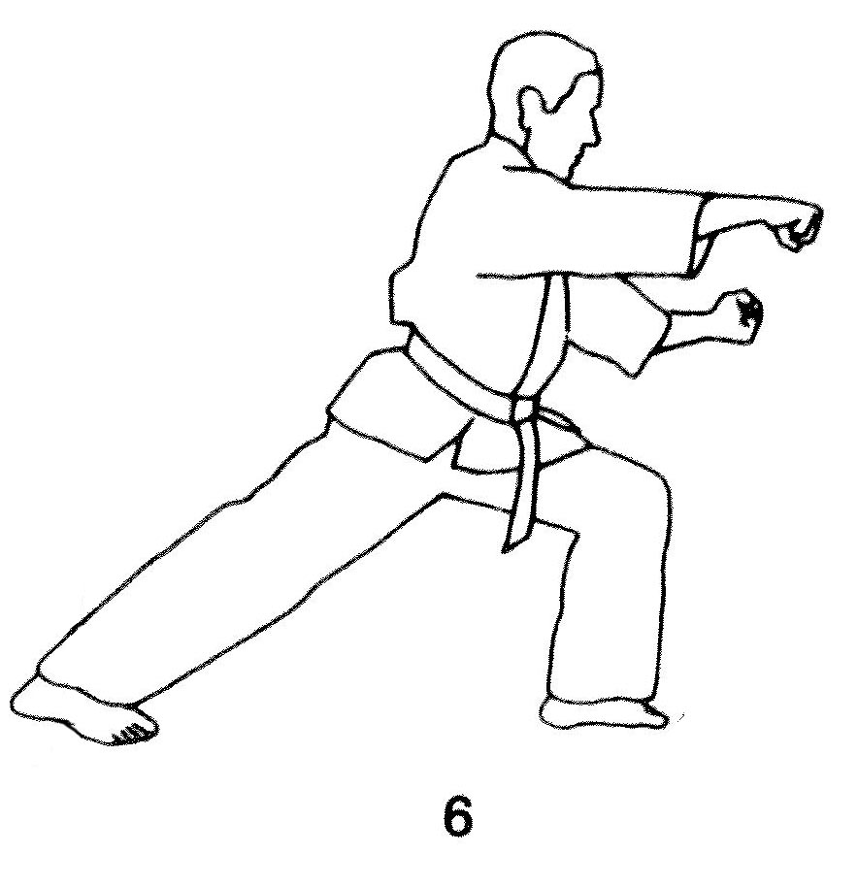
Comments: As Hanshi observes, “These punches deliver a shock to the body – floating ribs, spleen, heart, liver – as opposed to surgical strikes to a specific target(s).” Many students aim the upper punch at the solar plexus, which is incorrect. The technique is specifically designed as an alternative to our solar plexus punches.
Some photographs show the bottom punch extending slightly farther than the upper punch, while Fig. 71(13) and 205(50) show the reverse. We lock out the upper arm and have a slight bend in the lower arm, as shown in the Red Book pg. 66 and 71(6).
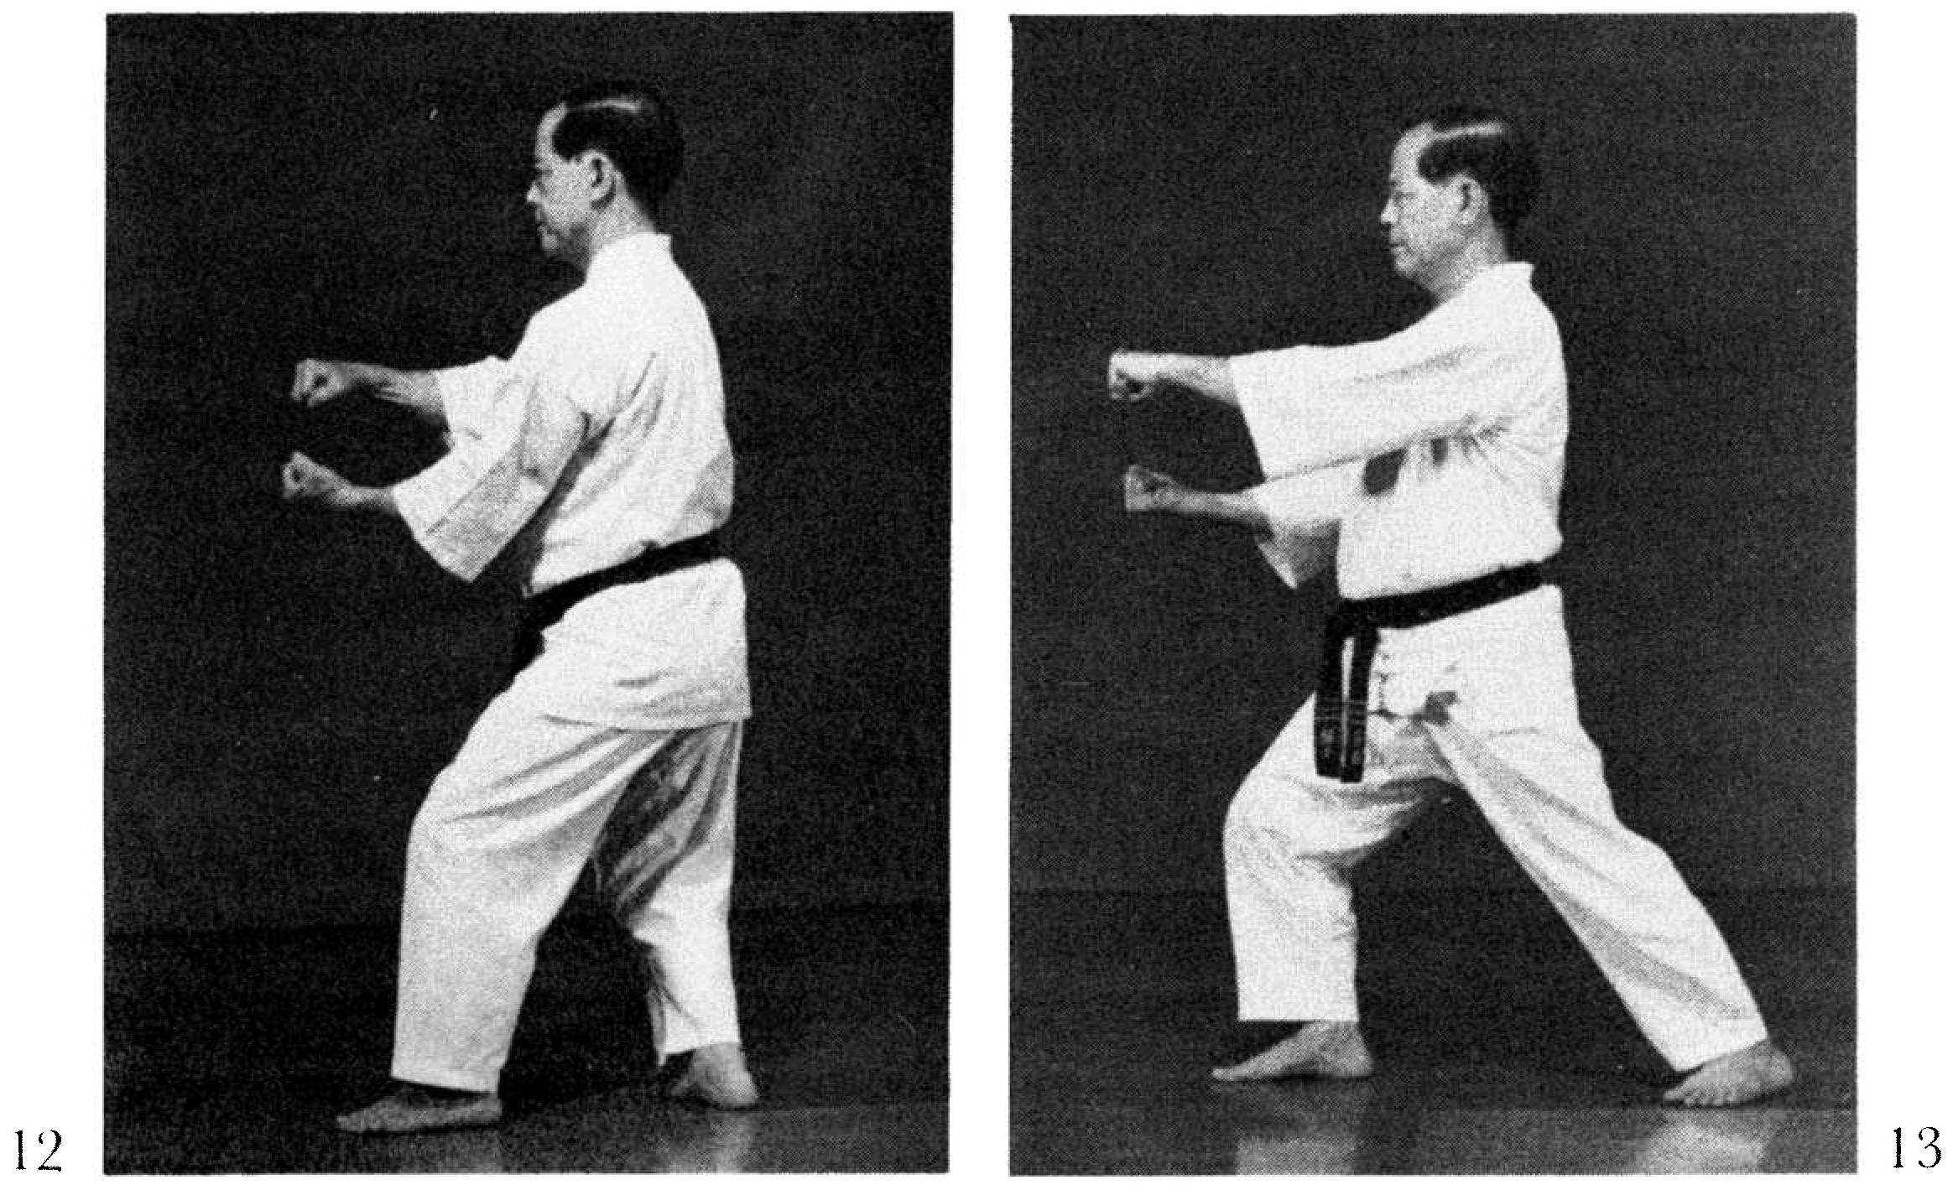
In Rohai and Passai the “circular block” of this technique is not included. Nagamine Sensei chambers both hands on one side of the body. Hanshi notes, however, that in this specific move Master Ueshiro permitted some flexibility in the chambering and delivery of the punches. To emphasize power one may “exaggerate” the wind-up by chambering on opposite sides, as shown in the Kata DVD.
Photographs:
71(12, 13)

Fukyugata ni pgs. 113-115
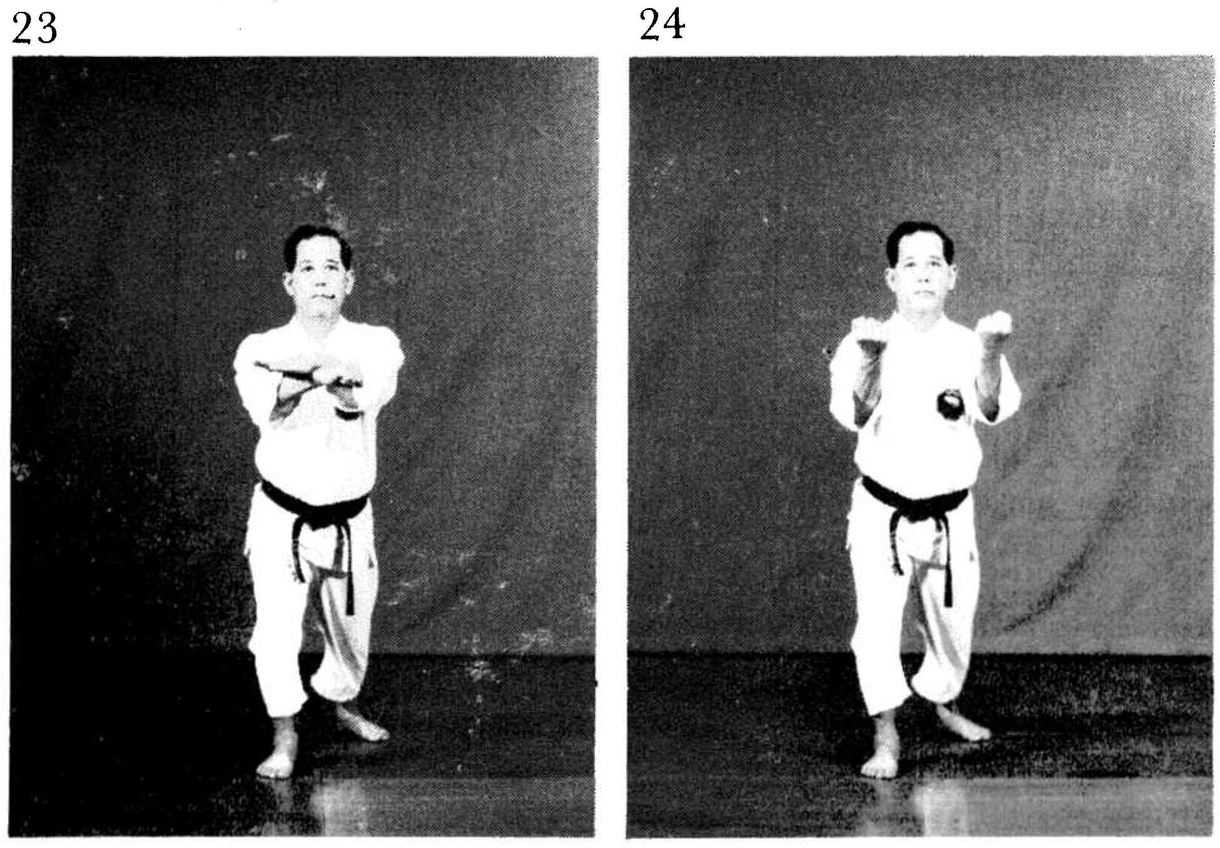
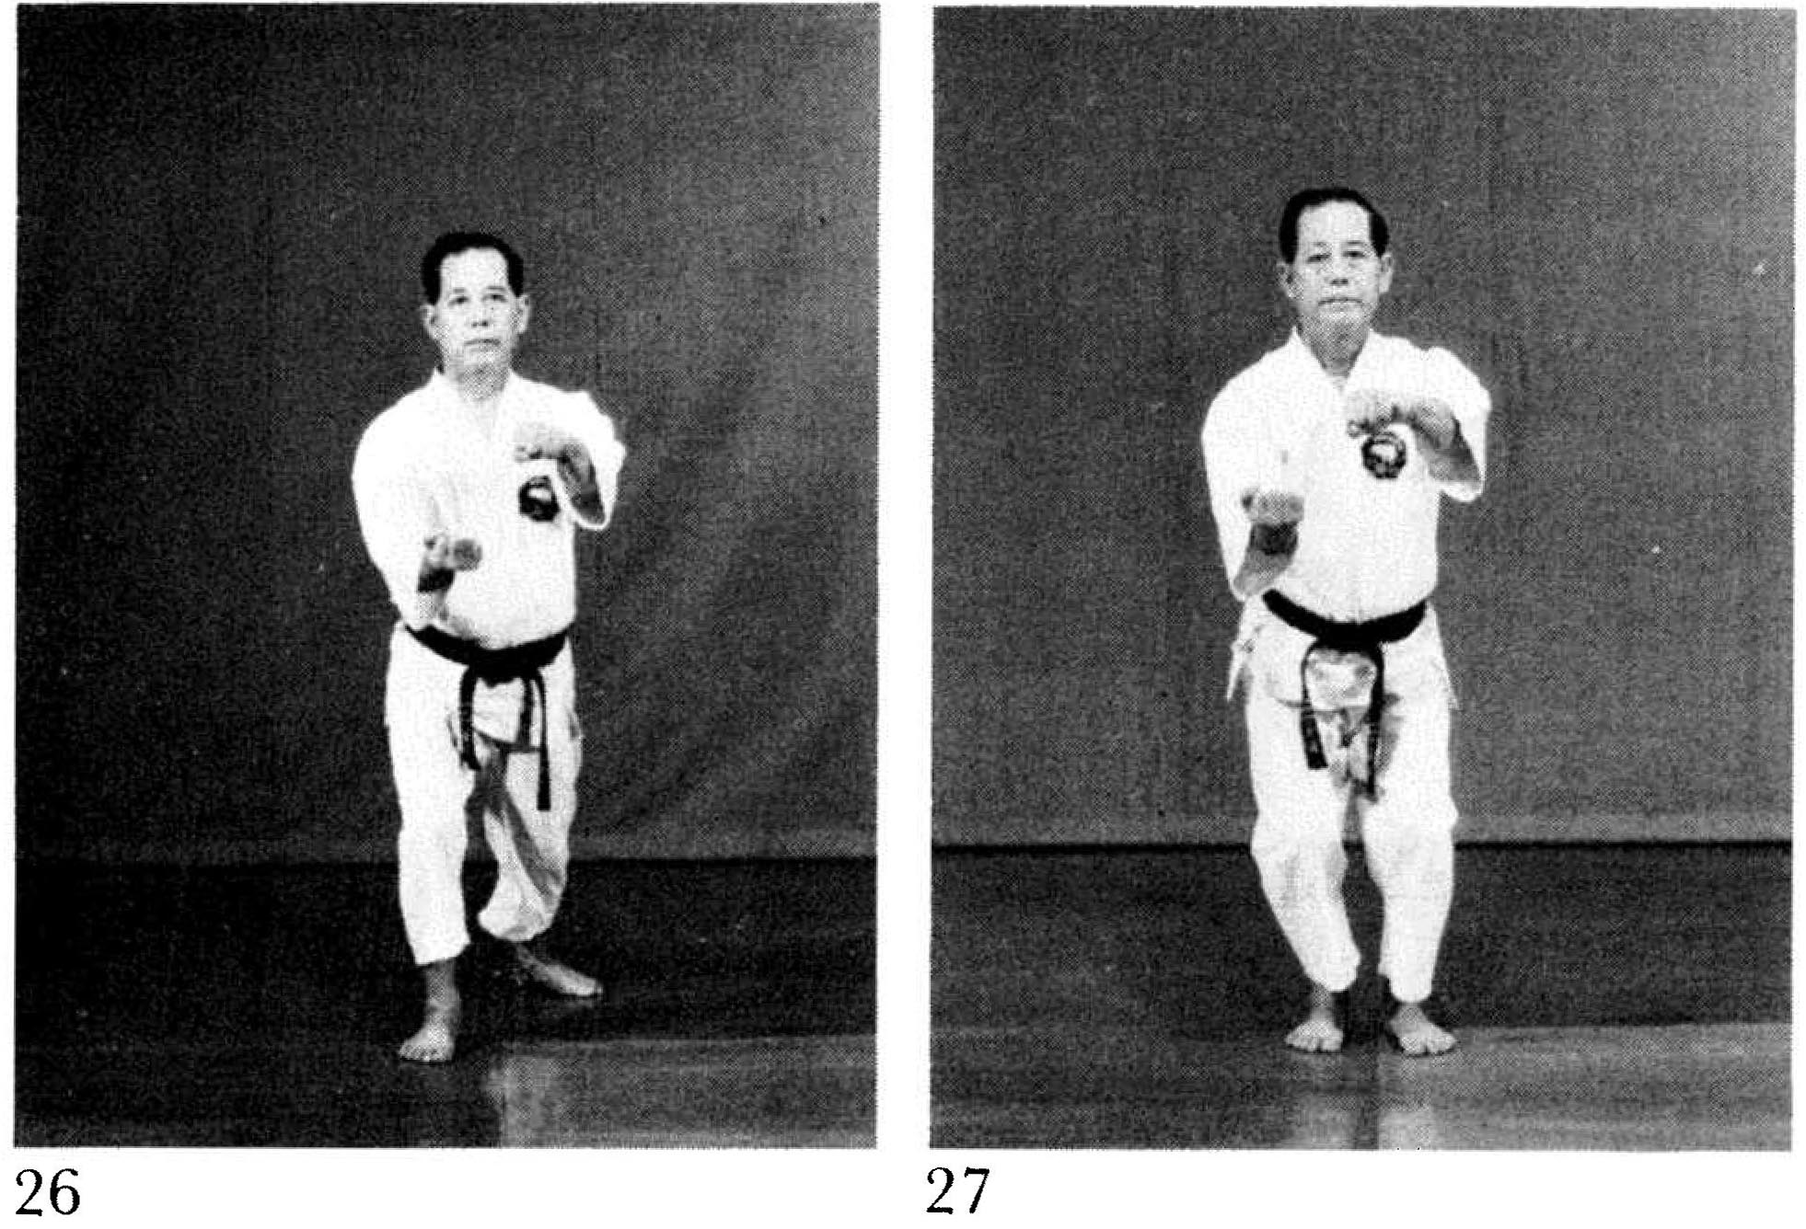
As per Fig. 27, keep the arms in the punching position as the left foot steps forward. Do not start chambering for the block until the right foot begins to move backwards.

Fukyugata ni pg. 114  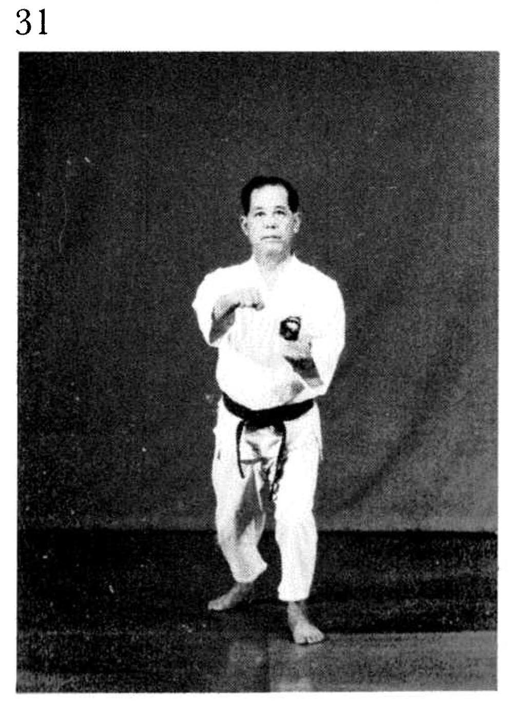 | Rohai 184  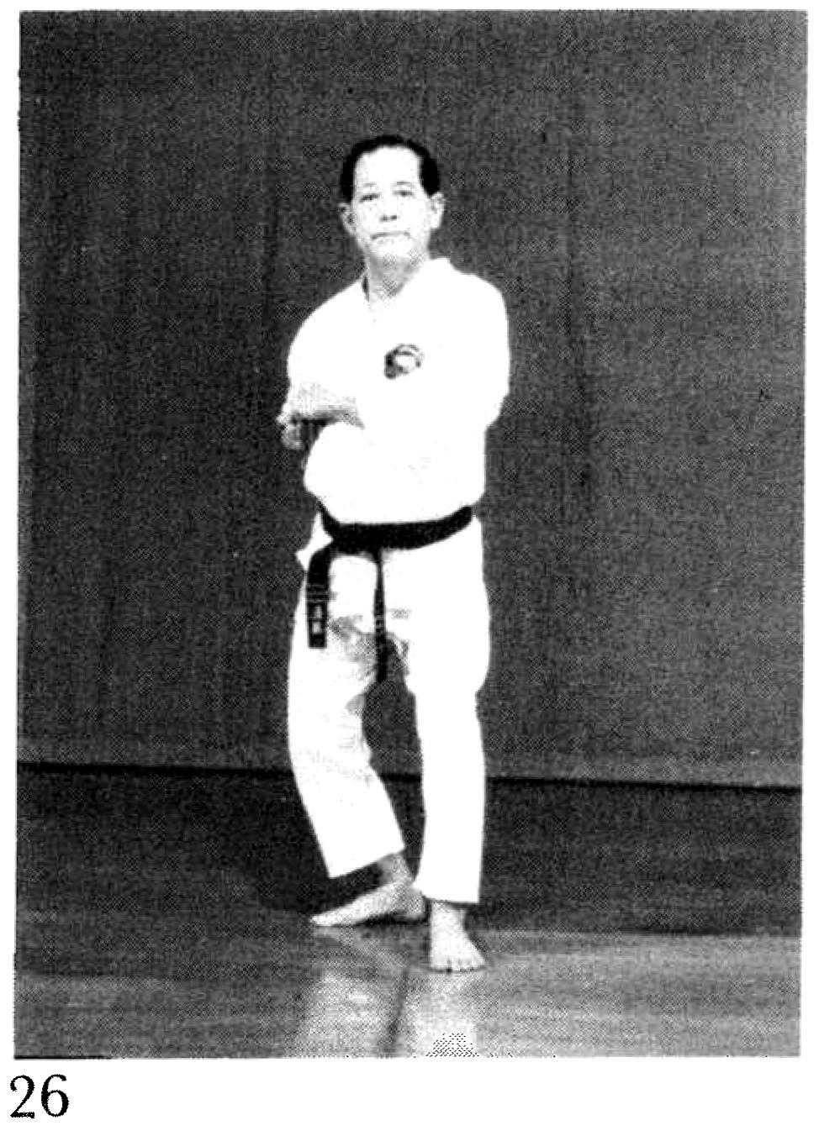

Rohai pg. 184  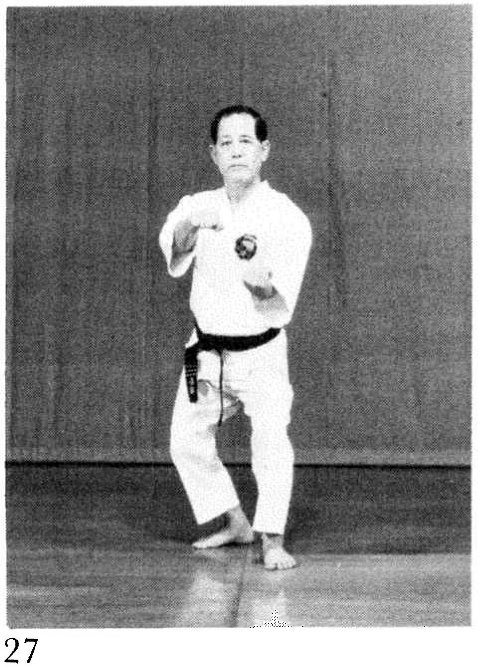 | Rohai pg. 185  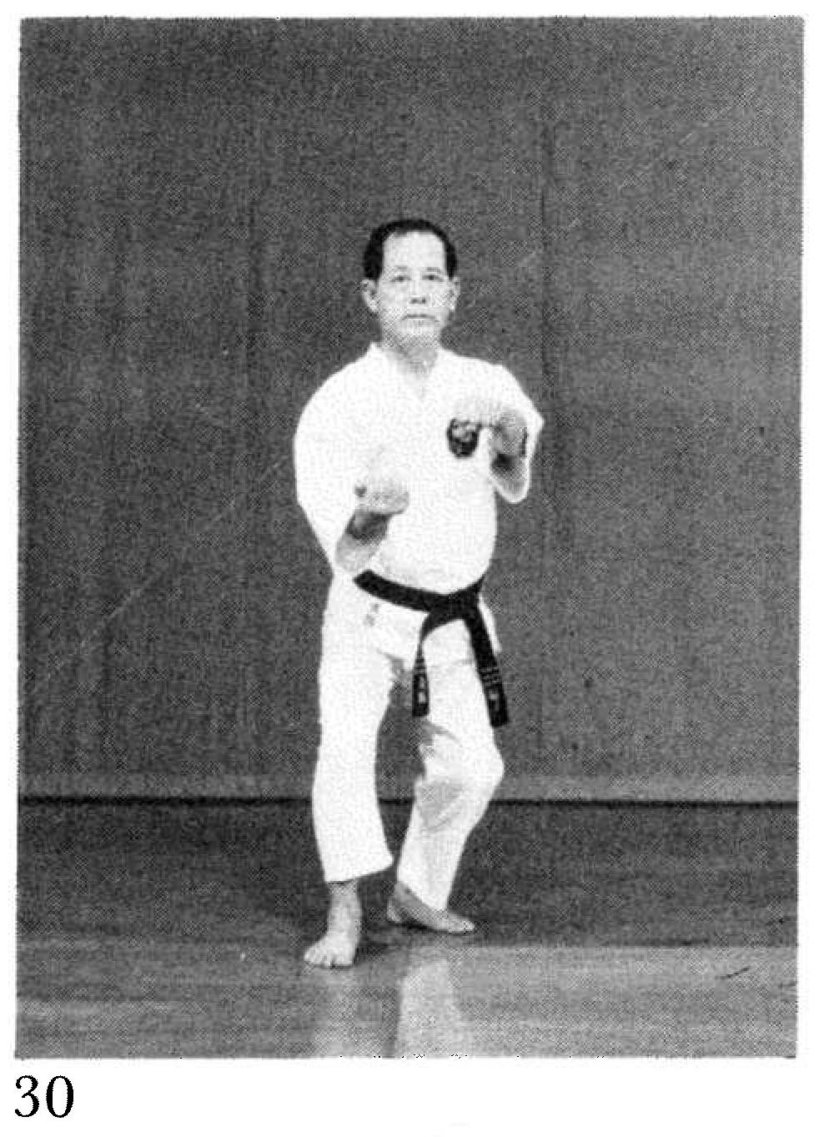

Passai pg. 202 – When searching we extend the foot outwards, then drop dramatically as the punches are delivered.  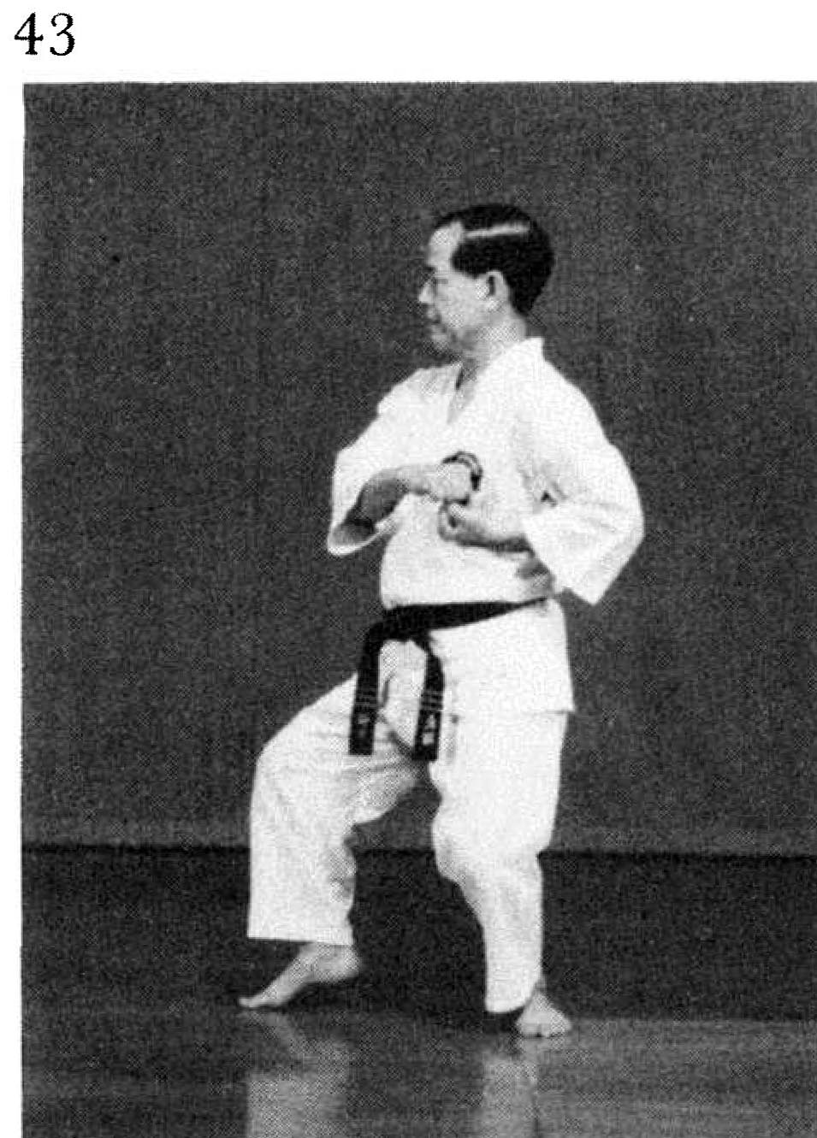 | Passai pg. 203  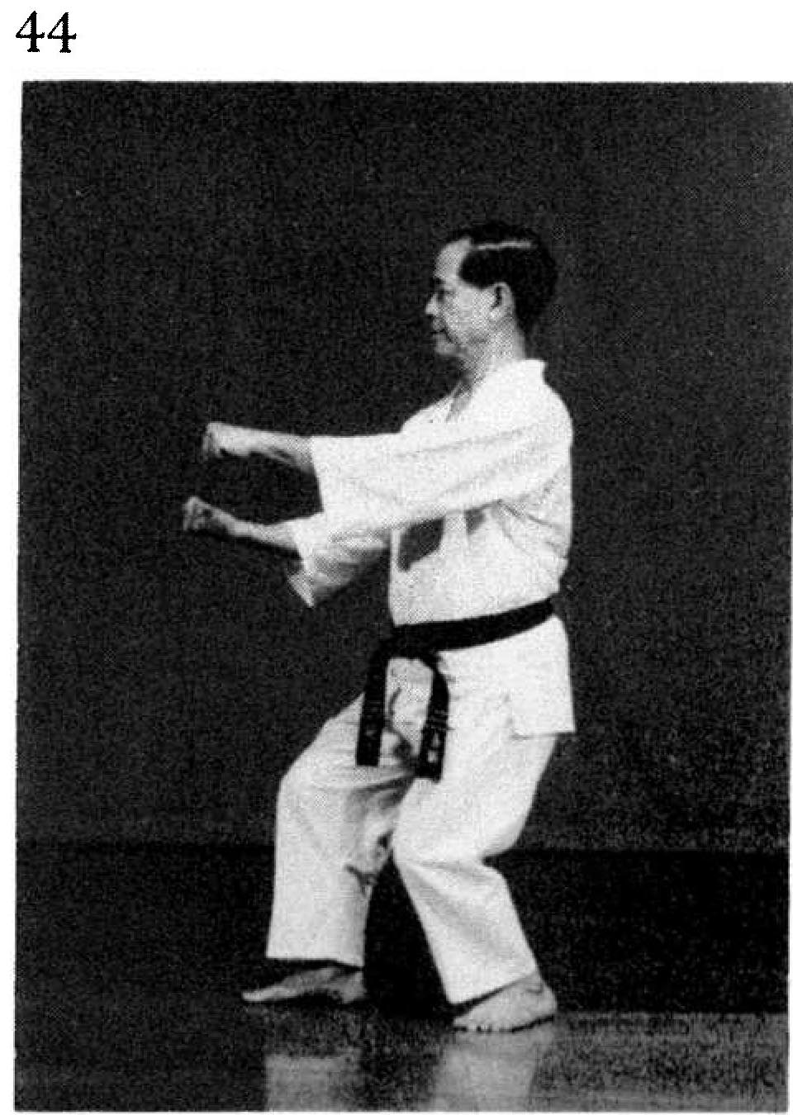
Passai pg. 204  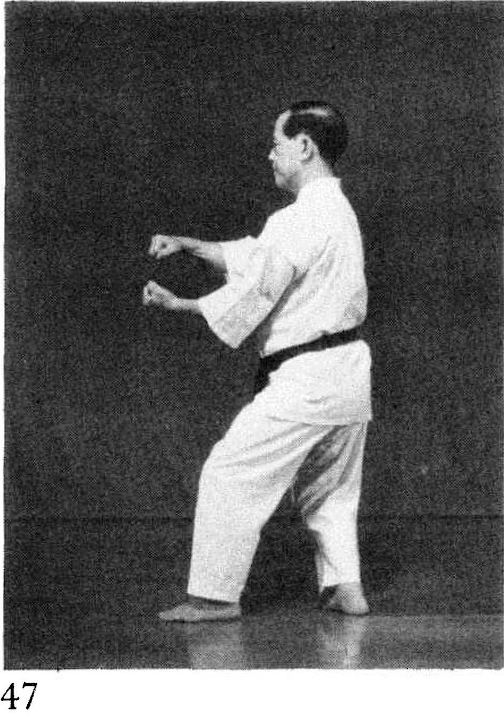 | Passai pg. 205  