Spec. number: 10
Technique: Augmented side punch (Morote-zuki)
Kata: N1, Kusanku
Page number: 72
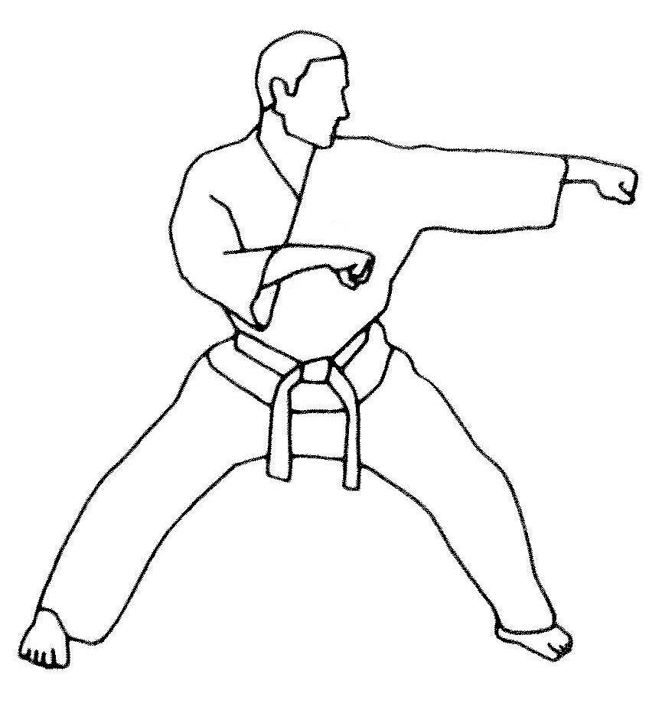
Description: “This is formed similarly to chasing punch with one of the hands serving to accelerate the force of the other while staying parallel to it.”
Comments: Although Nagamine Sensei describes the augmenting arm as “parallel,” the photographs as well as the Red Book and Kata DVD show the elbow slightly lower than the wrist to protect the floating ribs while the forearm protects the solar plexus. Some students have the augmenting arm positioned away from the body as if to deliver a punch. This is incorrect.
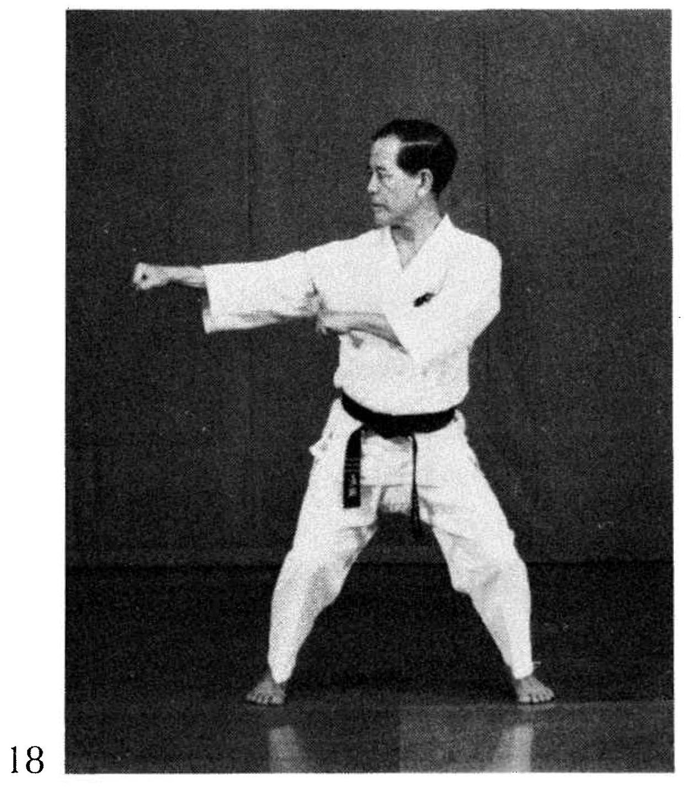
Note also that the fist of the augmenting arm is palm down as per the photographs, Red Book illustration and Kata DVD.

Photographs: 73(18)
Nihanchi sho: 151(21), 152(38)
Kusanku: 239(50)

Nihanchi 1 pg. 151  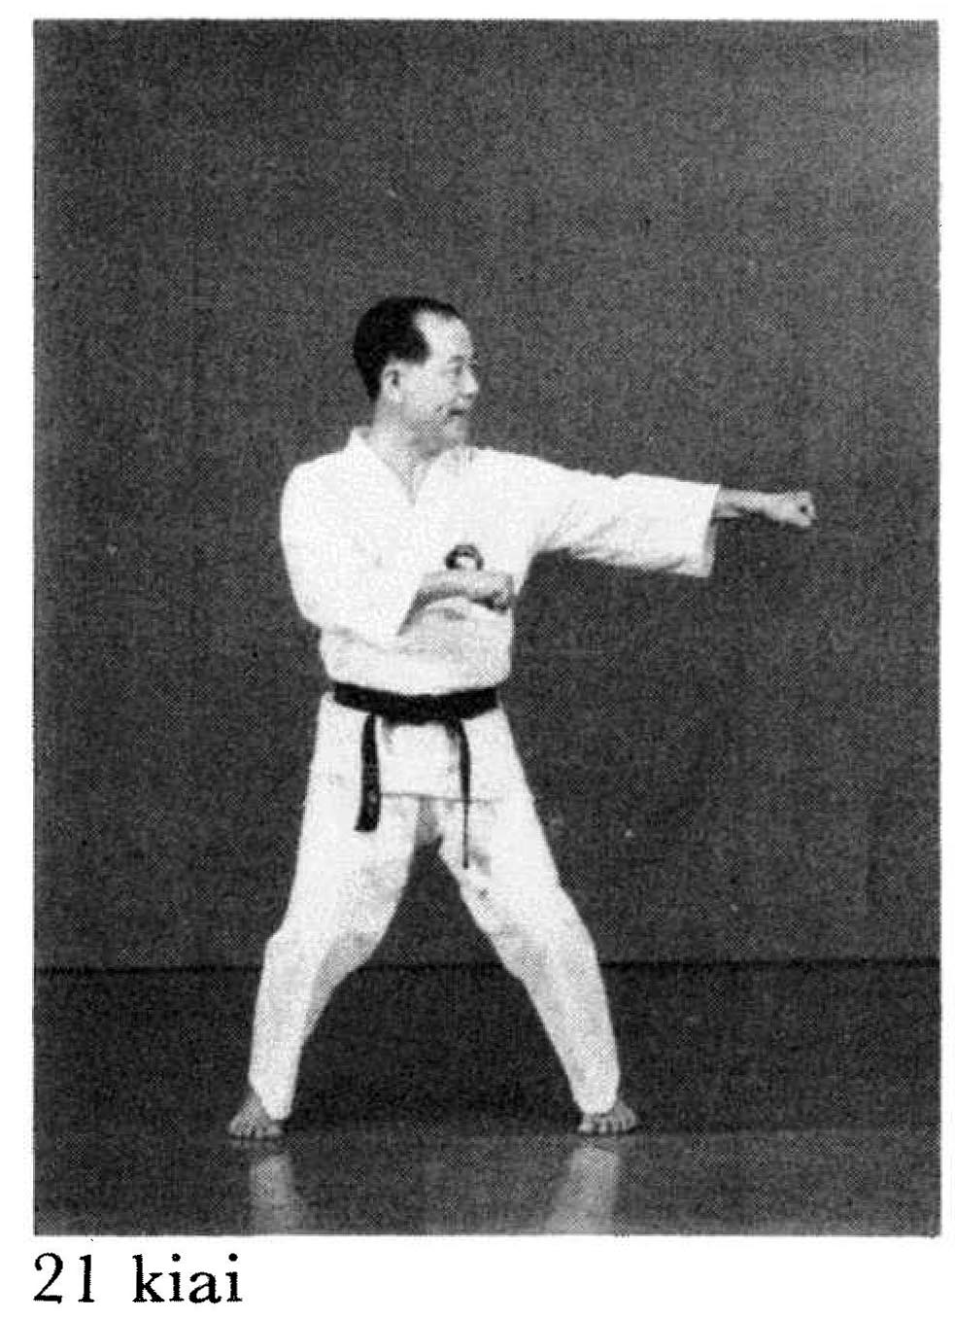 | Nihanchi 1 pg. 152  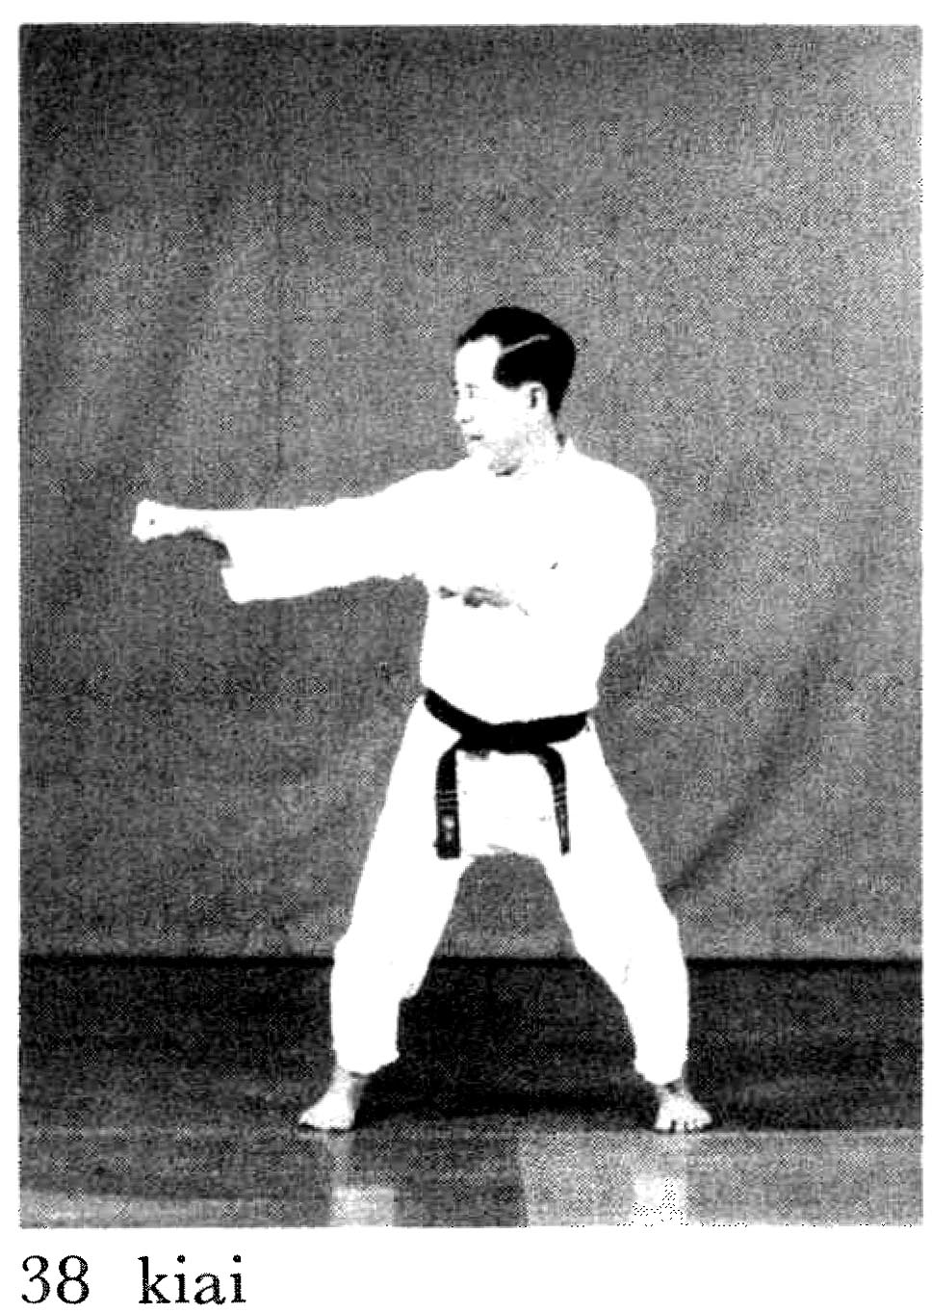
Kusanku pg. 239
