Spec. number: 11
Technique: Spear-hand thrust (Nukite-zuki)
Kata: P1, P3, Gojushiho, Kusanku
Page number: 74
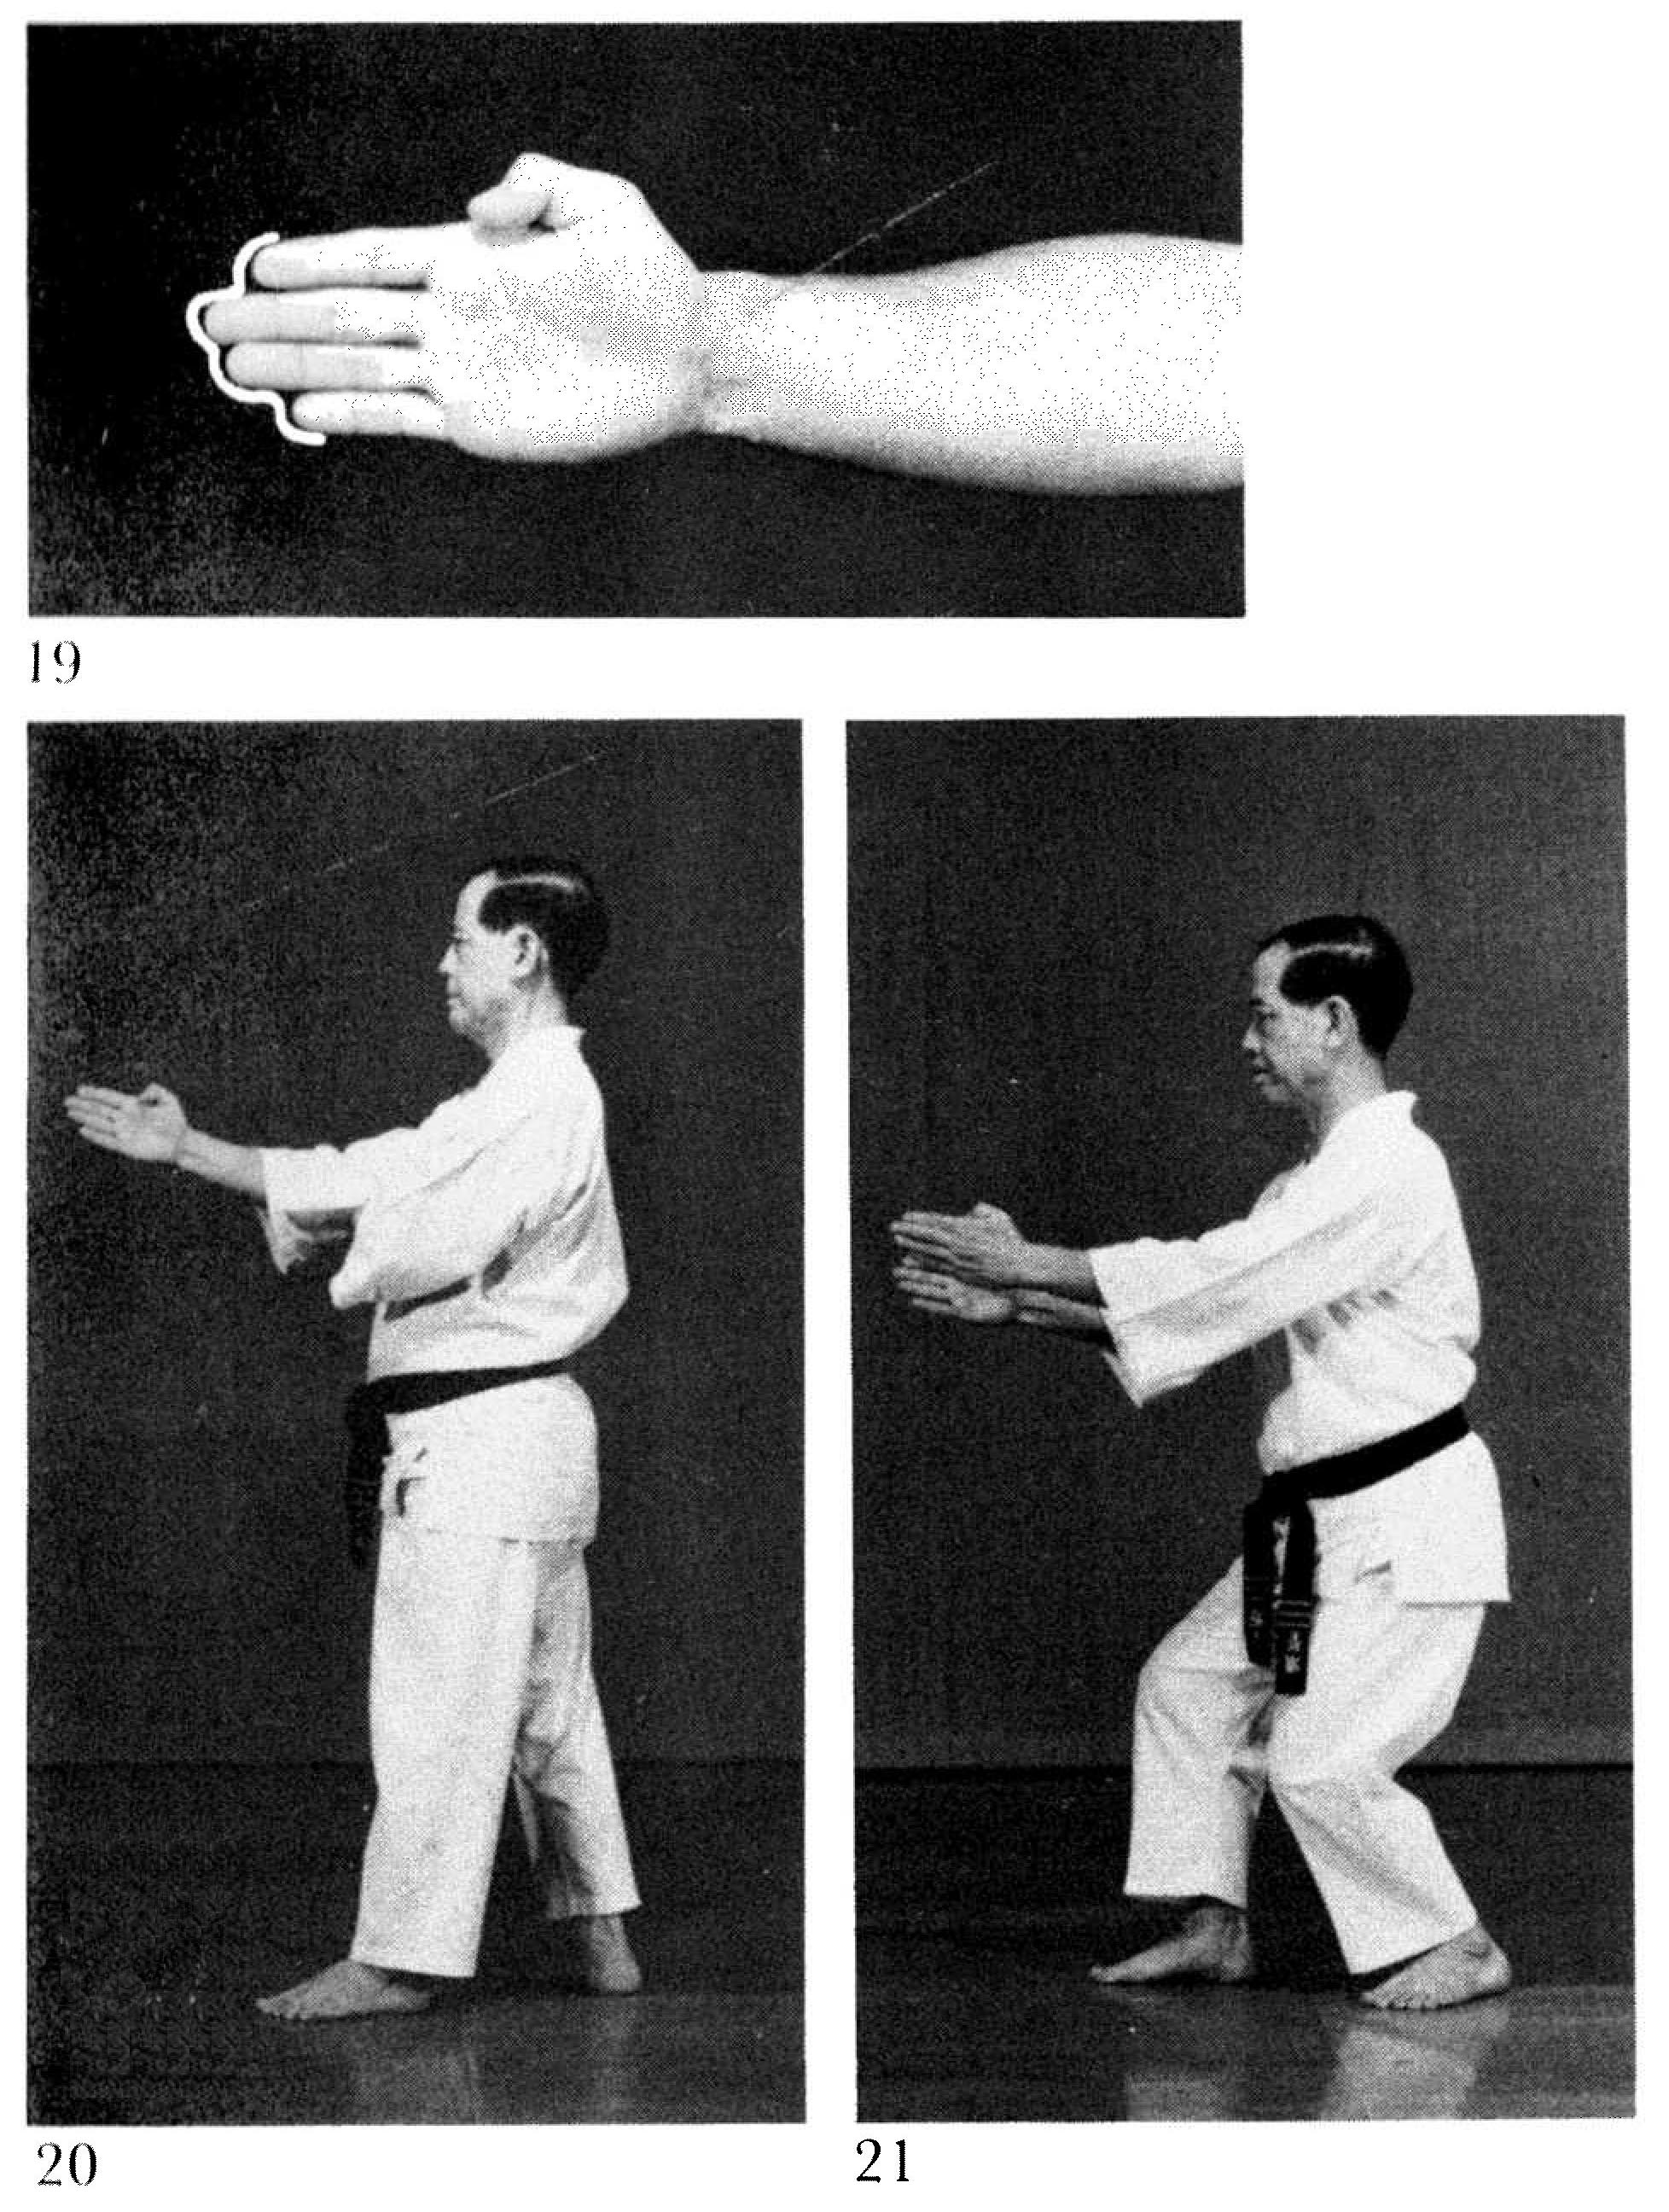
Description: “This technique is formed with the fingers extended and tightened together and is used to thrust at the eyes, solar plexus or ribs.”
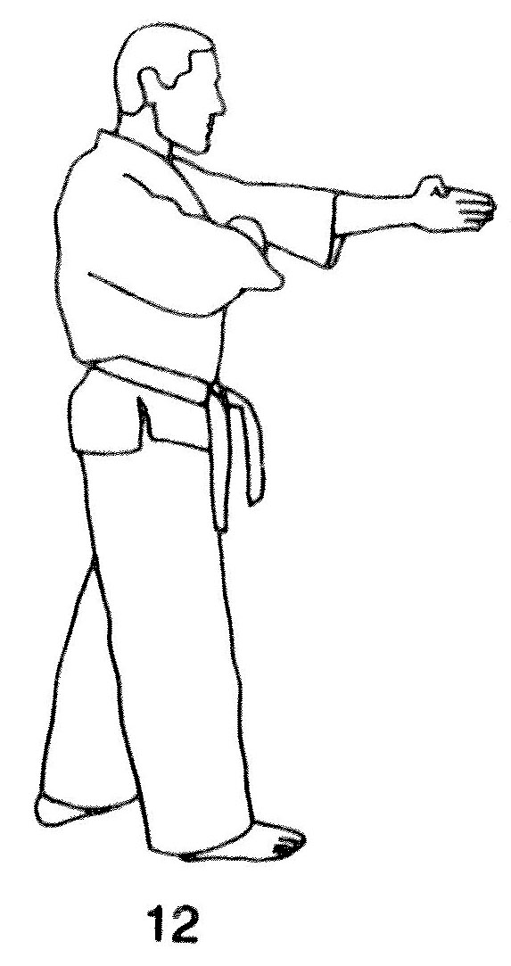
Comments: Some students bend the middle and ring fingers to form a straight line with the index finger. This is incorrect. See the introductory sequence to P1 in the Kata DVD.
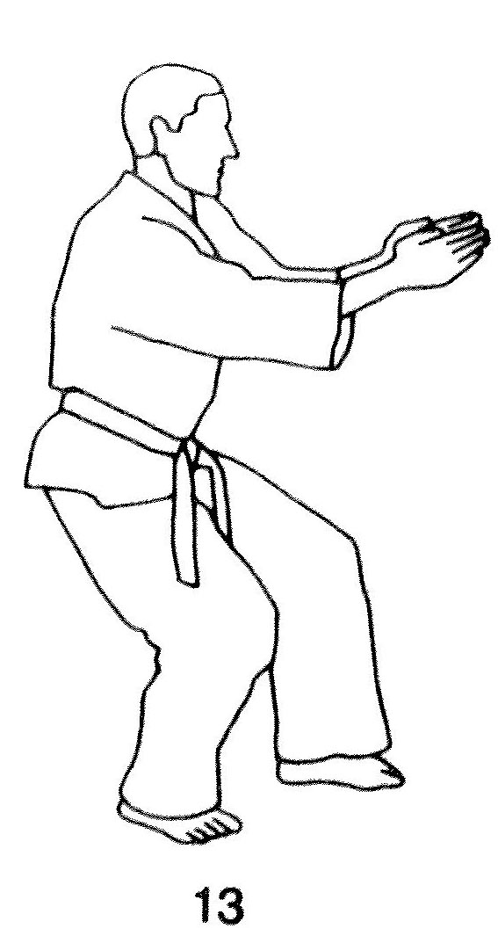
The photographs show a slight bend at the elbow with the hand aiming upwards. We lock out the elbow as in a middle punch, as seen in the Red Book pg. 72(12). An important exception is the double spear hand thrust in Gojushiho, which strikes upwards under the rib cage, as shown by Master Nagamine (Fig. 21) and the Red Book (Fig. 13).
Note that there is no bend in the wrist. Some students angle the hand up or down, which is incorrect.
Photographs: 74(19 – 21)

Pinan shodan pg. 118  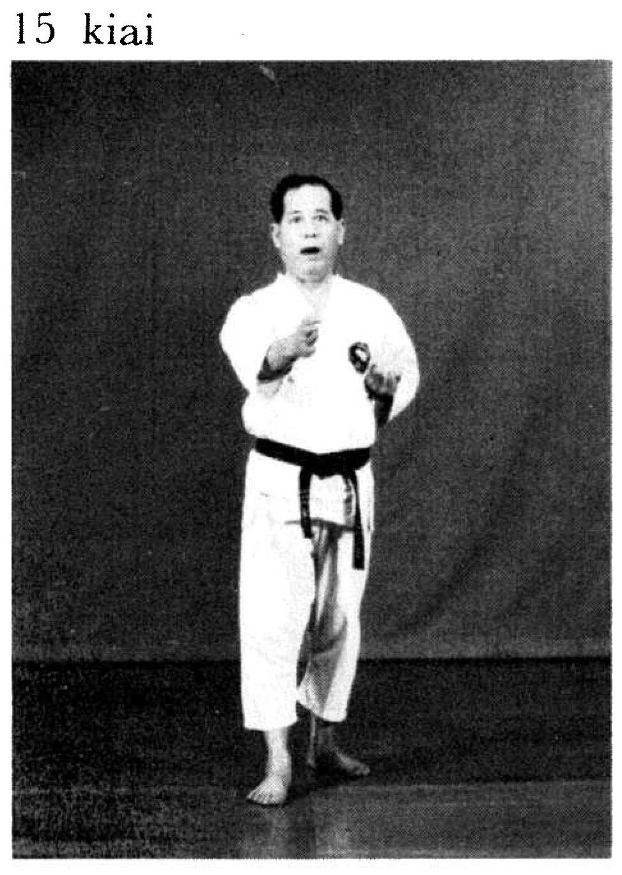 | Pinan sandan pg. 130  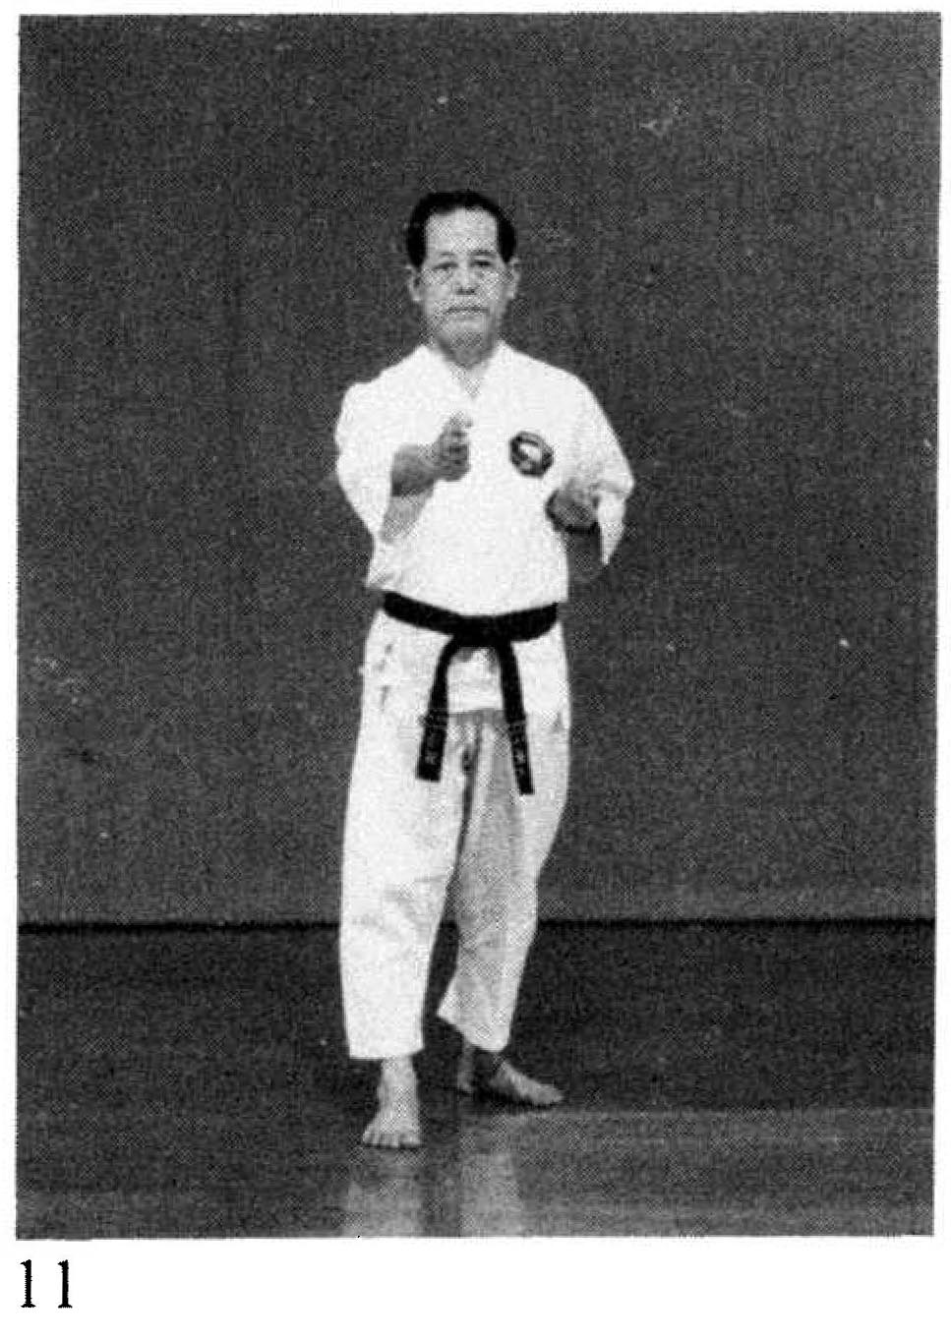
Gojushiho pg. 210  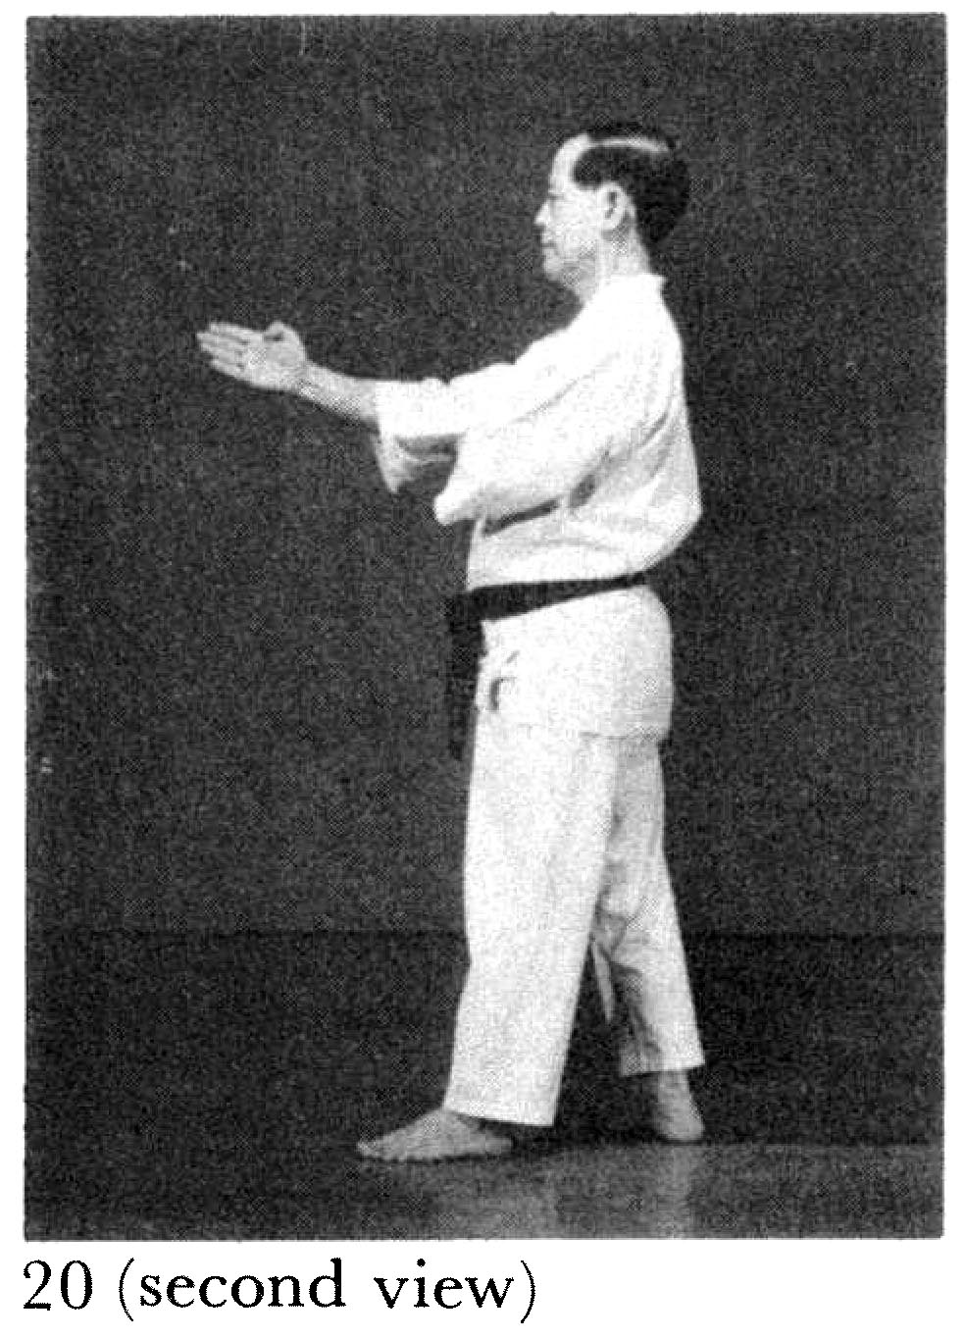 | Gojushiho pg. 210  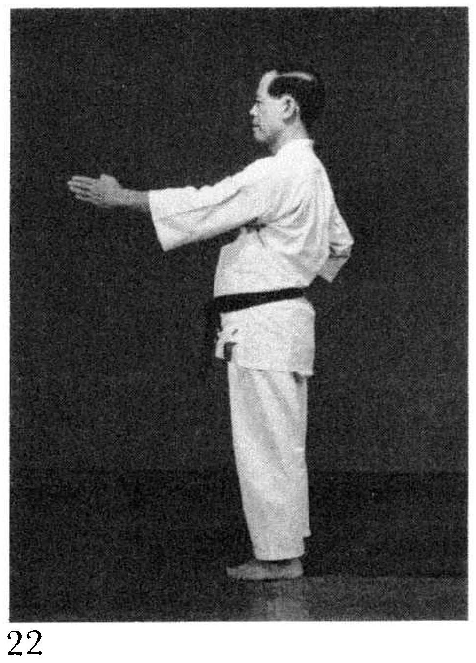

Gojushiho pg. 212 |  | Gojushiho pg. 212
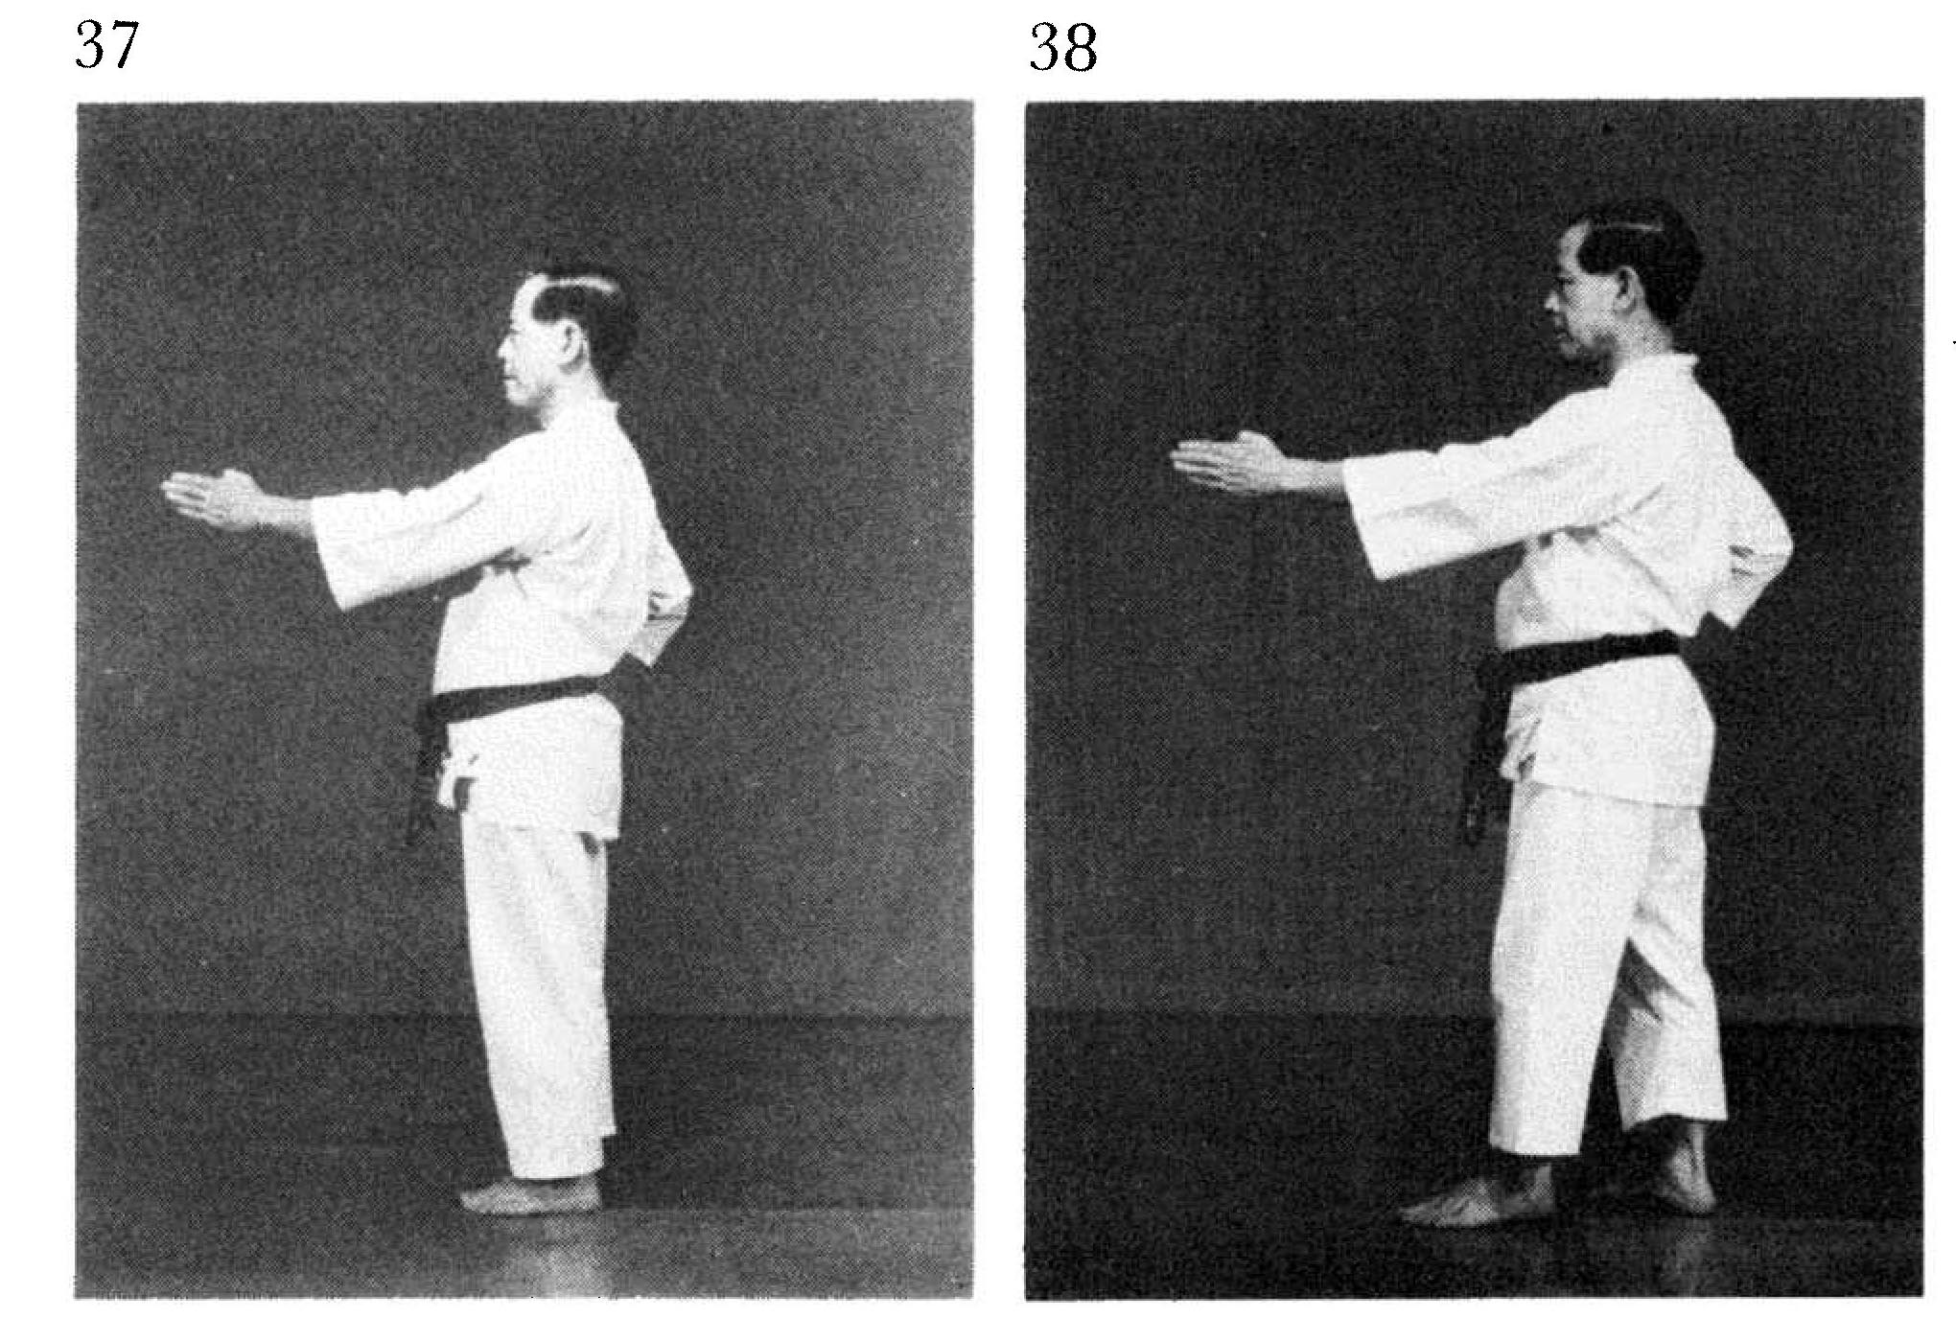
Gojushio pg. 212  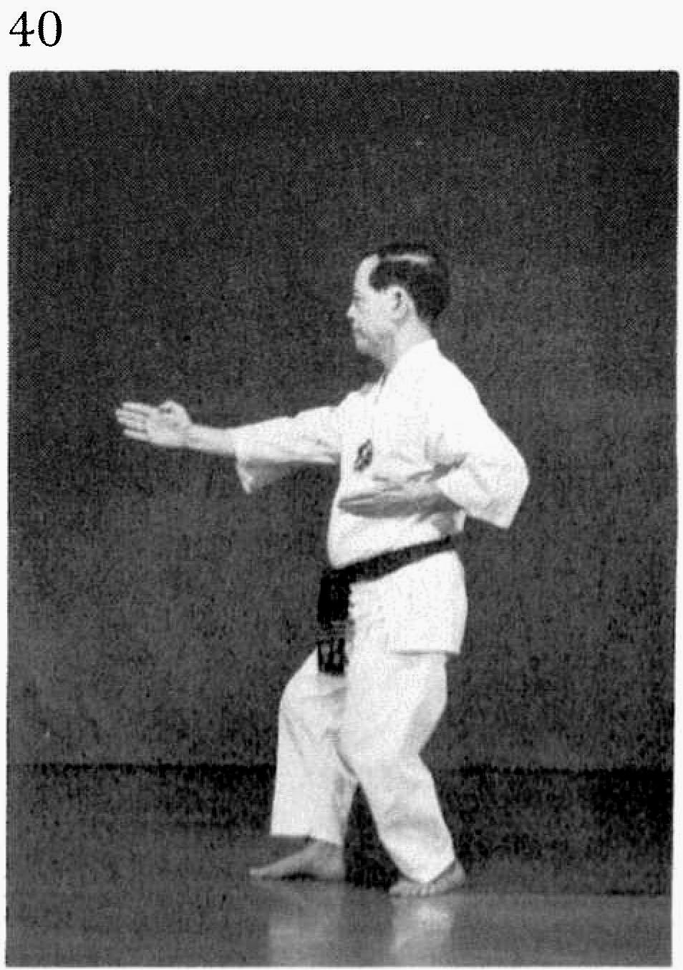 | Kusanku pg. 240  