Spec. number: 12
Technique: Hammer-fist strike (Kentsui-uchi)
Kata: P2, N3
Page number: 76
Description: “The fist is formed the same way as in seiken, but the side is used to block the opponent’s hand or arm by making a snapping motion with the forearm as if using a hammer.”
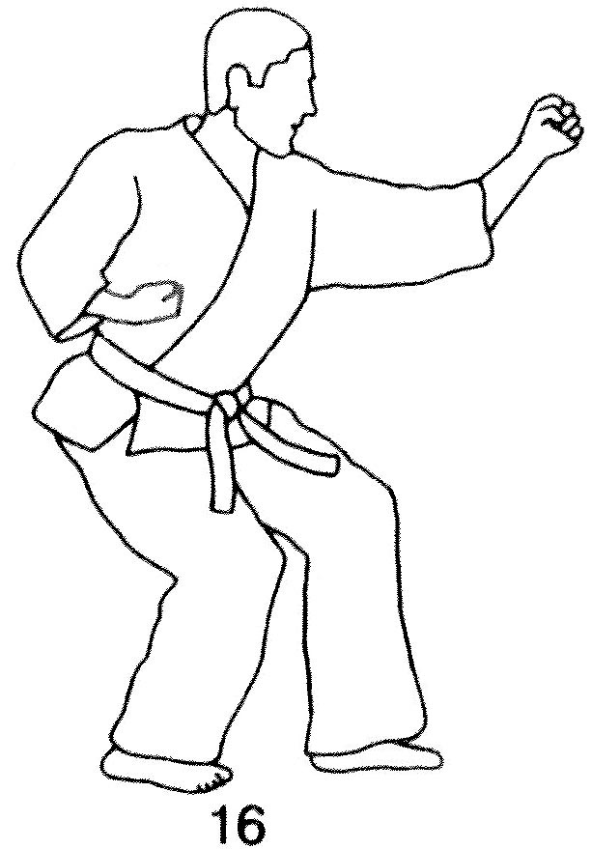
Comments: Although the description says “used to block,” this technique is listed with other uchi (striking) techniques and the forward foot should therefore be heel down, as shown in photographs 123(5) and 124(9).
. According to Hanshi, targets include the collar bone or bicep. Some students interpret the hammer-fist strike as a jab to the nose. This is incorrect. It does not snap back but rather snaps down, like a hammer.
Both the photographs and Red Book (pg. 73) show the wrist straight as in a punch, not bent up to “offer” the hammer fist.
Photographs: 76(27, 28, 29)
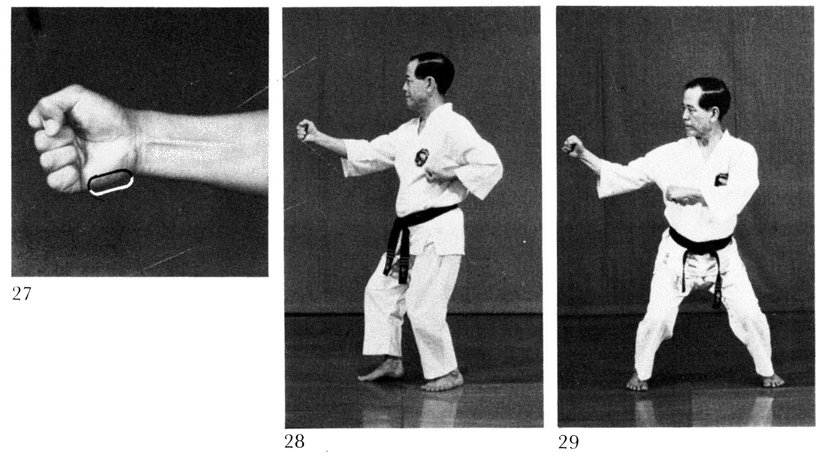
Pinan nidan: 123(5), 124(9)
Nihanchi san: 160(16), 161(33)
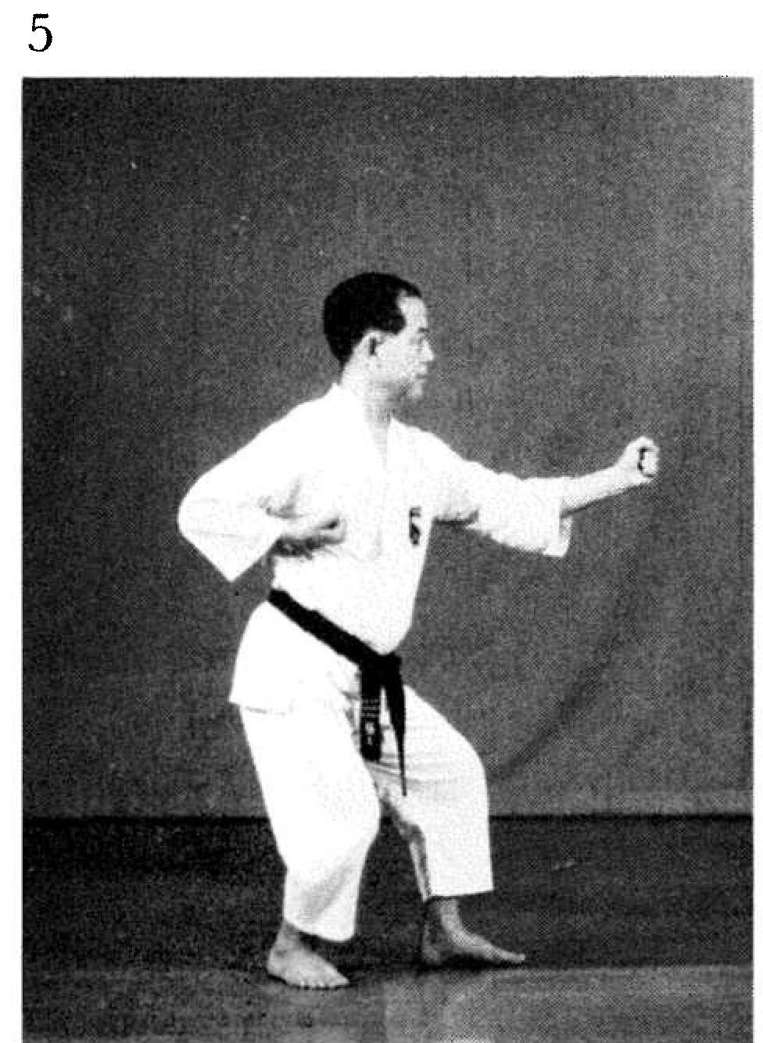 | 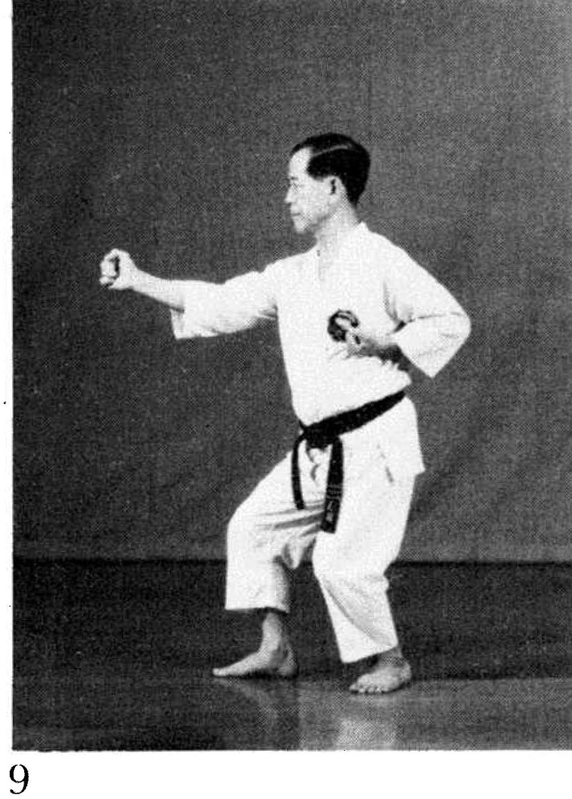
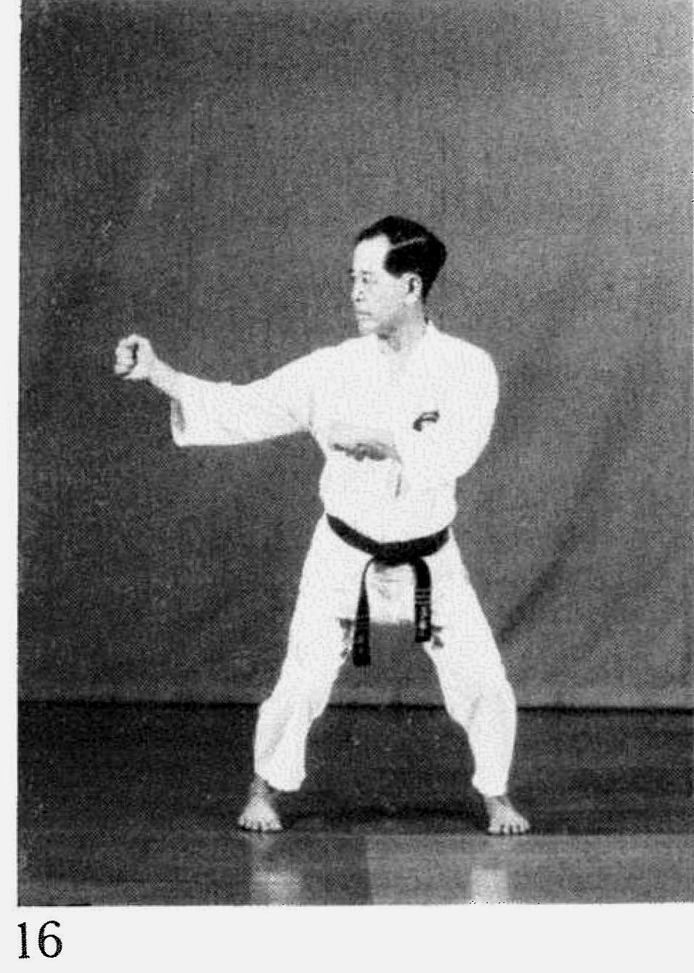 | 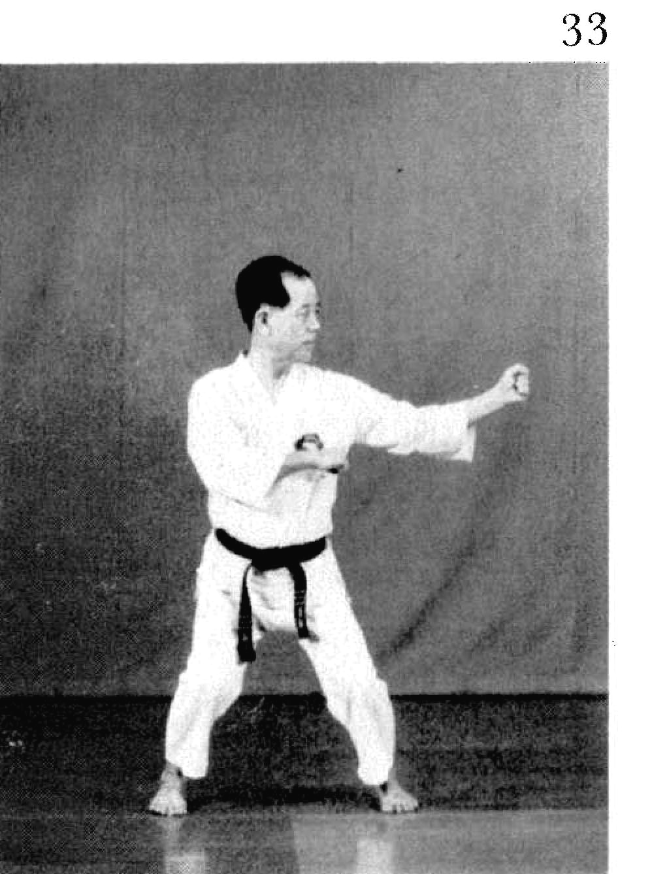  In N3 the augmenting arm is shown palm down. We have the palm slightly angled towards the chest.

