Spec. number: 13
Technique: Reverse knife-hand strike (Haito-uchi)
Kata: N1
Page number: 78
Description: “The ridge of the hand that lies in front of the thumb, is used to block and strike the opponent’s forearm, neck or fist.”
Comments: The “ridge hand strike” (as we call it) is described as a multi-purpose strike for offense, defense or both (simultaneously). It is not clear how Nagamine Sensei would use the ridge-hand to block and strike an opponent’s fist directly.
Note this technique only occurs in N1. The arm reaches out approximately 145 degrees, not 90 degrees.
Although some students exaggerate tucking the thumb under the palm as in Fig. 78(34), Hanshi prefers we keep the hand in shuto, as shown in Master Nagamine’s photos from the kata and in the Kata DVD. As Hanshi explains, “This gives us a more powerful weapon by incorporating the knuckle of the thumb into the neck strike.” See also the illustration on the inside cover of The Essence of Okinawan Karate-Do.
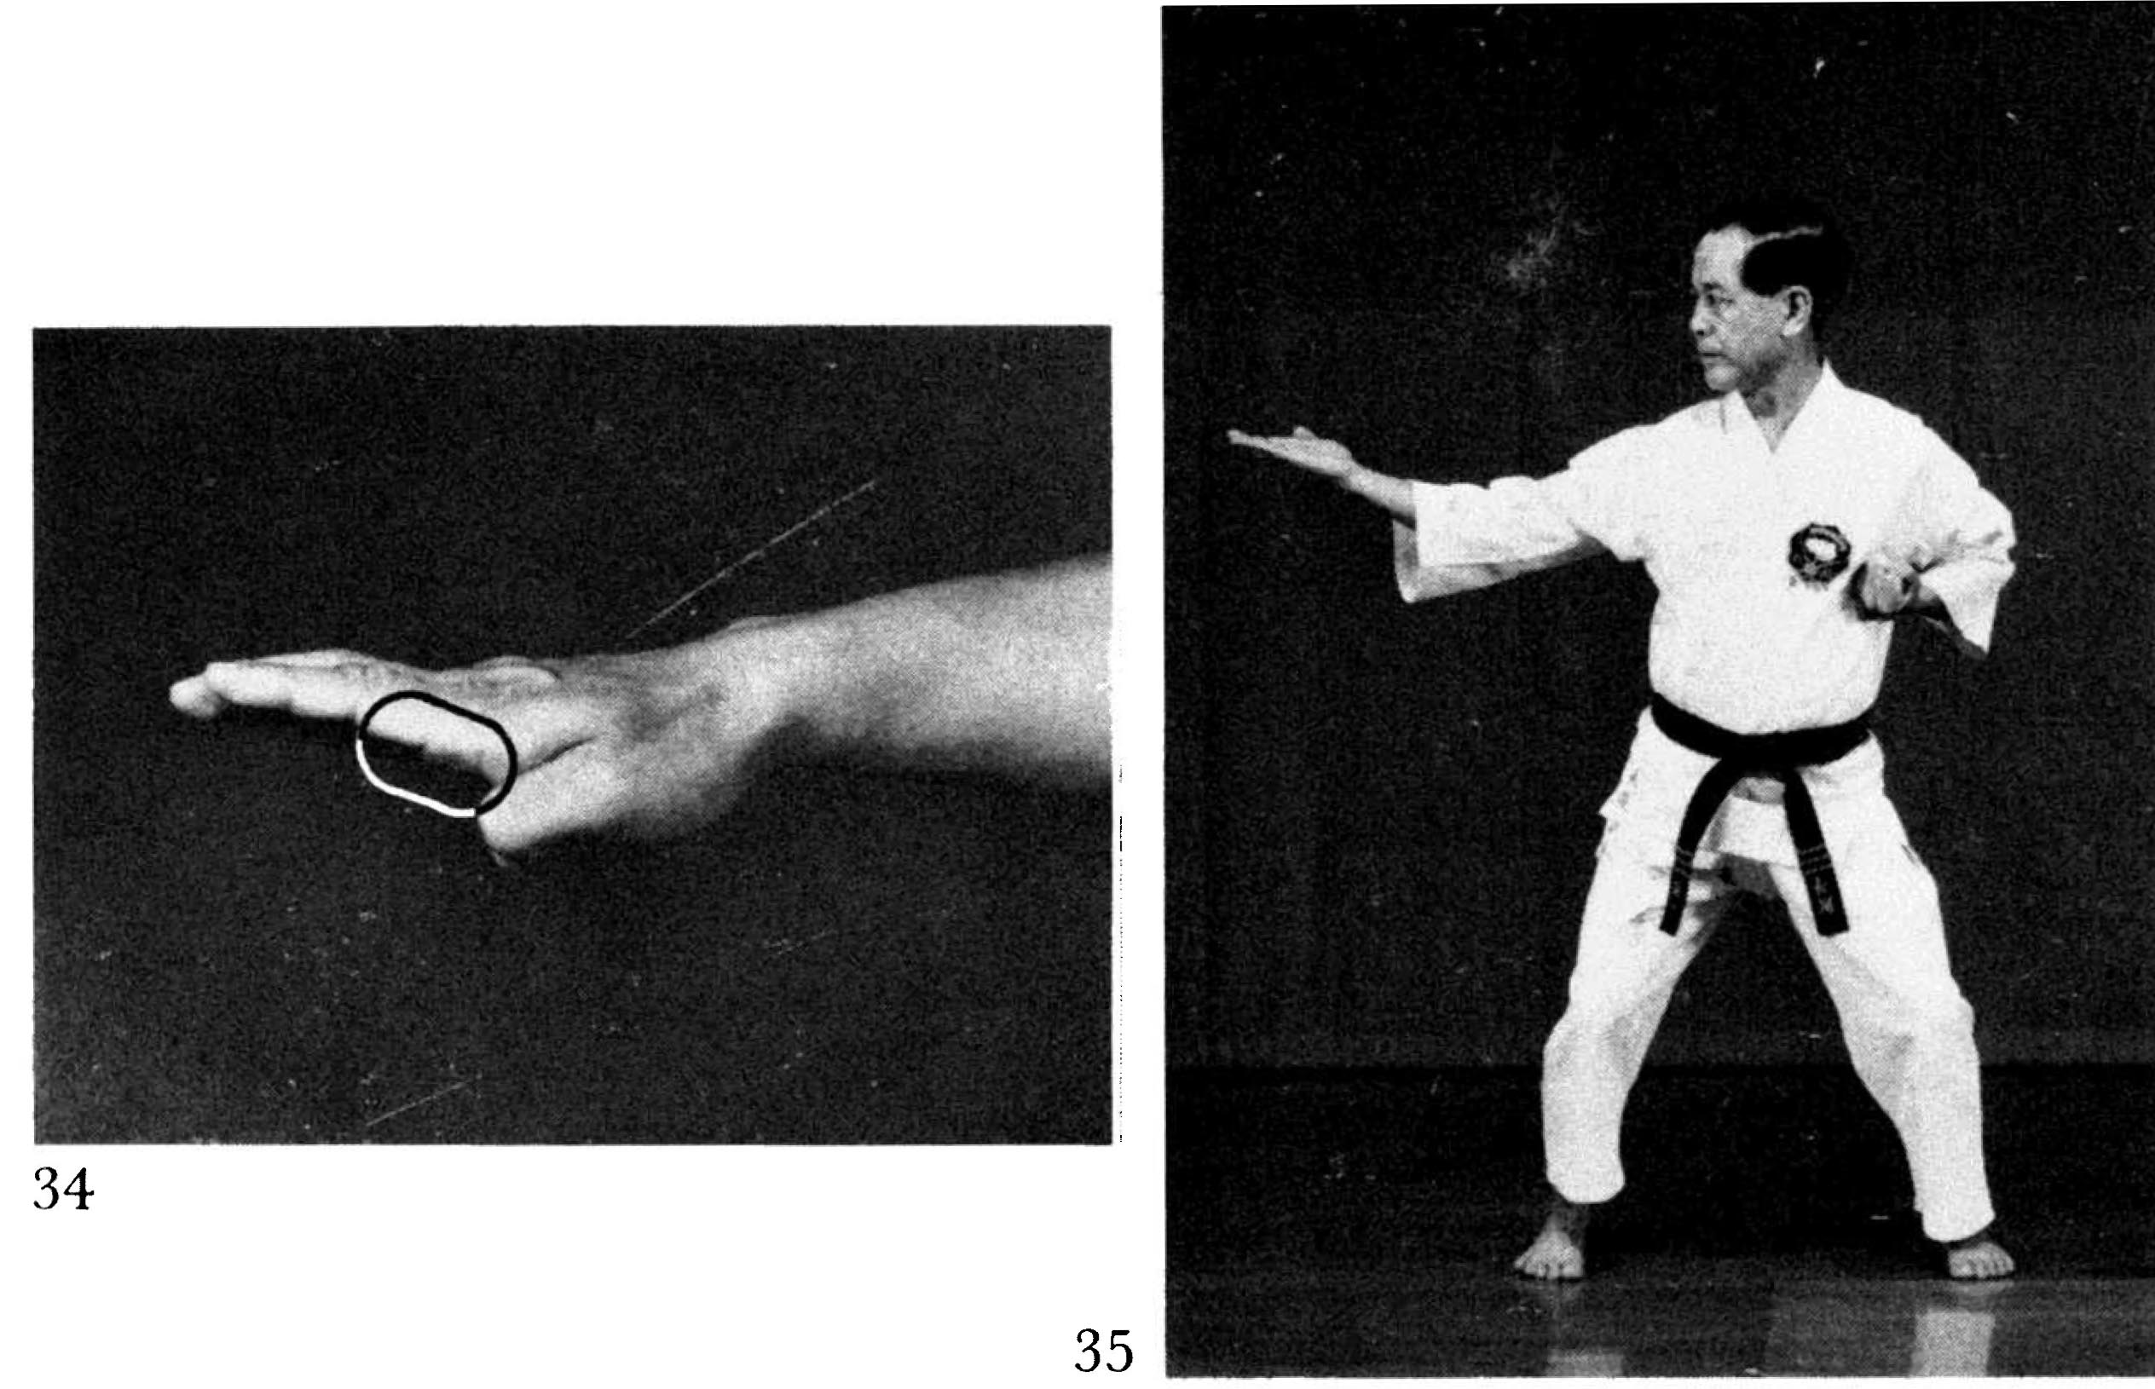
Photographs: 78 (34, 35)

Nihanchi sho: 149(6), 151(23)
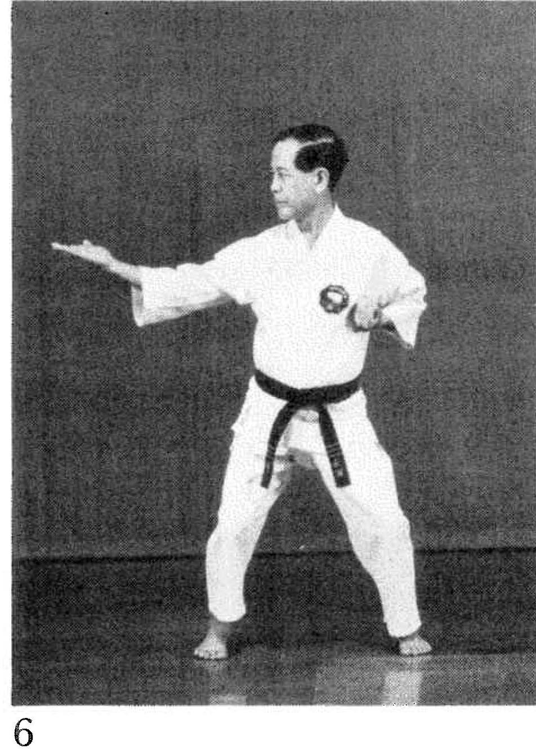 | 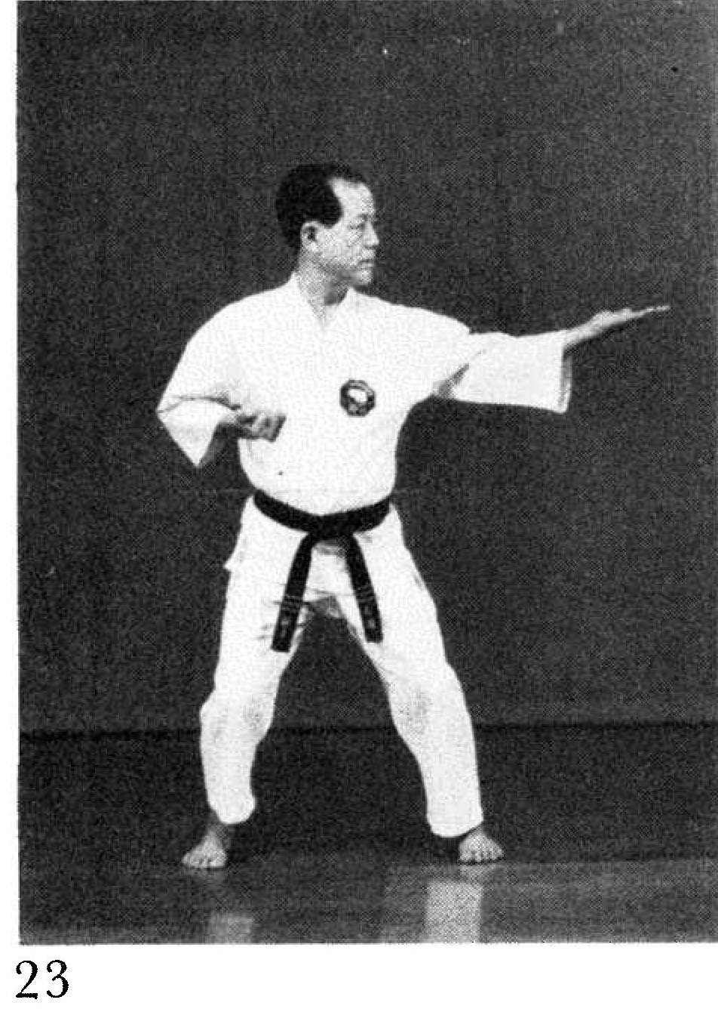
These and many other photographs of techniques performed to the side show the elbow in the pocket angling 45 degrees away from the body. We bring the elbow straight back, as if to strike an opponent behind us. See the Kata DVD and the Red Book pages 58, 59, 74 and 75.
