Spec. number: 14
Technique: Forearm block (Seiken-ude-uke)
Kata: All
Page number: 82
Description: “Both sides of the forearm, in conjunction with a fist, are used in various ways to block attacks.”
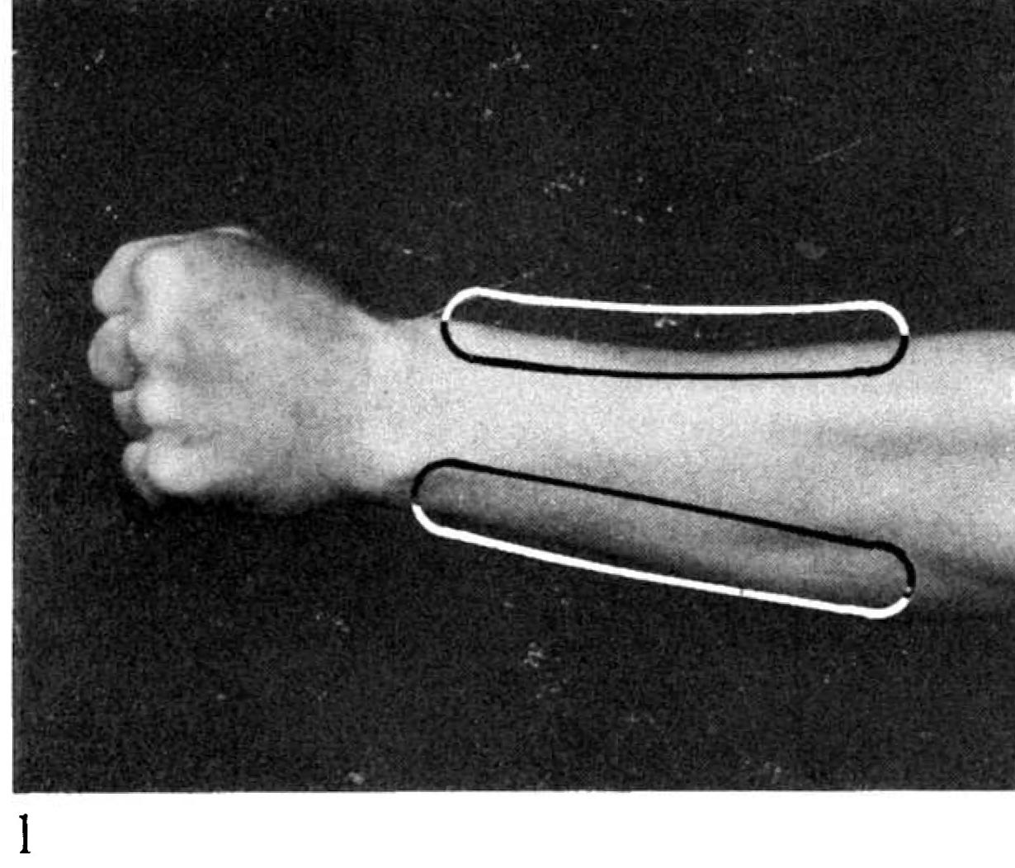
Comments: Many students block with the top of the forearm, especially in low blocks. This is incorrect and is usually caused by not fully chambering. As Hanshi explains, "The wrist must be fully rotated in the chamber, so that the exposed side of the forearm makes contact with the attack. At the point of impact the wrist/forearm rotate 180 degrees to the opposite side of the forearm, deflecting the attack."
Ideally, for down block and high block the inside edge of the forearm (below the thumb) makes contact with the attack. For middle block the outside edge of the forearm makes contact.
Note that the areas circled in Fig. 82(1) could be seen as including the “corners” of the forearm (i.e., the area between the sides and the top). Regardless, students should minimize contact with the top of the forearm.* We never make contact with the bottom of the forearm since this area contains unprotected tendons, ligaments and blood vessels.
Photographs: 82(1)

______________________

* Note that we do condition the top of the forearm during three-point arm training and the “high-low” exercise to prepare this area for possibly getting hit/blocked when we counter-punch.

