Spec. number: 15
Technique: Upper block (Jodan uke)
Kata: F1, F2, F3, P1, P2
Page number: 82
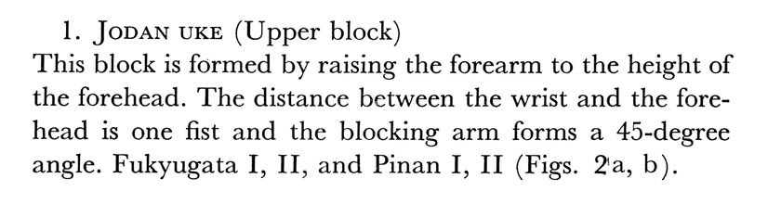
Description:

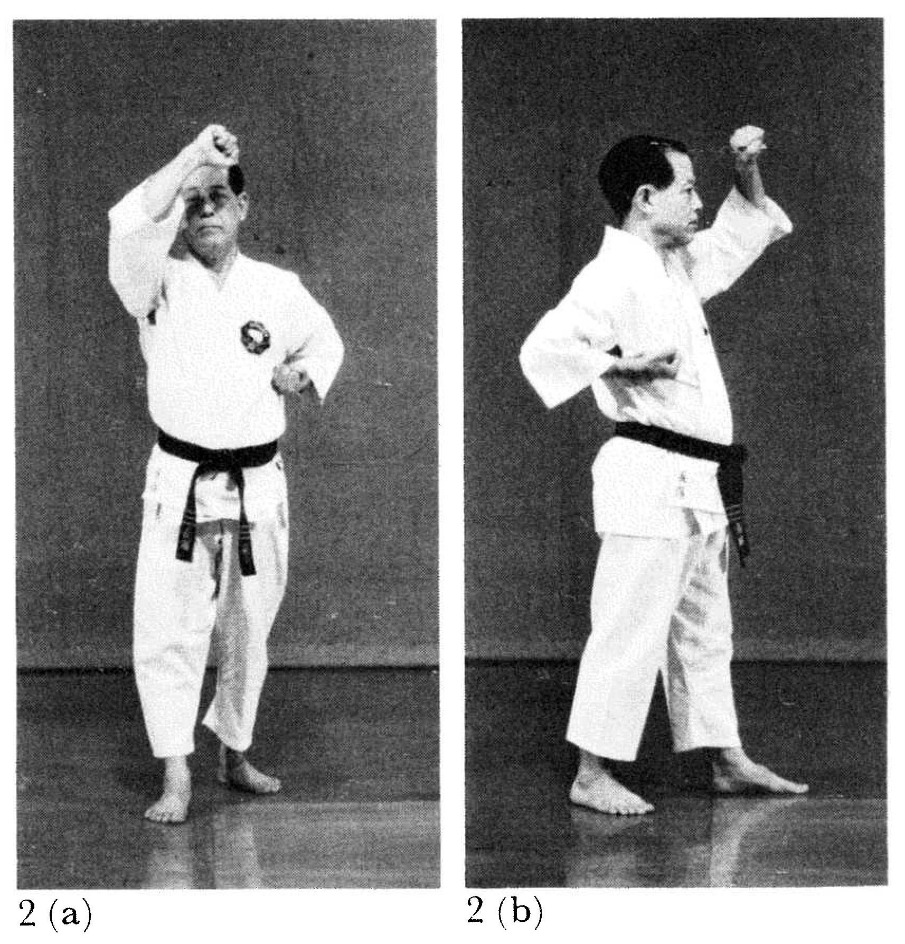
Comments: We raise the forearm to a height above the forehead to completely sweep the attack away from the face, as shown in the Kata DVD and Red Book pgs. 33(4a) and 74(1).
