Spec. number: 16
Technique: Palm-heel smash (Shotei-ate)
Kata: Rohai, Wanshu, Passai, Kusanku
Page number: 80
Description: “This is formed by opening the hand and bending the wrist backward until the bottom or heel of the palm is tensed and hardened; it is used to give a blow to the chin, groin, chest or kicking leg of an opponent.”
Comments: Notice that “a blow to the... kicking leg of an opponent” can be interpreted as a blocking technique.
Although Fig. 43 shows the wrist and finger tips bent almost 45 degrees, the majority of photographs illustrate palm heel smashes with the wrist and fingers nearly straight. A notable exception is the circular palm-heel smash in Kusanku (pg. 81 Fig. 48 and Red Book illus. page 73(28)).
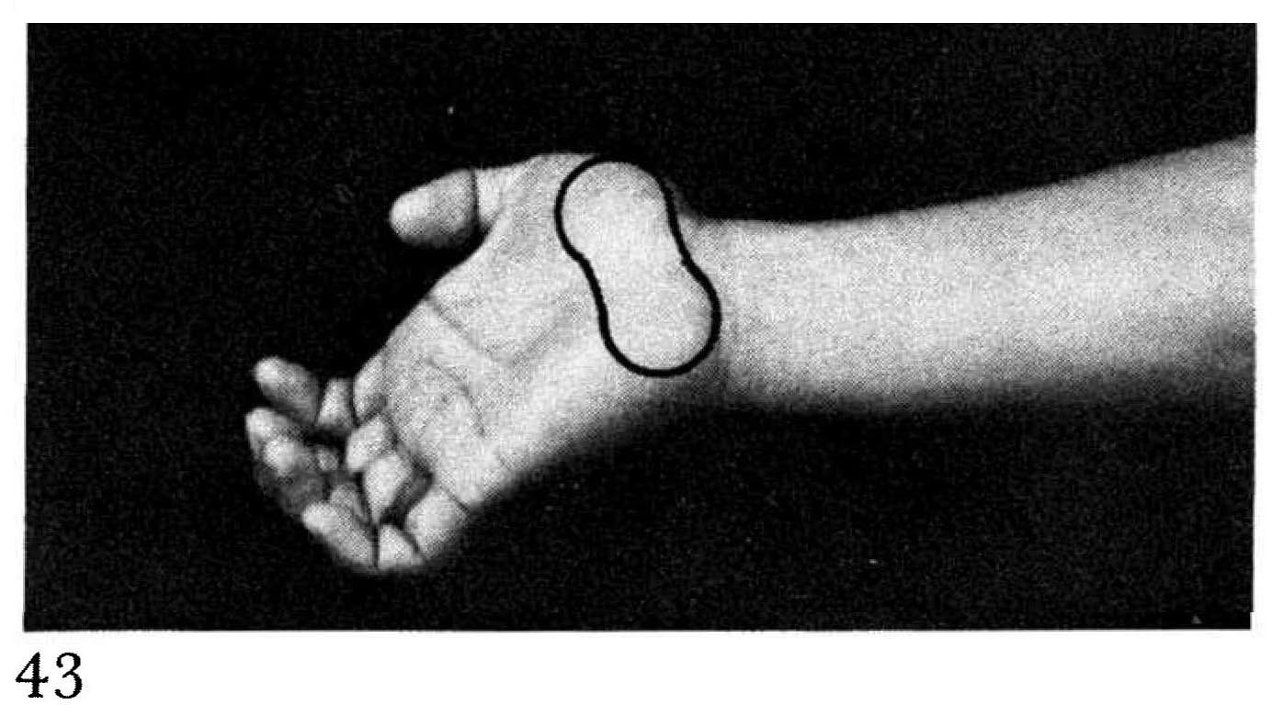
In upper and lower palm heel smashes the arm is shown at a 140 degree angle (Fig. 44, 47 and Red Book illus. 73(26, 28, 29). To exagerate power, one may optionally lock out the arm 180 degrees, for example when breaking a cement block. In middle palm heel smash (Wanshu) some students have a 90 degree bend at the elbow, as in a square punch. This is incorrect. The proper angle is 120 degrees.
Photographs: 81(43 - 47)

Technique 16(a): Upper palm-heel smash (Jodan shotei-ate)
Kata: Passai - See Spec. number 17
Technique 16(b): Middle palm-heel smash (Chudan shotei-ate): 81(45)

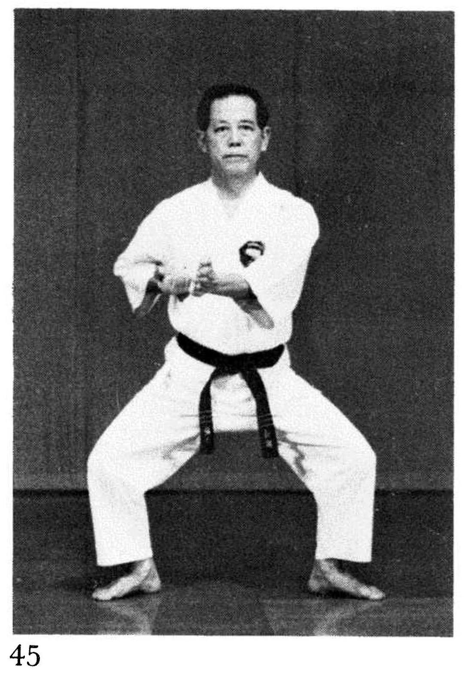 | 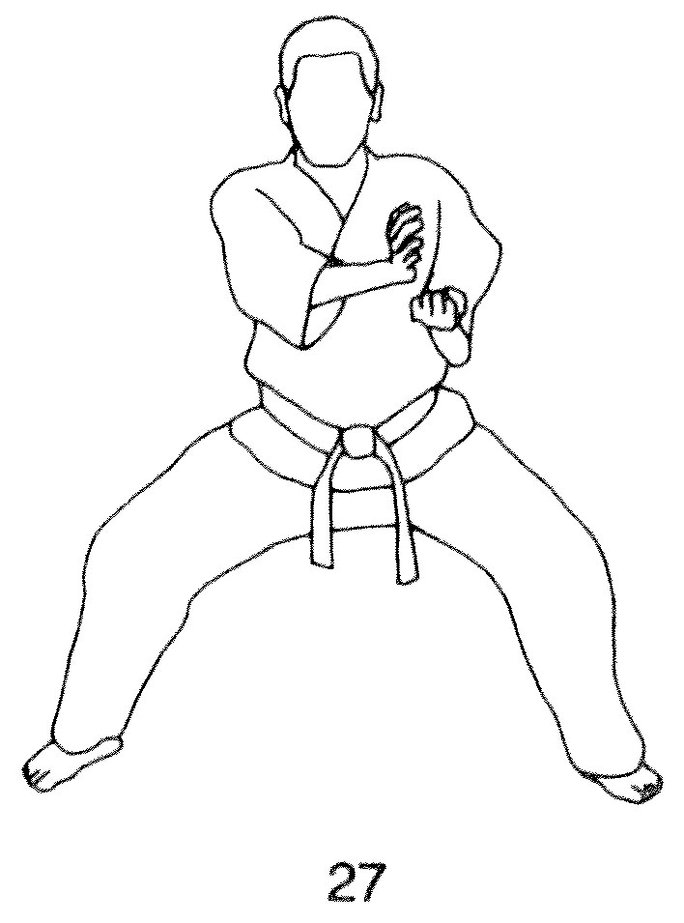 | Wanshu – pg. 190  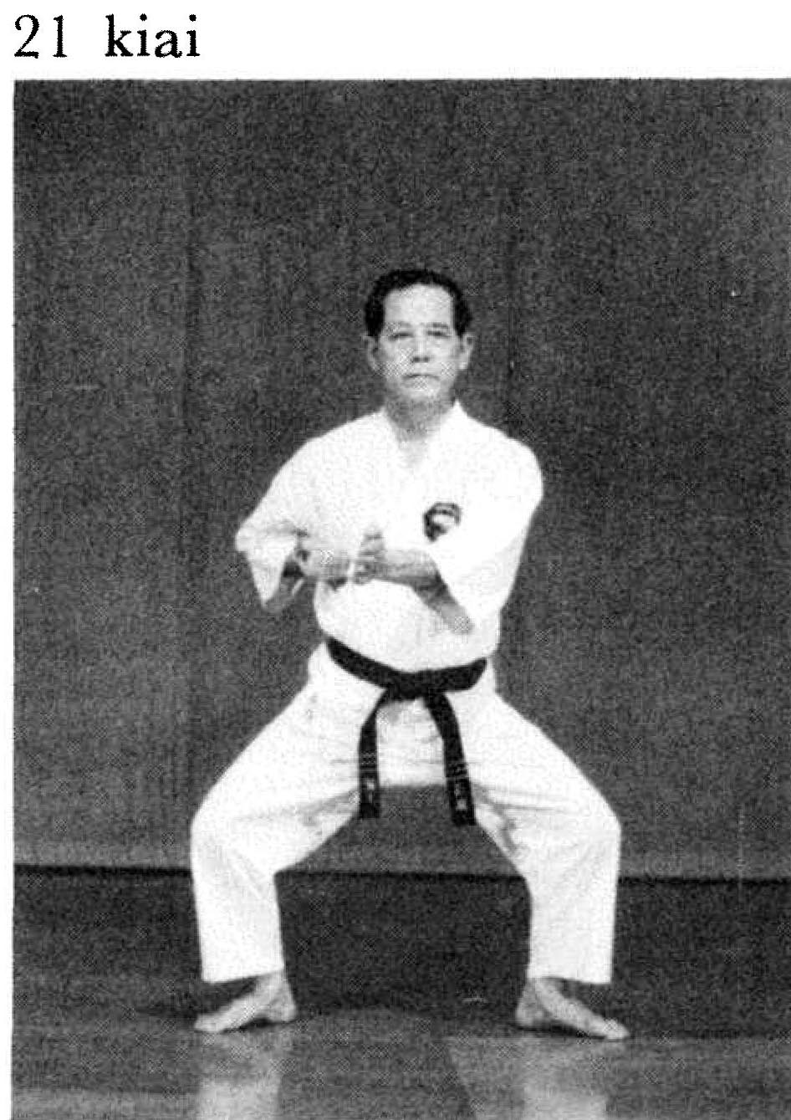

Technique 16(c): Circular palm-heel smash (Tomoe shotei-ate): 81(48)

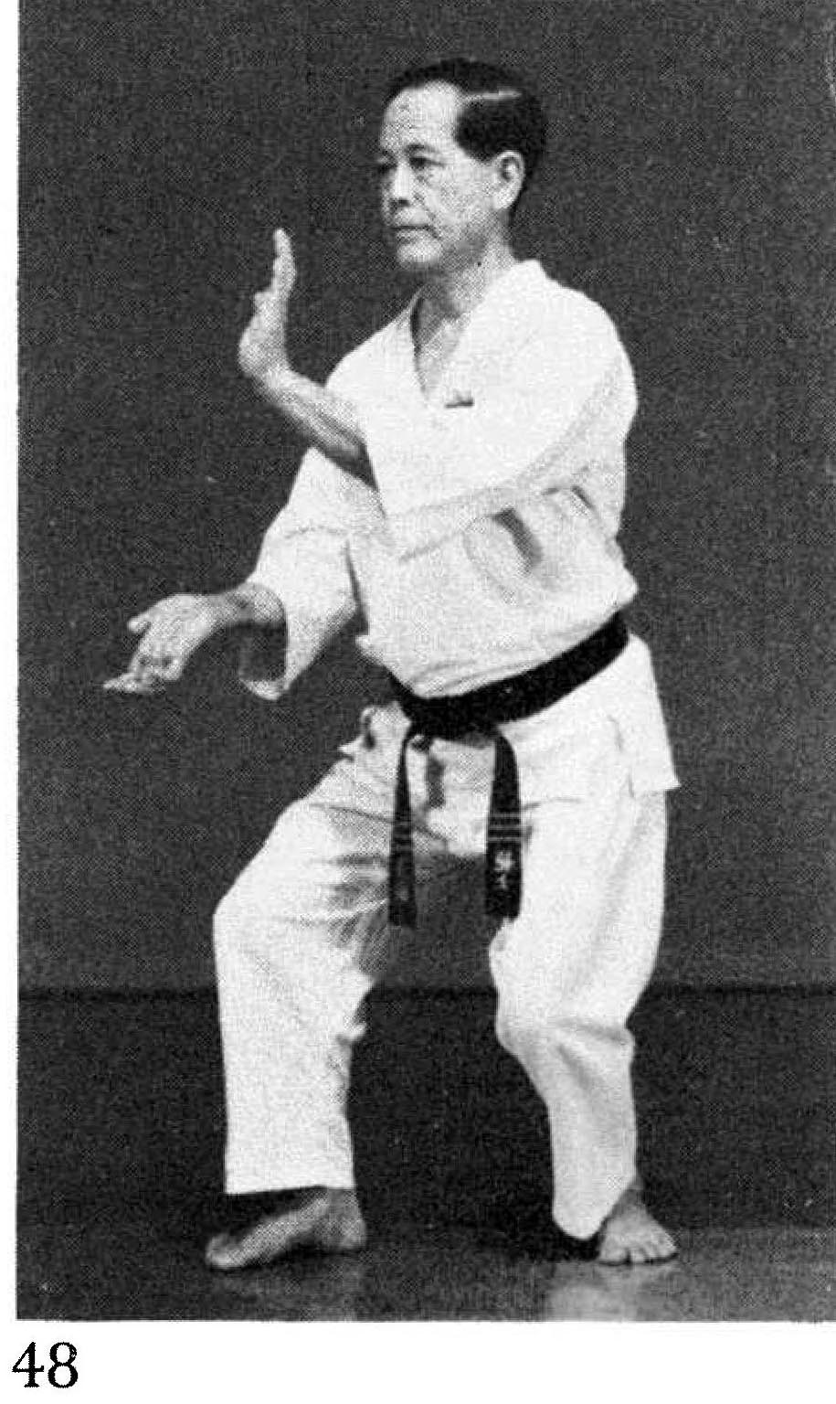 | 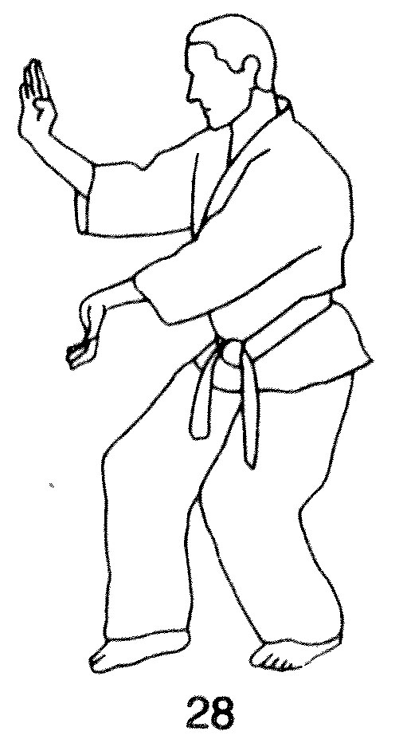 | Kusanku – pg. 243  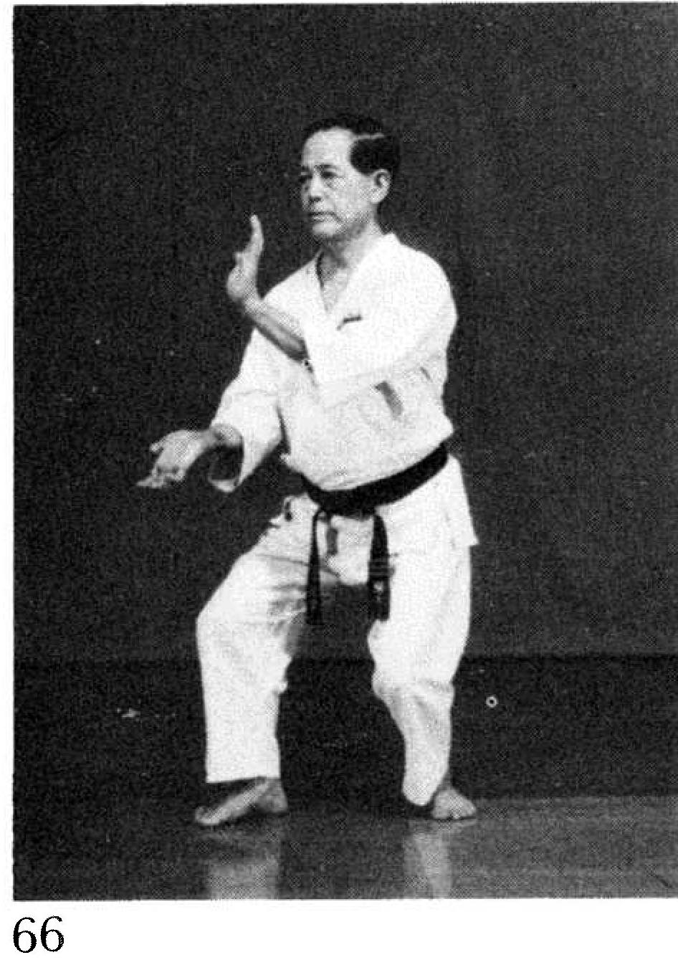
Technique 16(d): Lower palm-heel smash (Gedan shotei-ate) Fig. 82(46, 47)

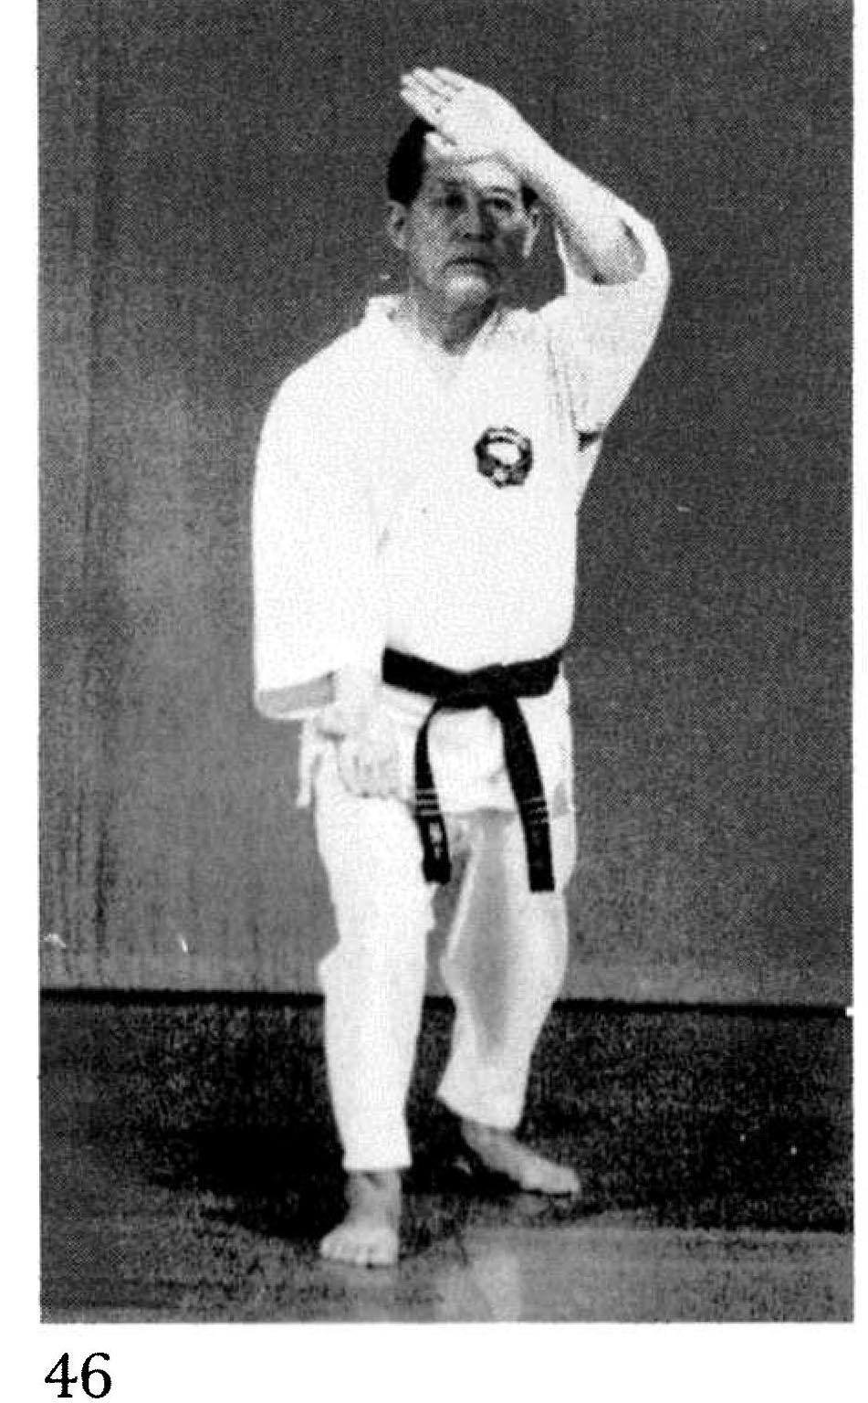 | 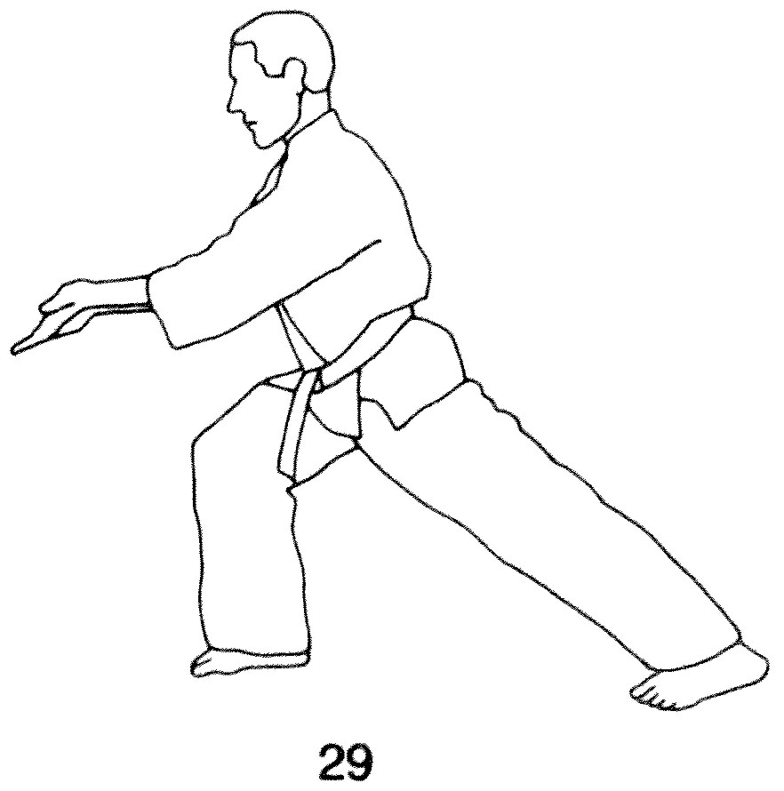 | 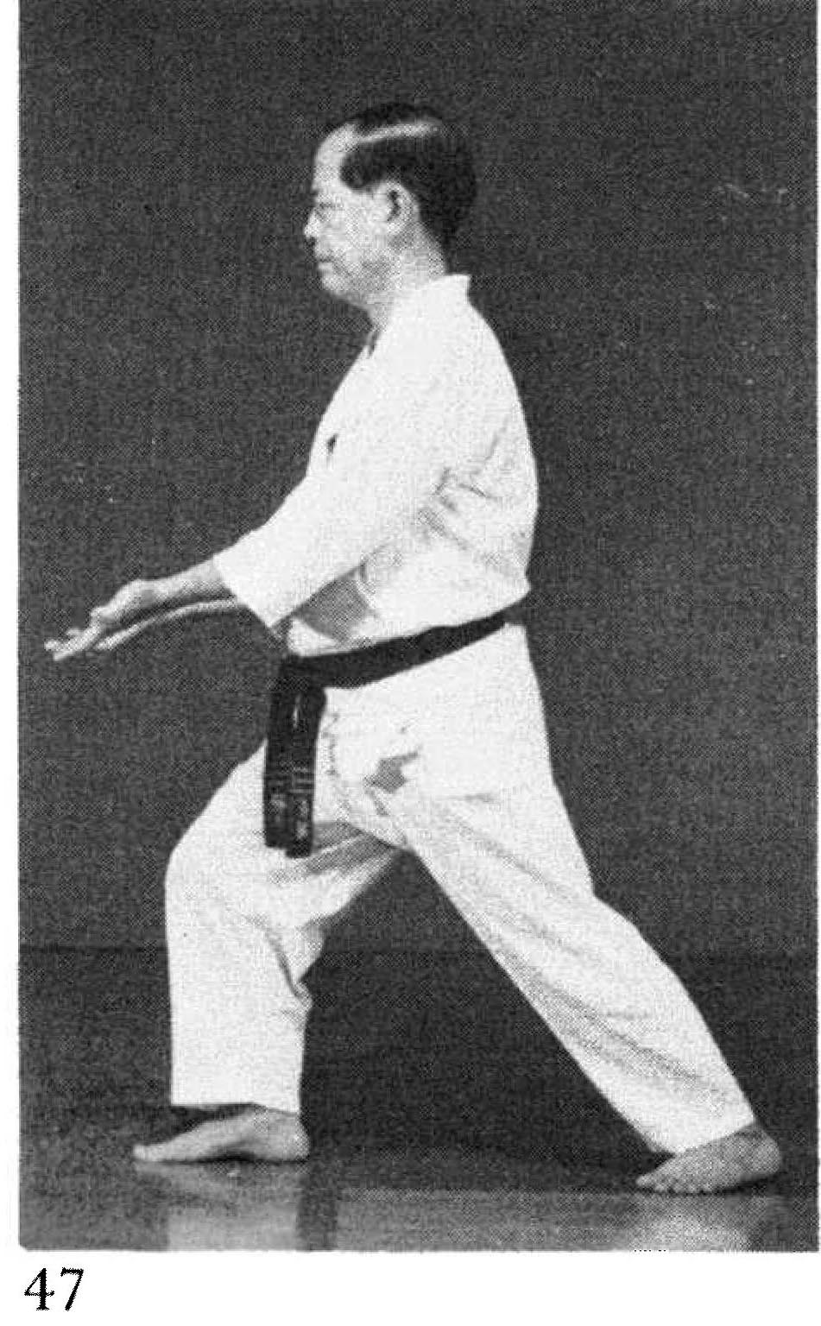
Rohai – pg. 182  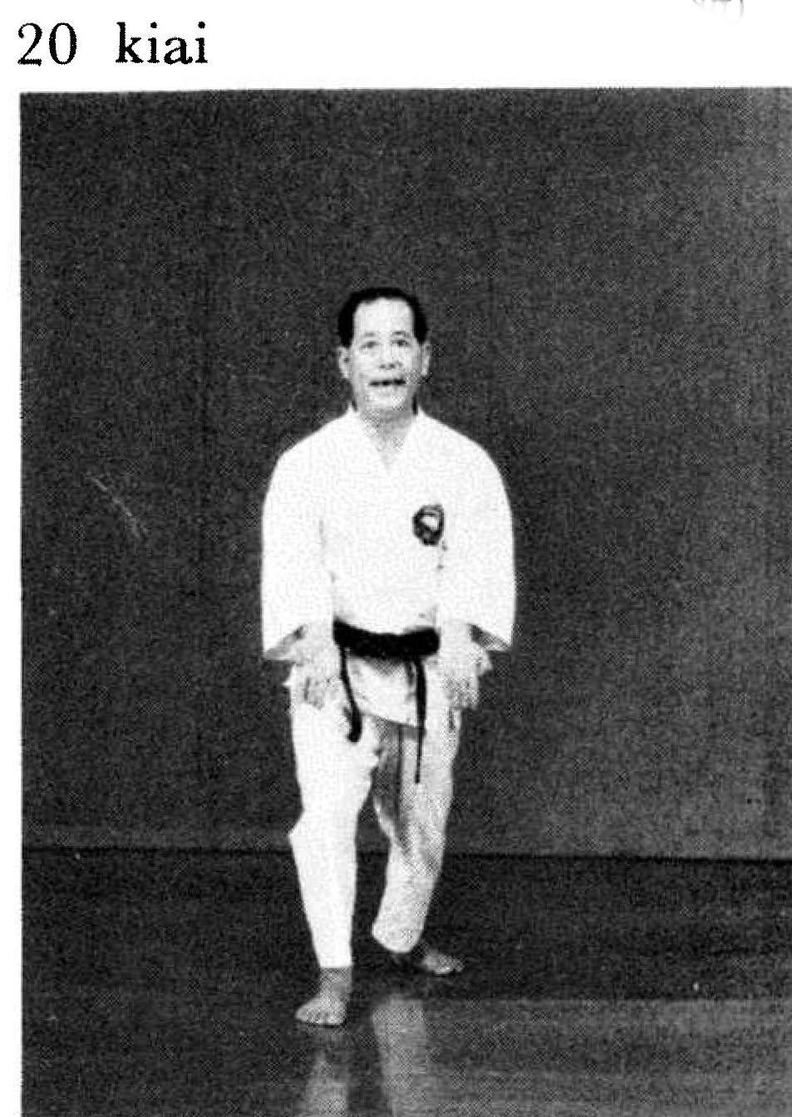 |  | Wanshu – pg. 192  