Spec. number: 17
Technique: Upper palm-heel smash (Jodan shotei-ate)
Kata: Passai
Page number: 80
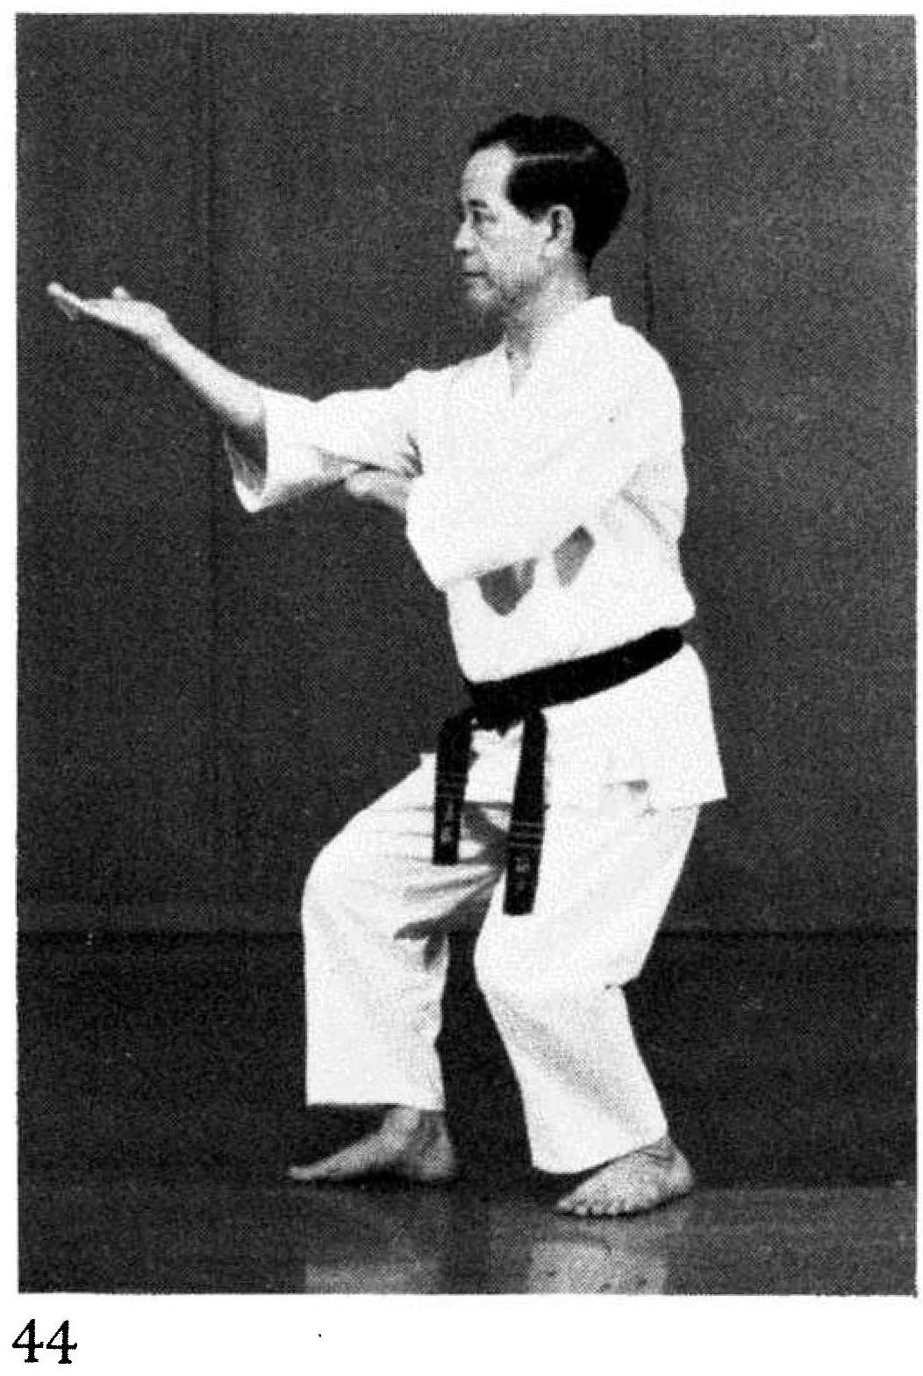
Description: “This technique is used to strike the chin upward.”
Comments: In Passai we use this tech-nique as a knife-hand thrust to the throat, not a palm-heel smash to the chin.
Note that the arm is shown at a 140 degree angle. To exagerate power, one may optionally lock out the arm 180 degrees, for example when breaking a cement block.
Photographs: 81(44)
Red book: 73(26)
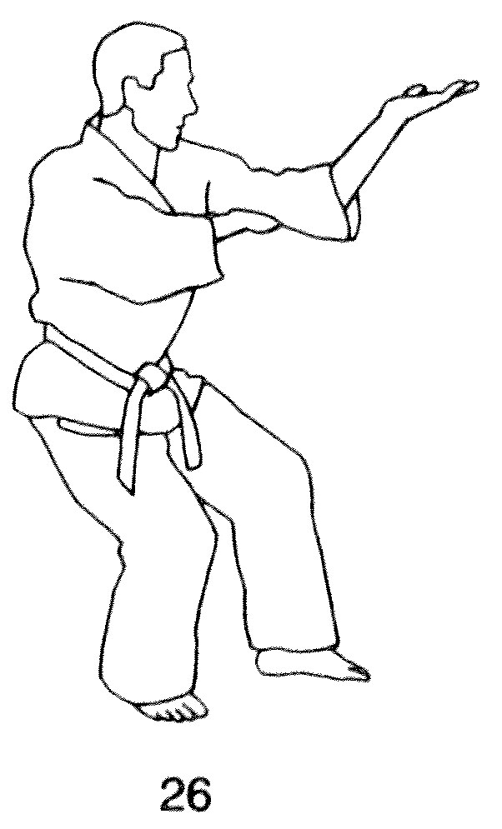
Passai: 197(10), 198(12, 18), 199(16)

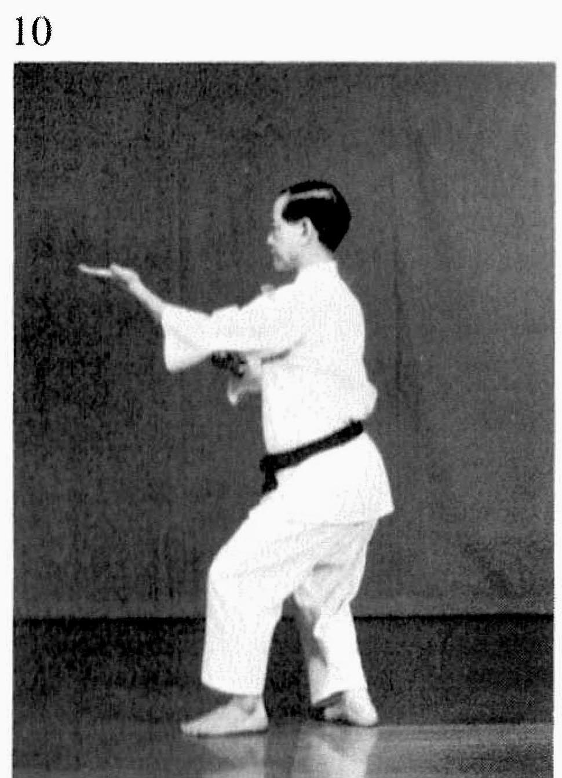 | 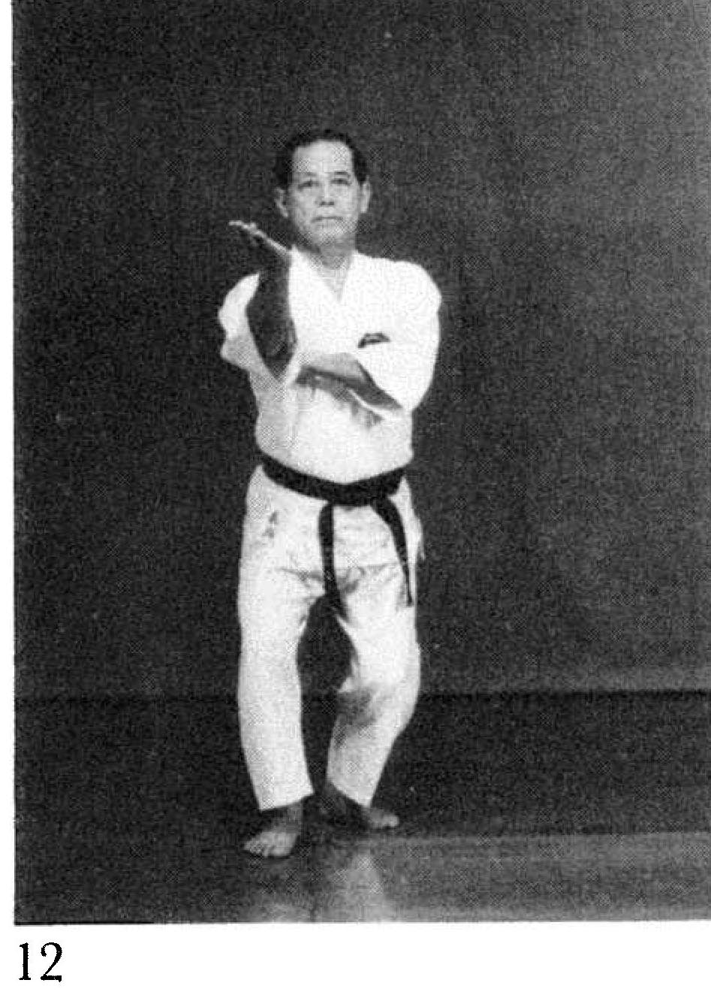
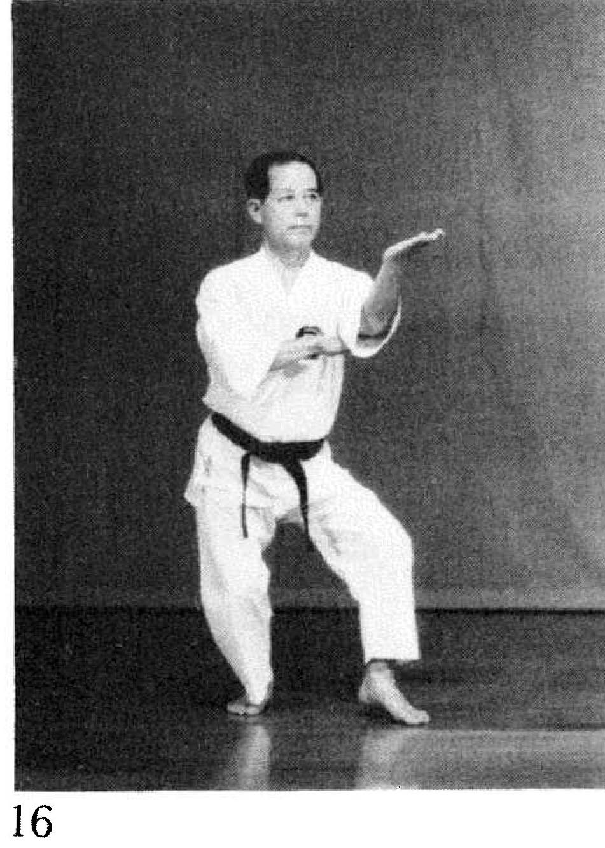 | 