Spec. number: 18
Technique: Middle sideward block (Chudan yoko-uke)
Kata: N2, N3, Wanshu
Page number: 83
Description: “This is the same as chudan soto-uke* except that it is executed to the side.”
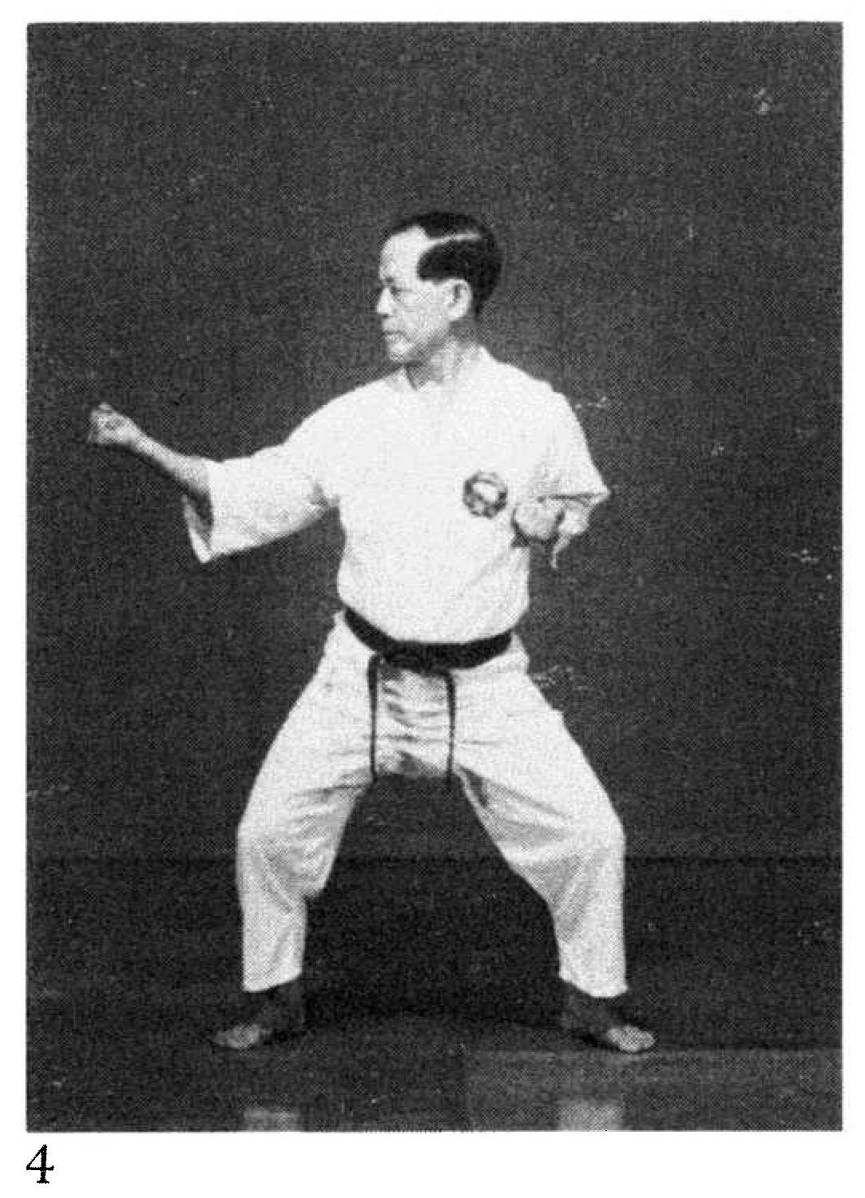
* “by bending the arm at approximately a 90-degree angle”
Comments: Despite the above description, Fig. 4 and the kata photographs show the sideward block at about a 120 degree angle. As Hanshi explains, “The block may extend from 90’ to 120' depending on the distance of the imaginary or real opponent.”
Note that in this photograph Master Nagamine has the elbow straight back, not angled out 45 degrees. See the Red Book Illus pg. 58(3).
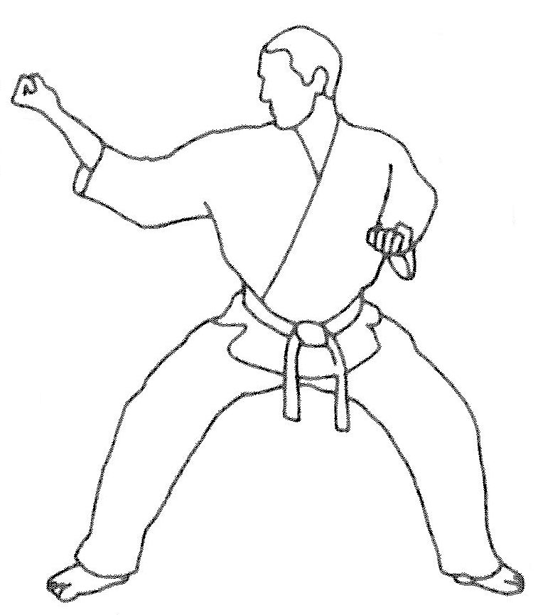
Photographs: 83(4)

Illus. 58(3)
Nihanchi ni pg. 155  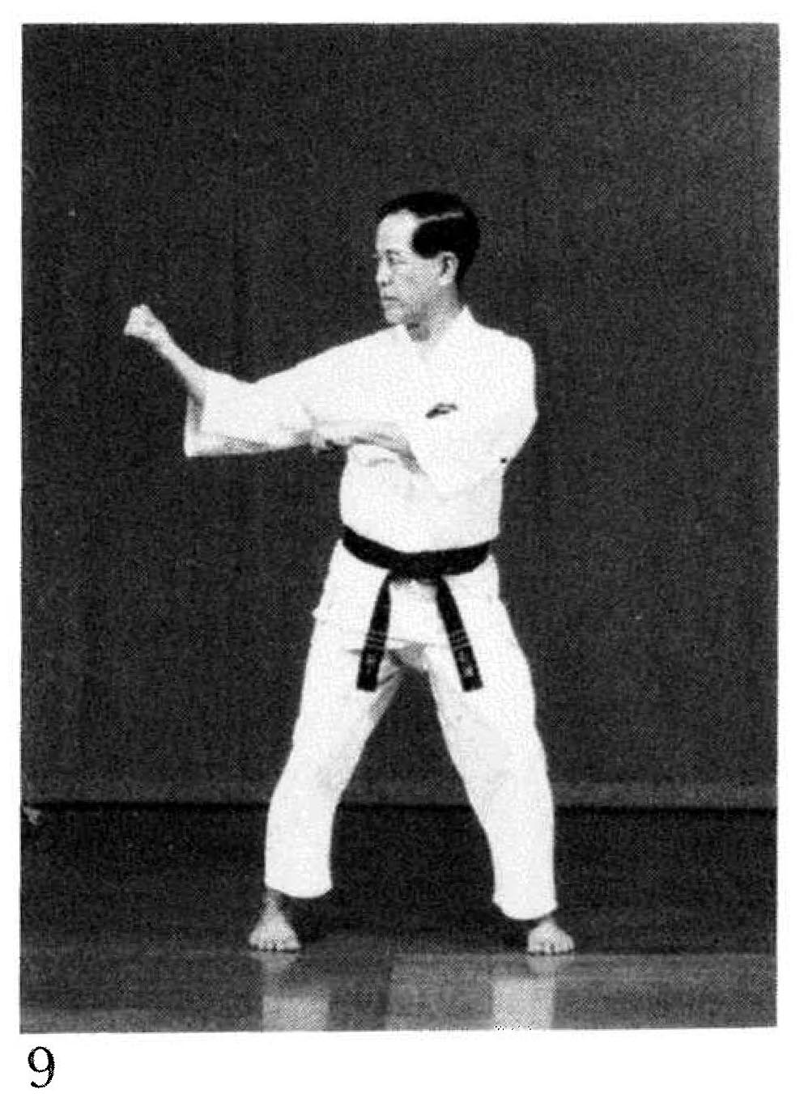 | 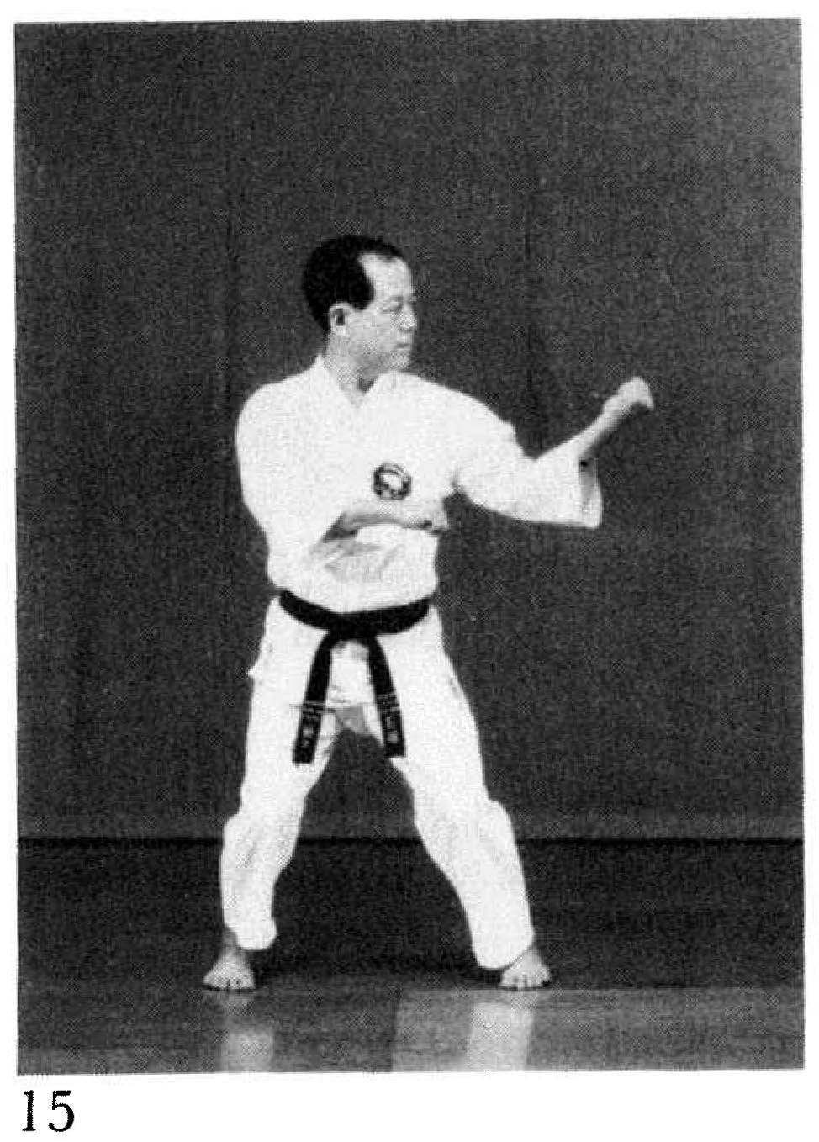
Nihanchi san pg. 159(14), 161(31)  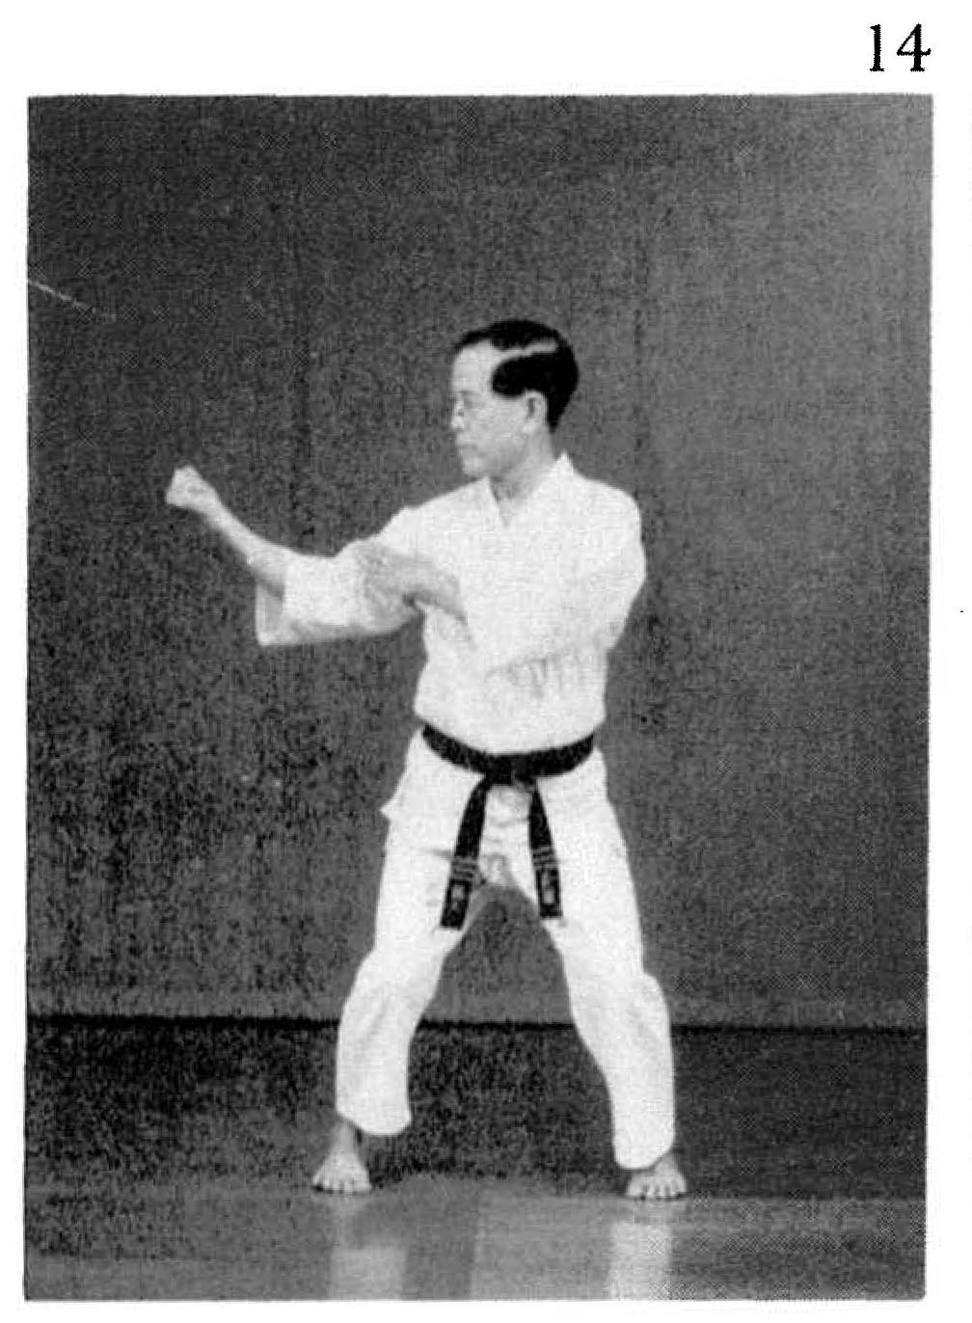 | 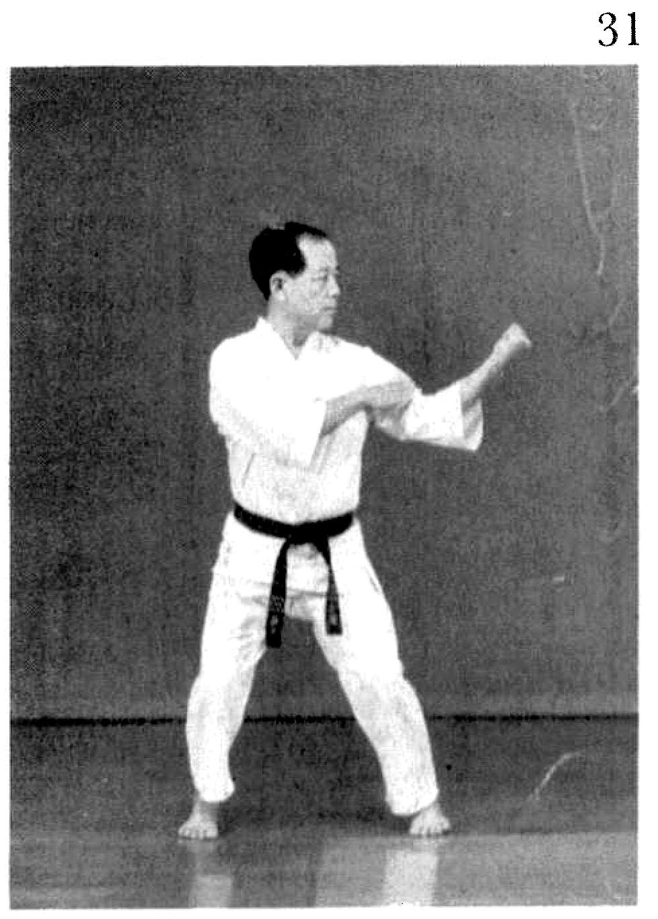

Wanshu pg 193(28, 29, 30) [block not shown in profile]
