Spec. number: 19
Technique: Lower sideward block (Gedan yoko-barai-uke)
Kata: F2, N1, Kusanku
Page number: 84
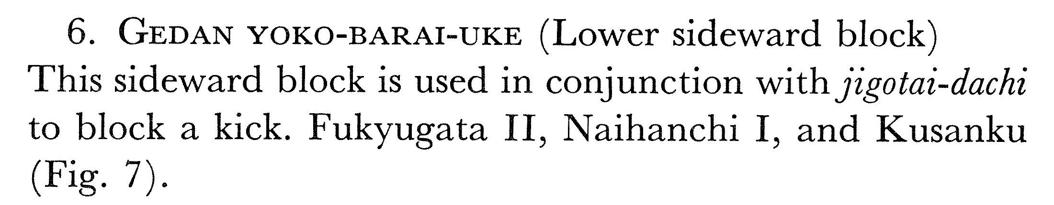
Description:

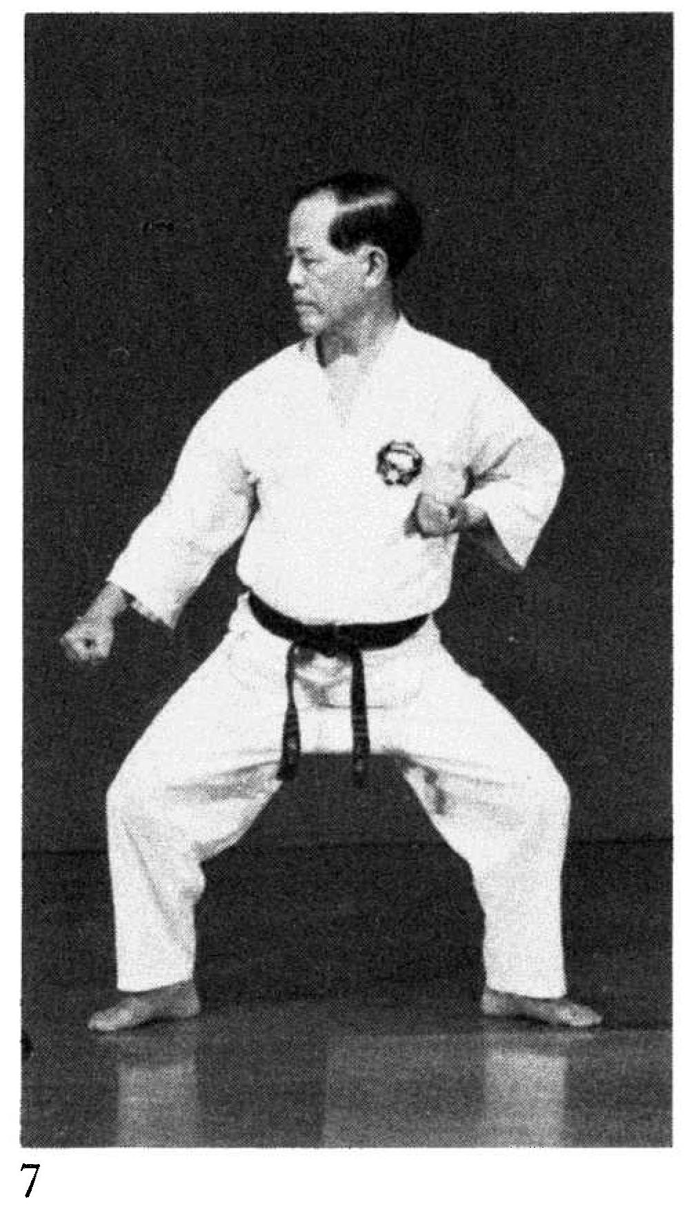
Comments: Fig. 7 shows the elbow in the pocket angling away from the body 45 degrees. The same is seen in chasing punch 73(16), back fist 75(25), and reverse knife-hand strike 78(35).
We pull the elbow straight back, as shown in the Red Book and Fig. 83(4), below.
Photographs: 84(7)

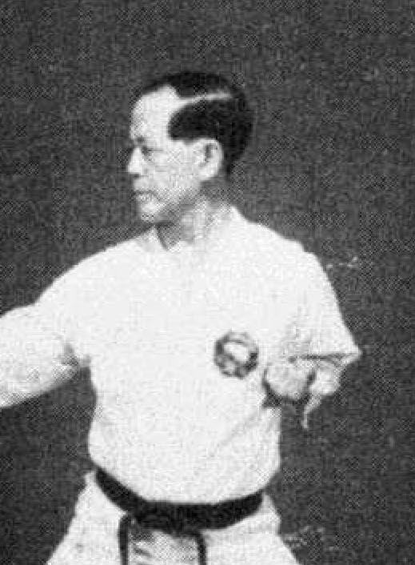
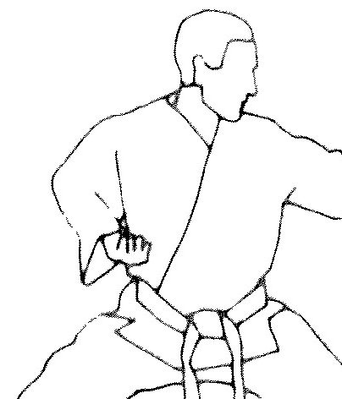
Illus. 58(3) from the Red Book (left) and Fig 83(4) from the Essence of Okinawan Karate-Do (right) showing the proper position of the elbow (straight back) in all sideward blocking or punching techniques.
F2: 110(9), 111(6)  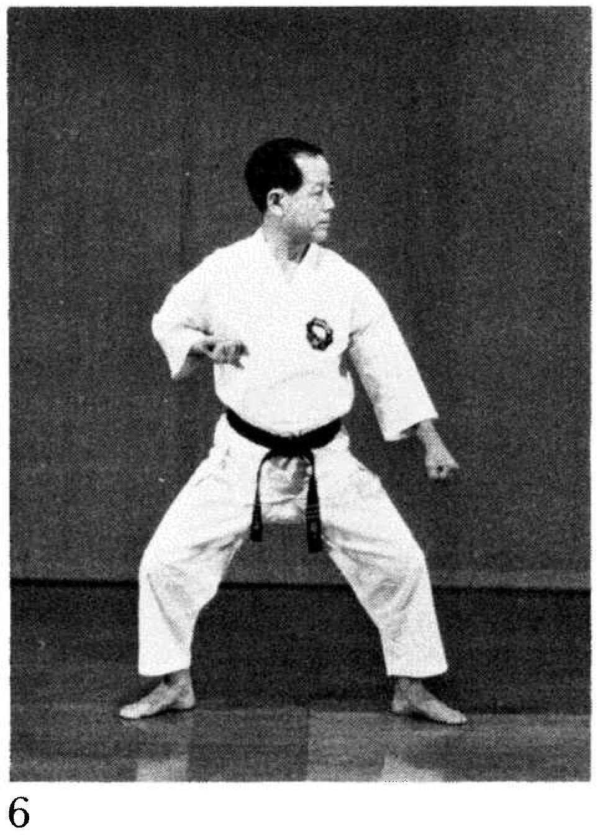 | 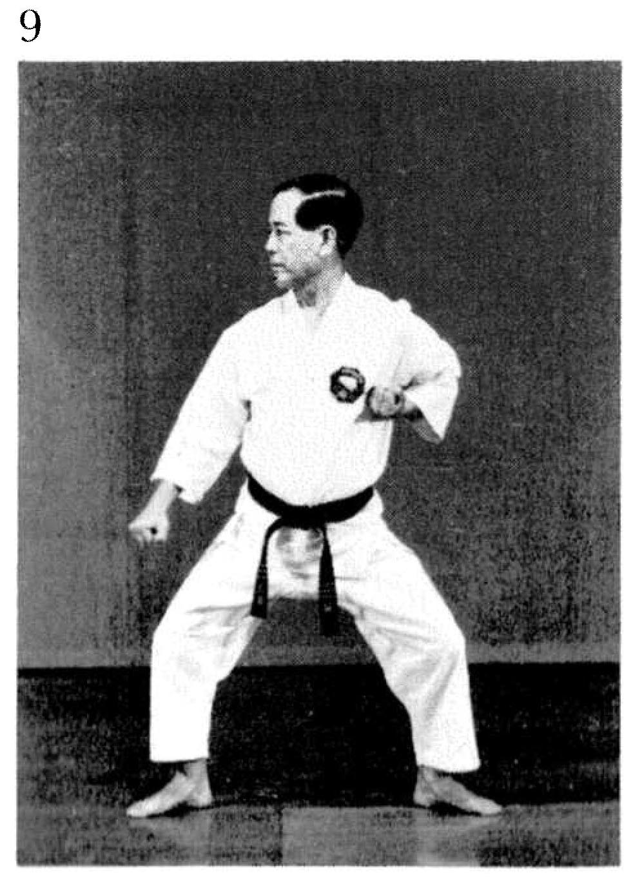
N1 pg 149(9), 150(26)  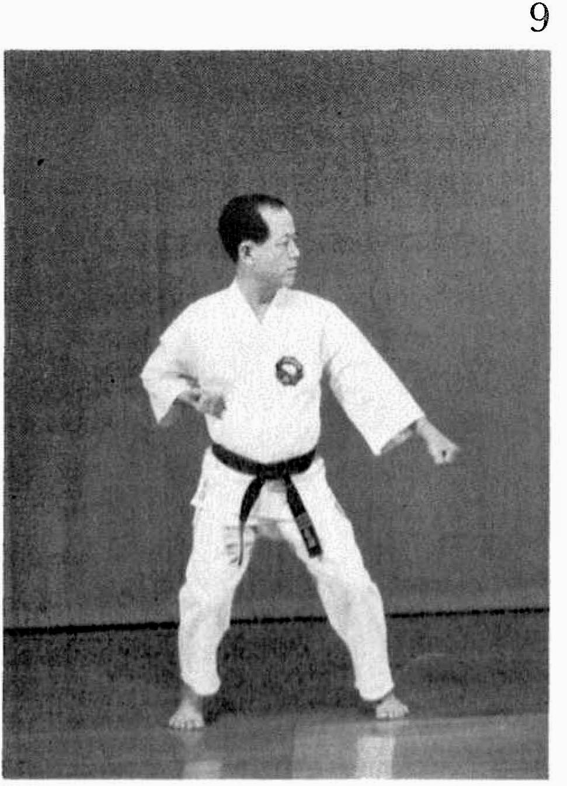 | 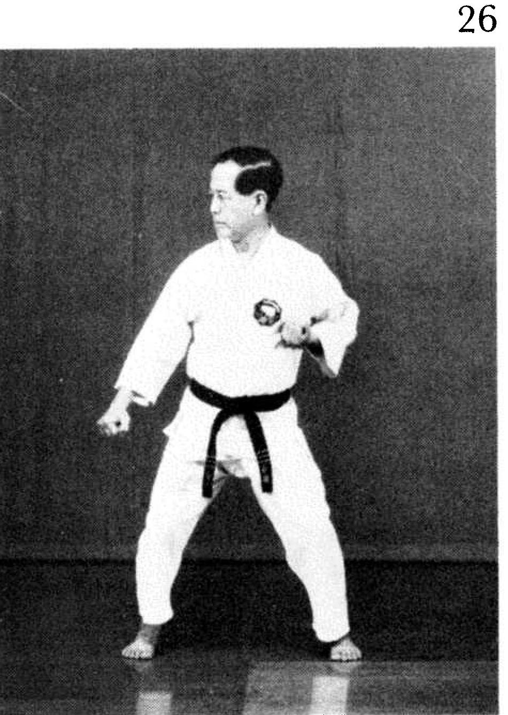
Kusanku pg. 242(68)  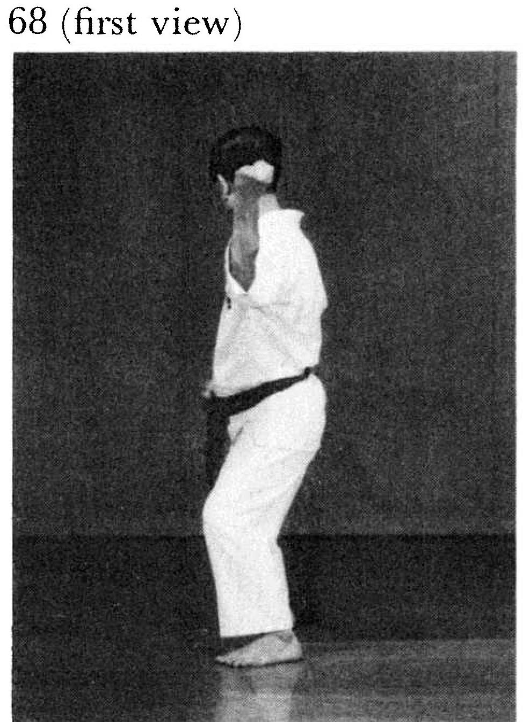 | 