Spec. number: 20
Technique: Dropping downward block (Otoshi-uke)
Kata: P5, Passai
Page number: 88
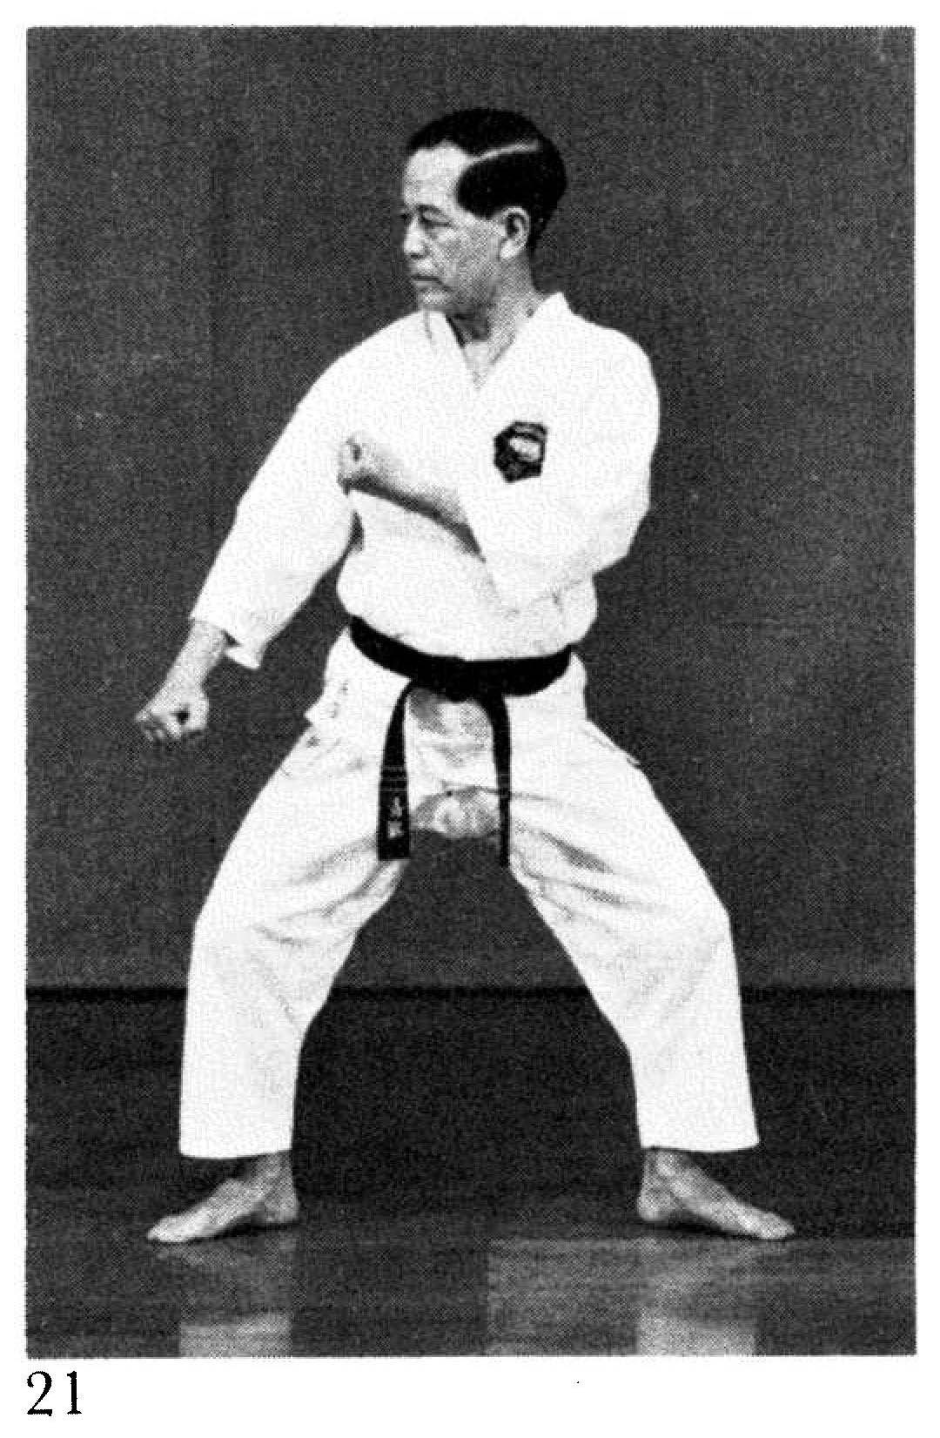
Description: “The arm is dropped down from the height of the ear
to block a kicking leg.”
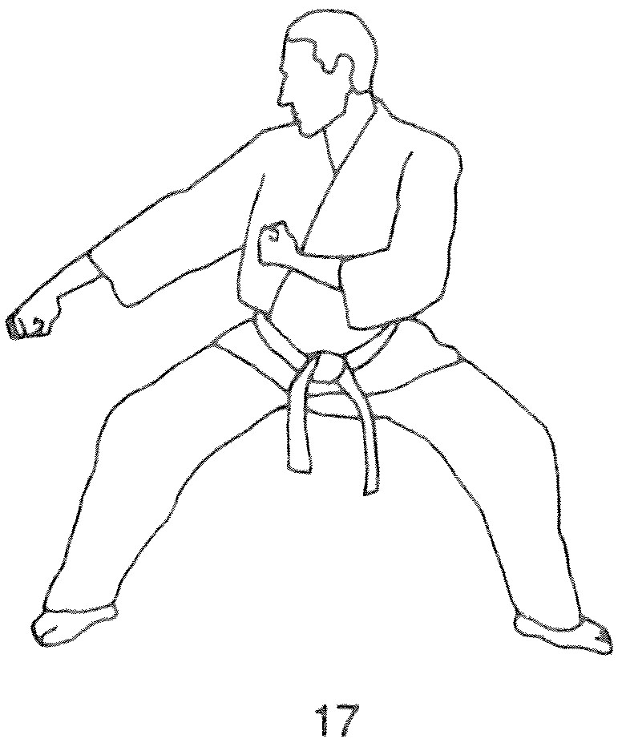
Comments: Fig. 21 and Illus. 17 from the Red Book show the complementary arm angling upwards to protect the solar plexis. The fist is about arm- pit height. Many students have this arm angling downwards, which is incorrect.
As per Master Ueshiro and the Kata DVD, our knife-hand down block (Spec. 21) is very similar to the “dropping downward block” shown here.

Photographs: 88(21)
Pinan godan: 144(21)
Passai: 199(21, 22, 23), 202(35)

Pinan godan 144(21)  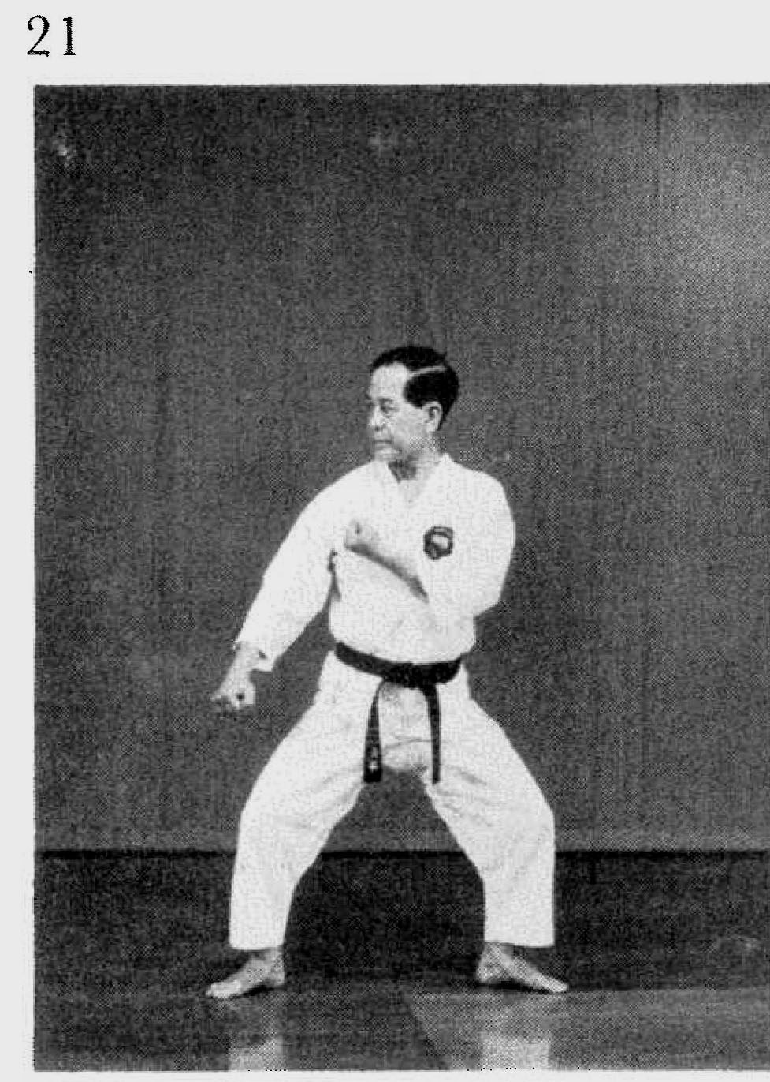 | Passai 199(21)  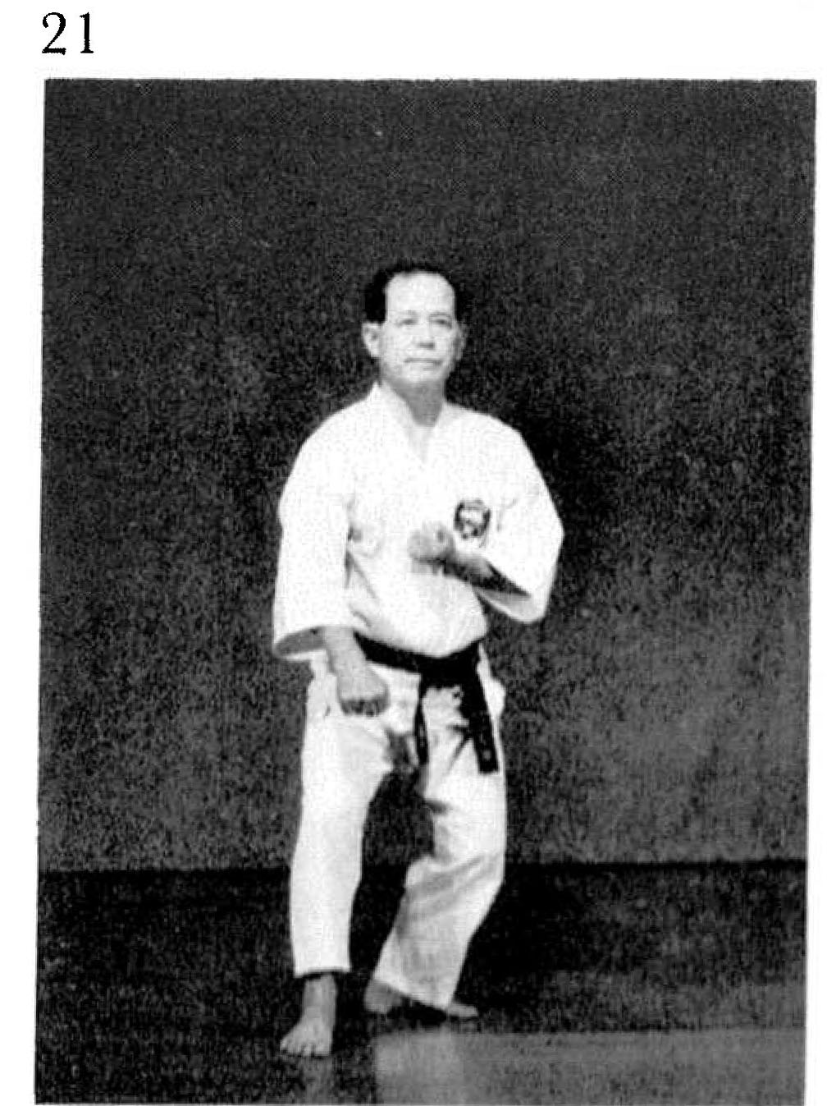
Passai 199(22)  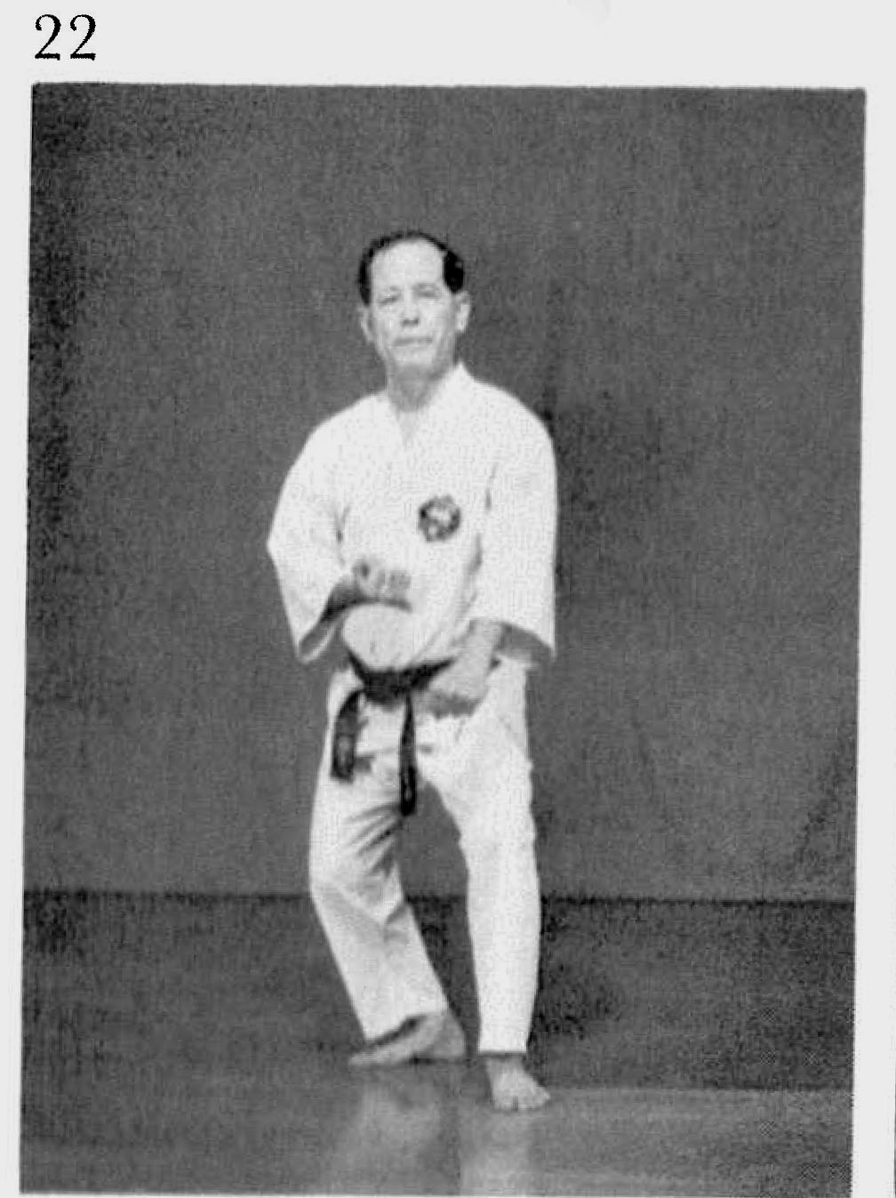 | Passai 199(23)  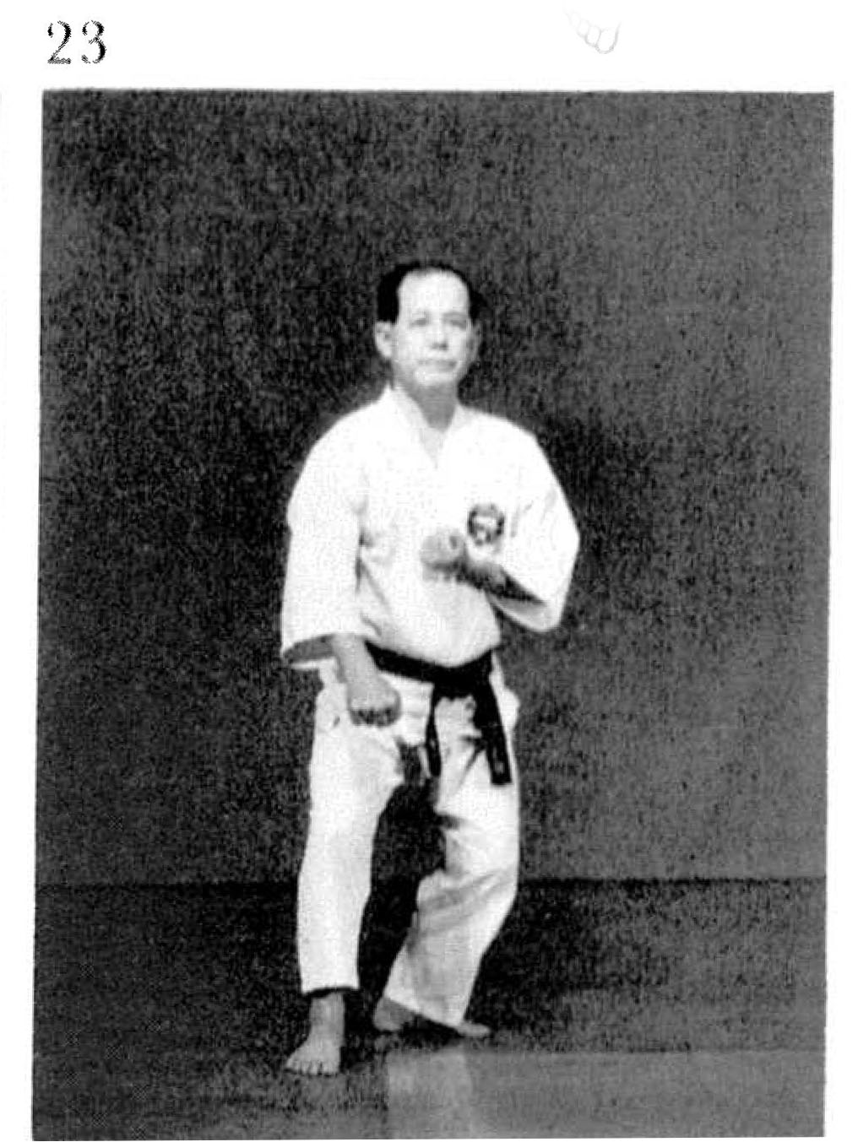

Passai 202(35)
