Spec. number: 21
Technique: Lower knife-hand block (Gedan shuto-uke) and
Lower sideward knife-hand slashing block (Gedan shuto yoko-barai-uke)
Kata: P2, Rohai
Page number: 90
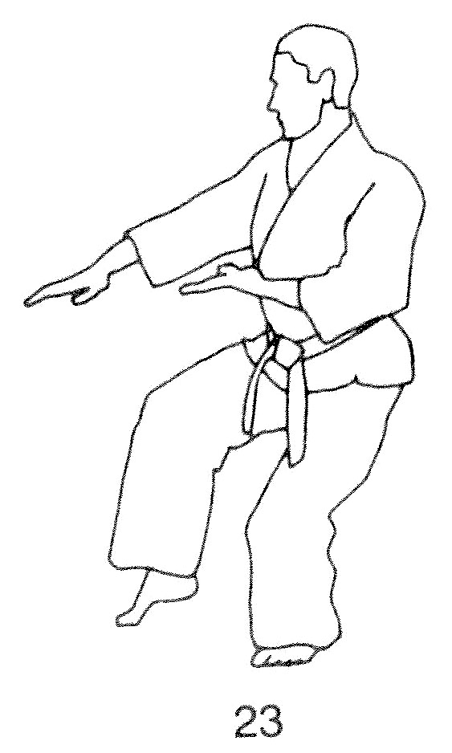
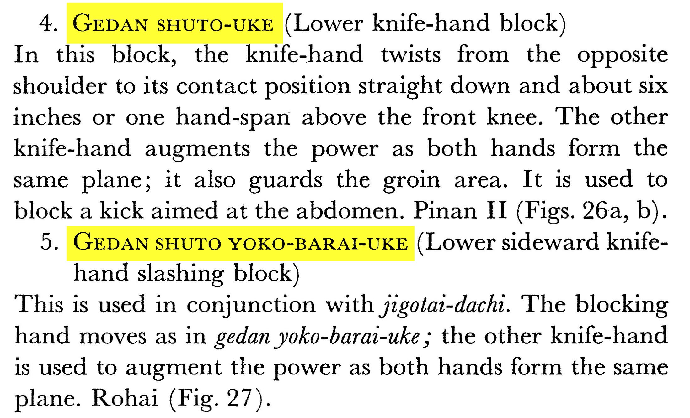
Description:

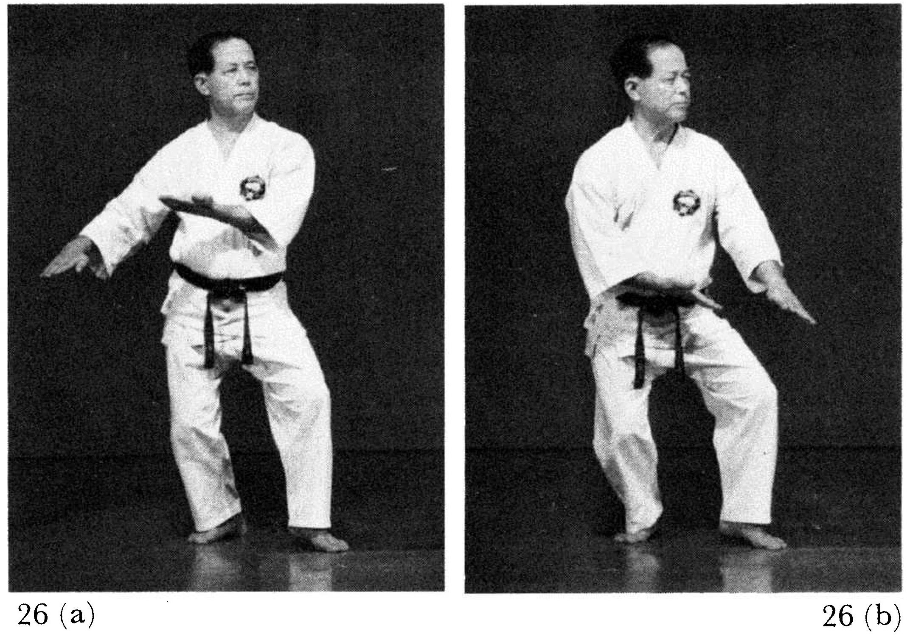
Comments: As per Master Ueshiro and the Kata DVD, our lower knife-hand blocks follow more closely the descriptions of “dropping downward block” in Spec. 20. Specifically, we chamber the
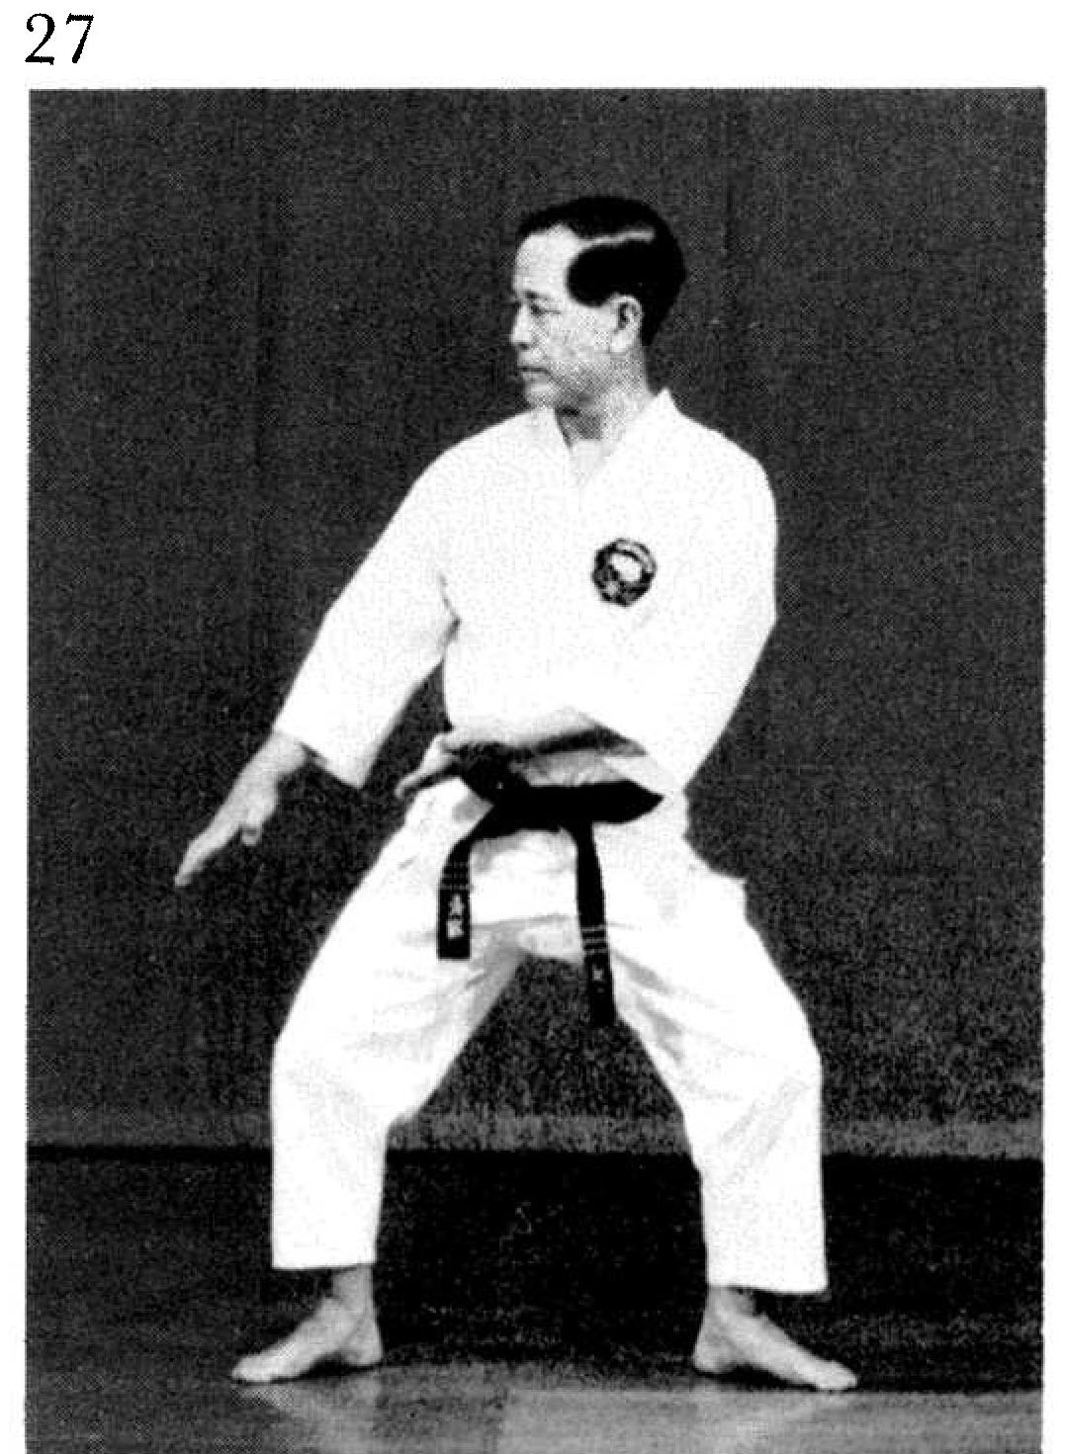
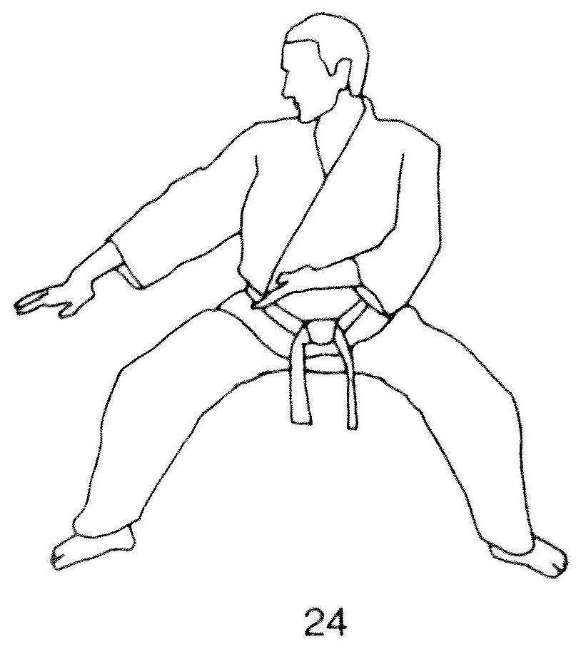
blocking hand closer to the ear, not the shoulder, and finish the block 9 to 12 inches above the knee, not 6 inches. Also, the augmenting hand sweeps past the groin, not “guarding it.” See Illus. 23, above, from the Red Book and photos 126(23) and 90(27) where the augmenting hand ends above the belt. Some students stop the augmenting hand at the belt or lower, which is incorrect.
Also, Fig. 26(a) shows the augmenting arm chamber-ing away from the body. As Hanshi explains, “We chamber the arm in line with the body with the wrist close to the hip, twisted as far as possible to maximize torque/power.”
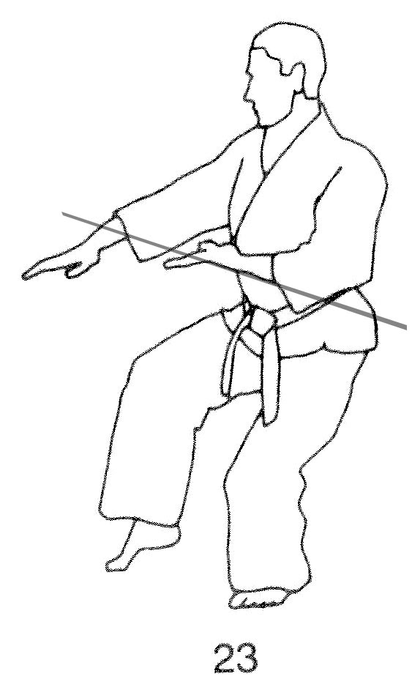
Note the subtle difference in the angle of the augmenting forearm in Illus. 23 vs. 24, below:
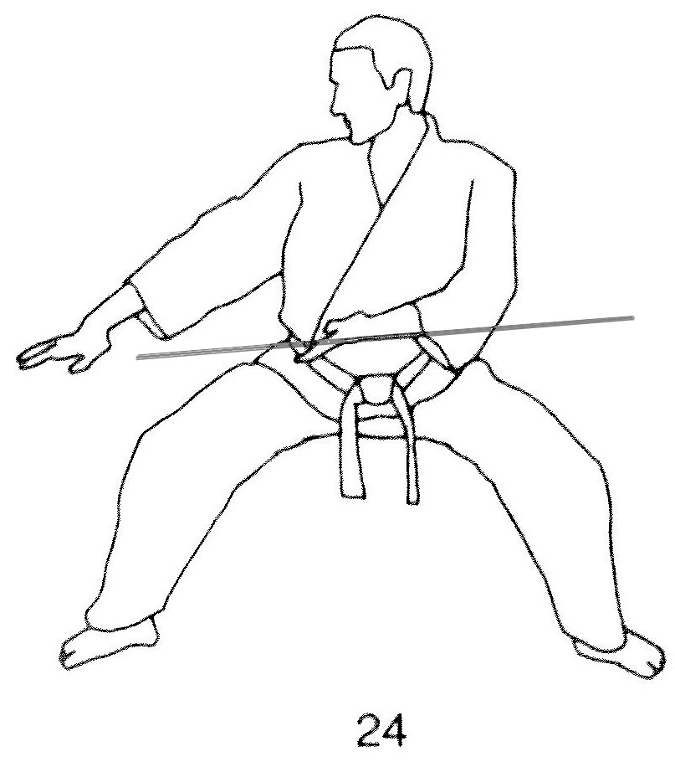

Photographs: 91(26a, 26b, 27)
Pinan nidan: 126(23, 24, 25), 127(26)
Rohai: 181(5)
Pinan nidan 126(23)  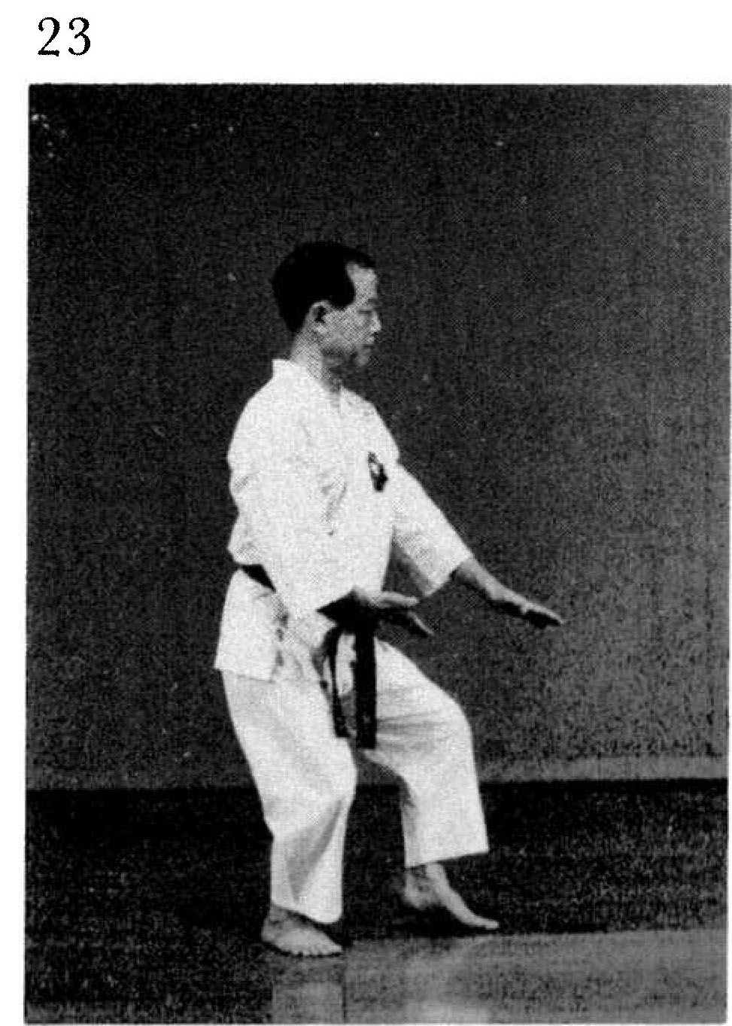 | Pinan nidan 126(24)  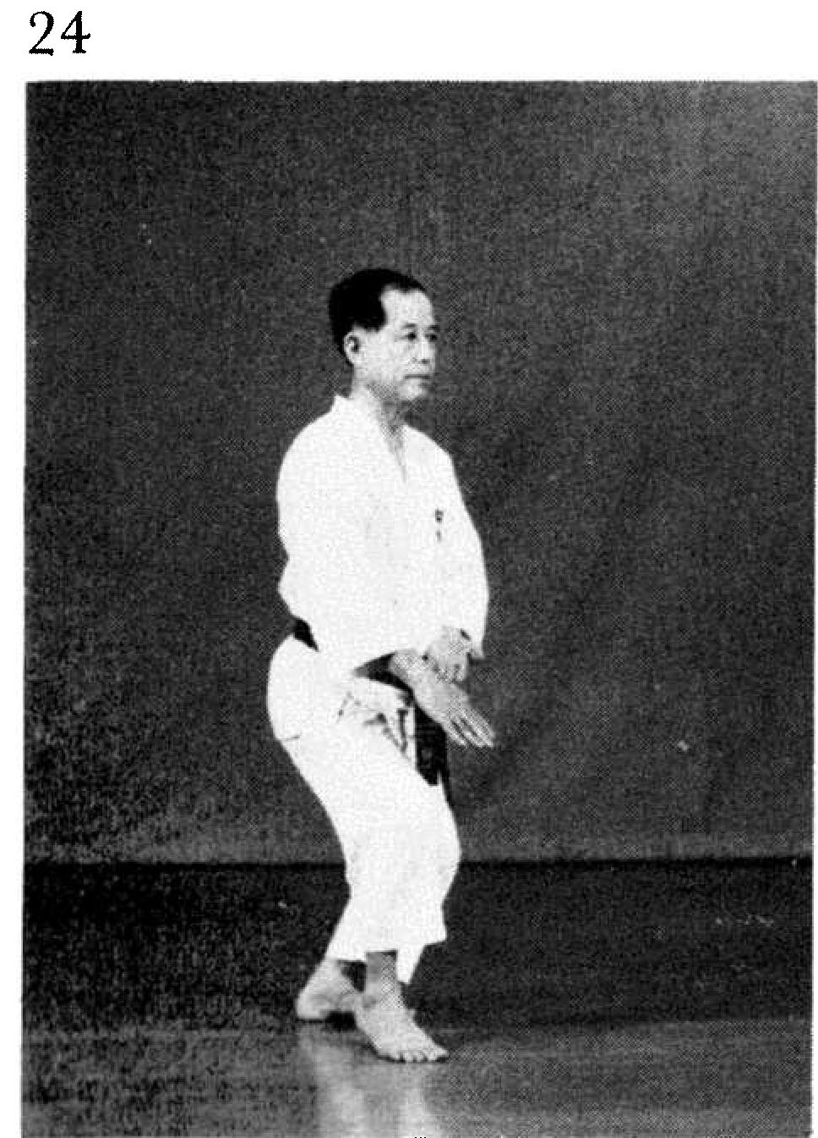
Pinan nidan 126(25)  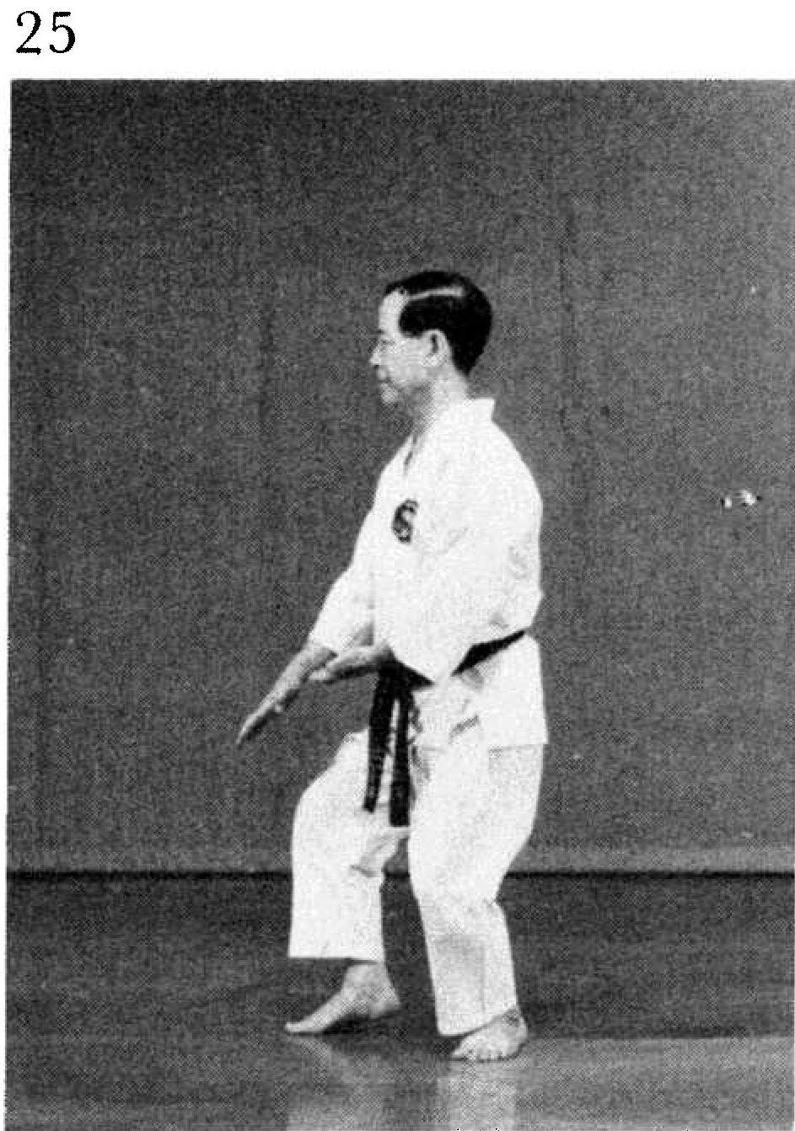 | Pinan nidan 127(26)  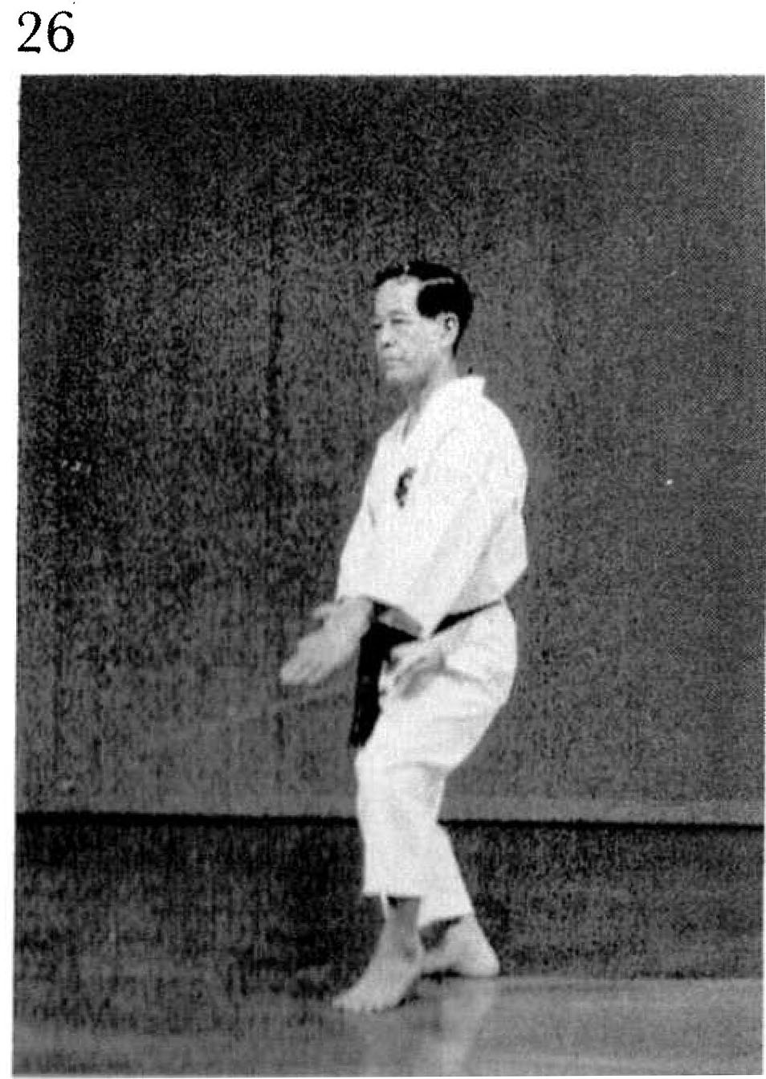

Rohai 181(5)
