Spec. number: 22
Technique: Lower cross block (Gedan kosa-uke)
Kata: P4, P5, Chinto
Page number: 86
Description: “This is formed by blocking downward with the forearm and crossing it with the right fist. (Fig. 14)”
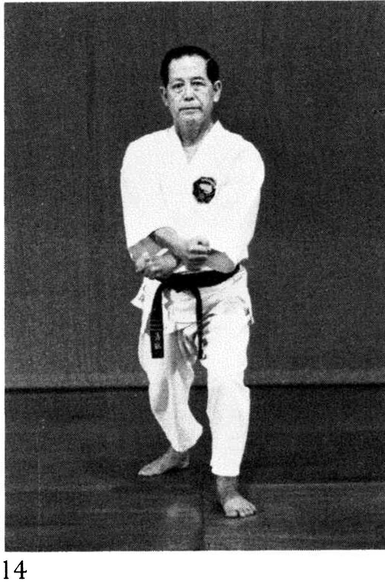
Comments: As taught by Master Ueshiro, we use the supporting / augmenting right hand in this block to deliver a powerful punch to the opponent. The result is that the final position of the crossed hands is slightly over to the left – a subtle difference from the photographs in P4 and P5.
Also, regarding the wind up, Hanshi explains that “We chamber with the wrists in the final position, glued together as a single unit. The right hand carries the left and there is no torque in the strike.” Please see the Kata DVD.
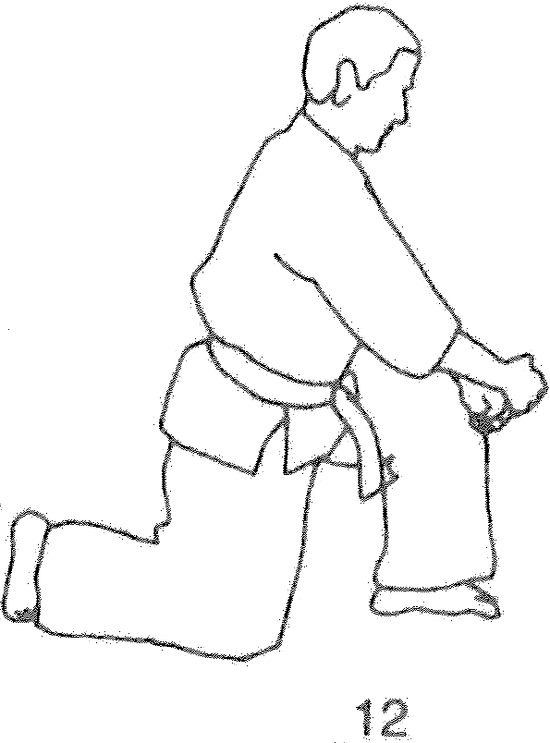
Hanshi continues, “In the heat of battle, contact is made with both fists and/or the left forearm and may include a smash with the left elbow as we blast through the opponent.” The technique emphasizes power over precision.
The Red Book inadvertently identifies Illus. 74(12) as a lower cross block. This move from P5 is actually interpreted as a downward double punch.
Lower cross block seems to occur in Kusanku on pg. 238(48), although it is not listed on page 86.
Photograph: 86(14)
Pinan yondan: 136(7)
Pinan godan: 143(13)
Chinto: 221(18, 19)
Kusanku: 238(48)
Pinan yondan pg. 136  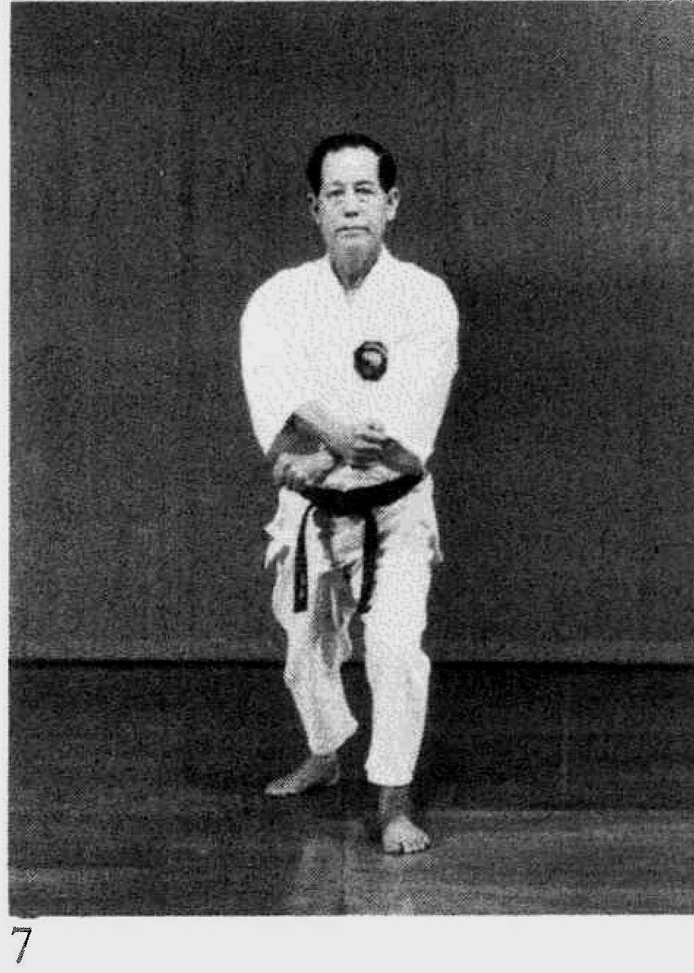 | Pinan godan pg. 143  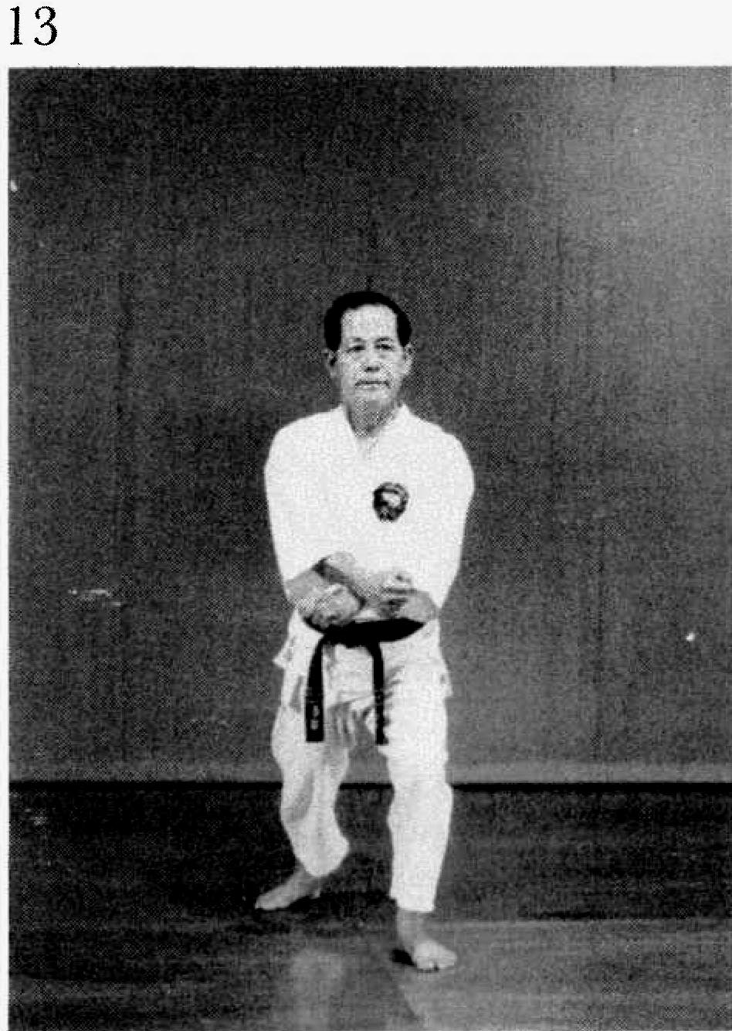

Chinto pg. 221  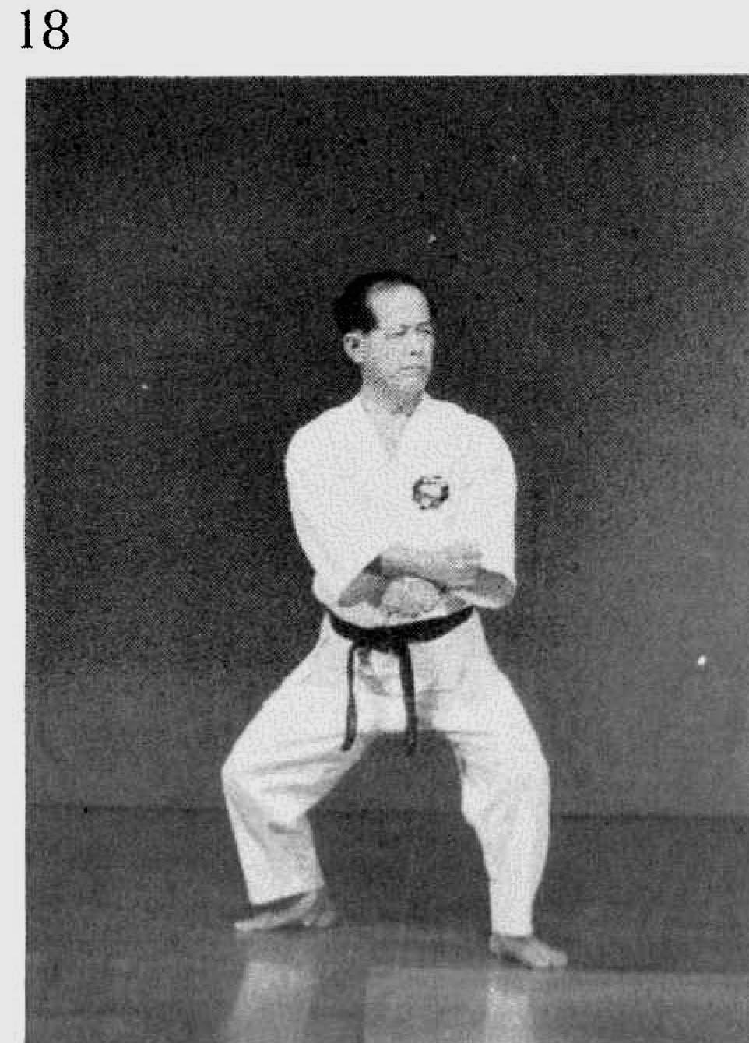 | 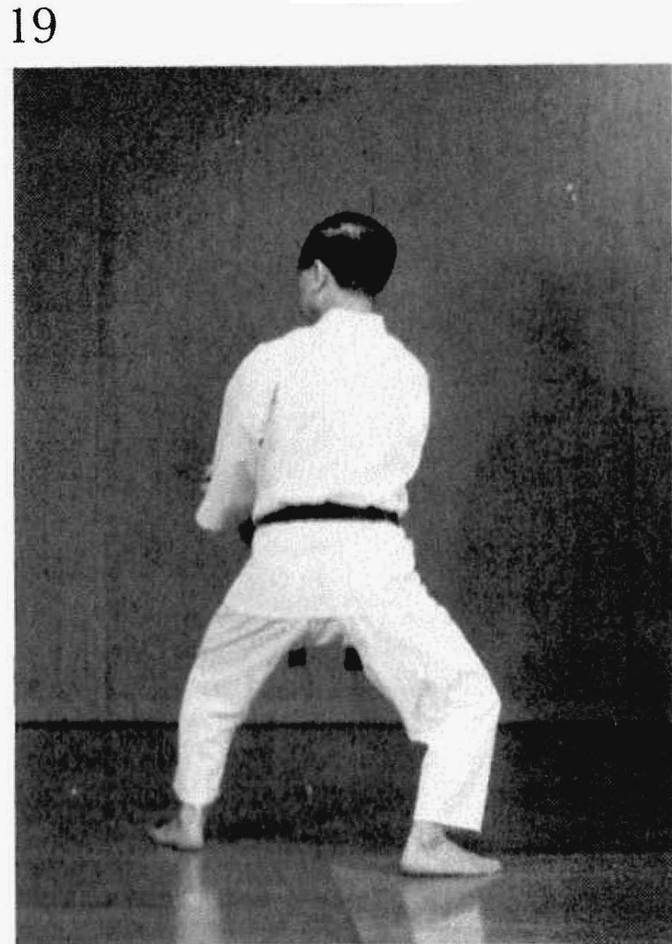
Kusanku pg. 238(48)
