Spec. number: 23
Technique: Augmented forearm block (Morote soe-uke)
Kata: P1, P4, P5
Page number: 86
Description: “This mid-region outward moving block is formed by using chudan soto-uke and augmenting the movement with the other arm.”
Comments: The photo on page 86 and illustrations from the Red Book show the top of the hammer fist in the reinforcing arm making contact just above the blocking arm’s elbow. Some students reinforce the blocking arm with the front two knuckles, which is incorrect.
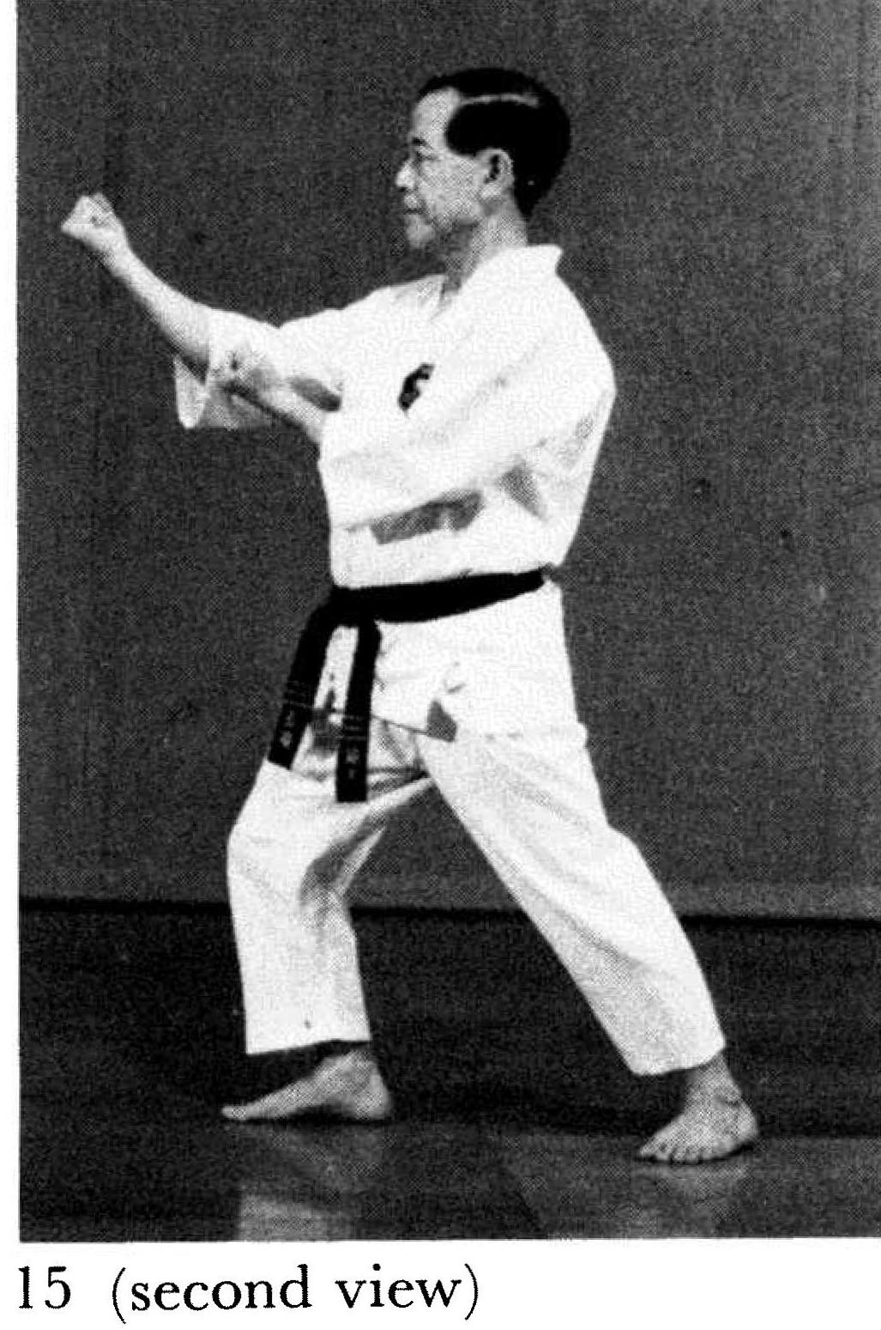
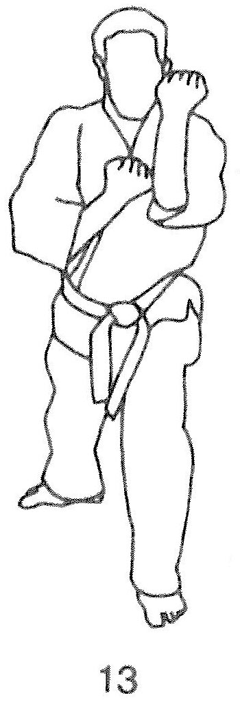
The photos also show the blocking arm at a 120’ angle. As Hanshi points out in middle sideward block (spec. 18), “The block may extend from 90’ to 120' depending on the distance of the imaginary or real opponent.”
Photographs: 86(15)
Pinan shodan: 120(27)
Pinan yondan: 136(9), 139(28,
29), 140(30)
Pinan godan: 142(11)

Pinan shodan pg. 120  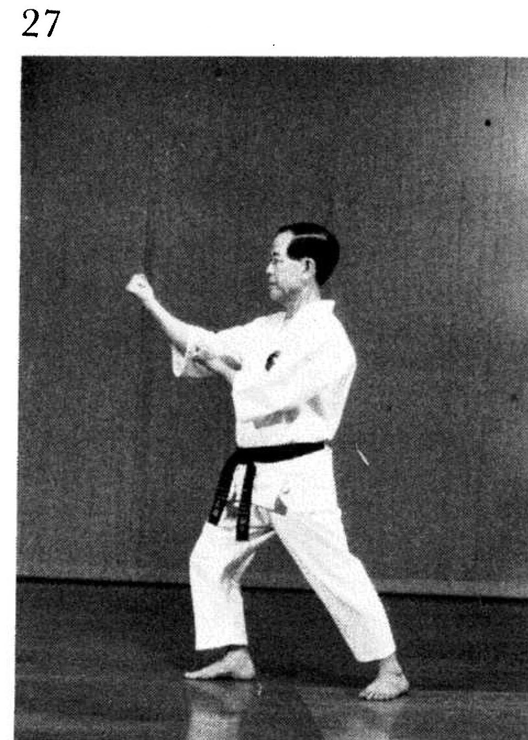 | Pinan yondan pg. 136  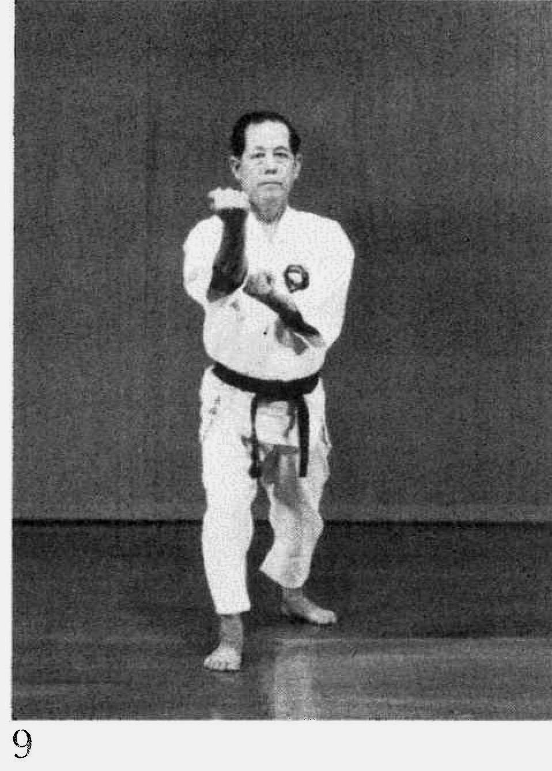
Pinan yondan pg. 139  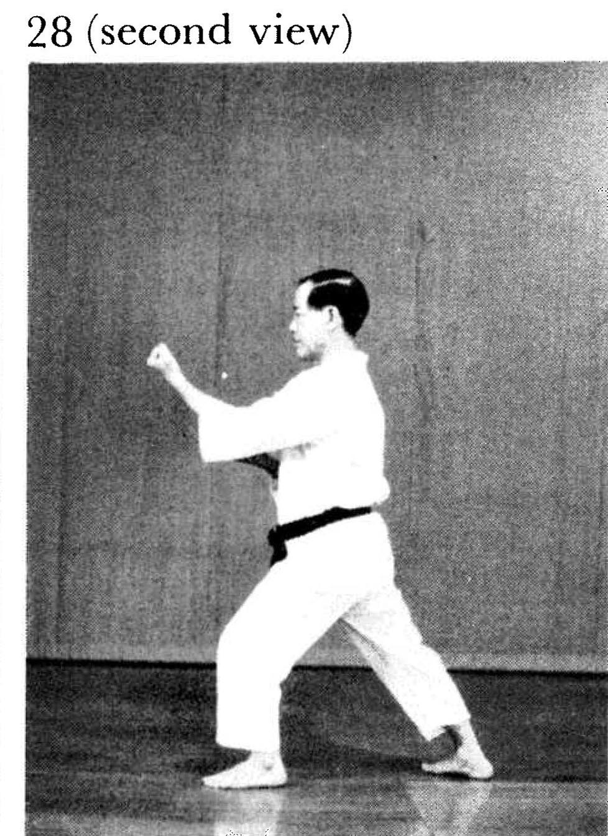 | Pinan yondan pg. 139  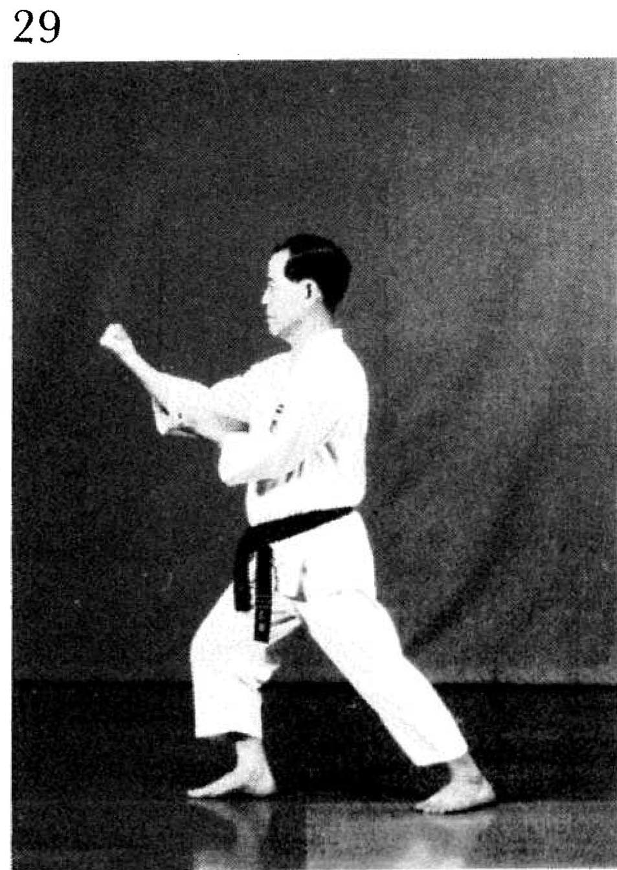

Pinan yondan pg. 140  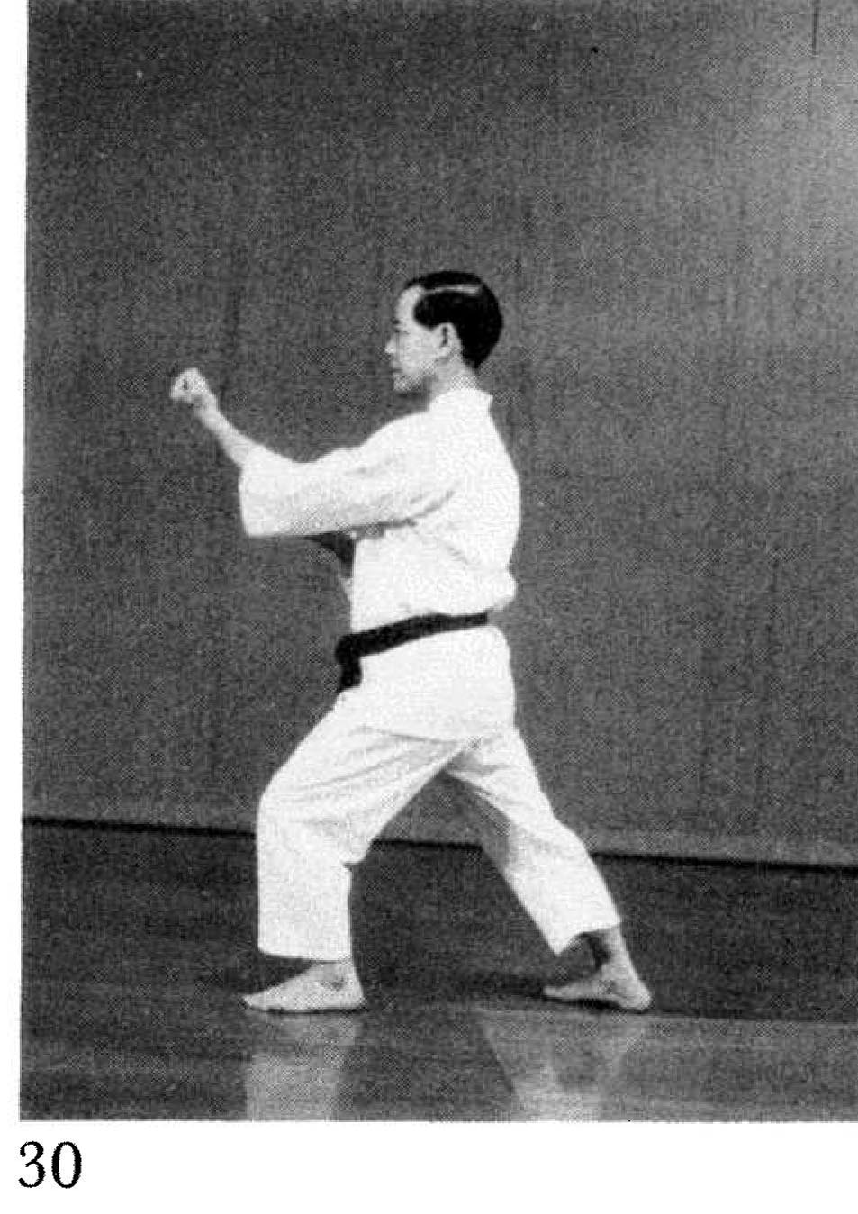 | Pinan godan pg. 142  