Spec. number: 24
Technique: Removing block (Hazushi-uke)
Kata: N2, Gojushiho
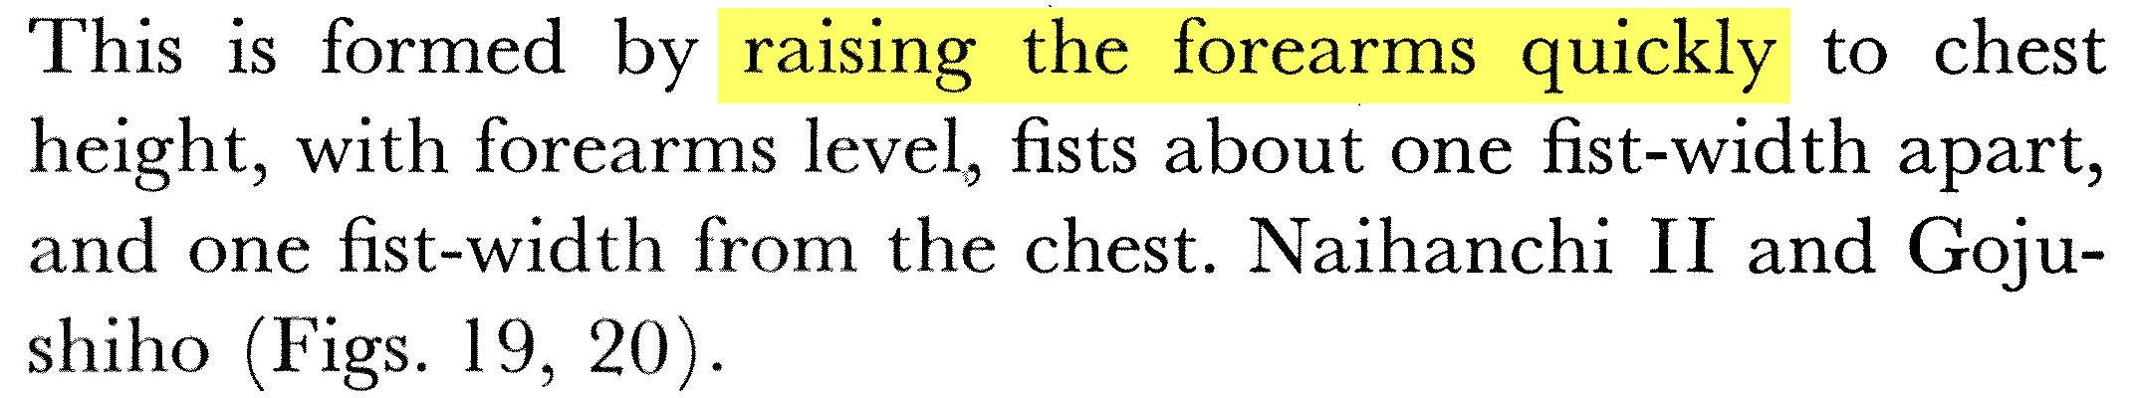
Page number: 88
Description:

Comments: Hanshi describes the bunkai as striking or escaping from an opponent who has grabbed us from behind. Master Ueshiro also emphasized the offensive use of this technique by making a big windup (chambering the arms in an “X”) followed by powerful elbow strikes to the sides. See the Kata DVD.

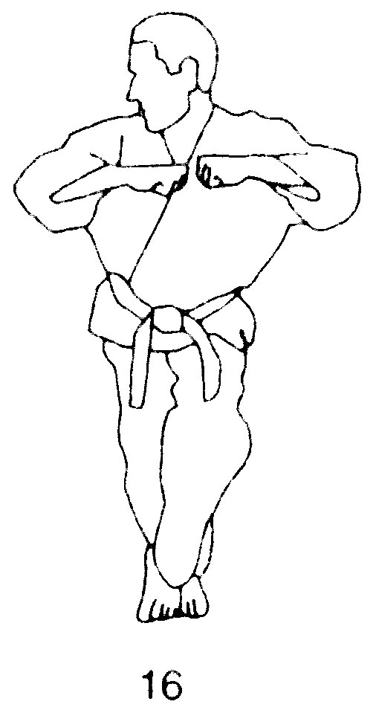

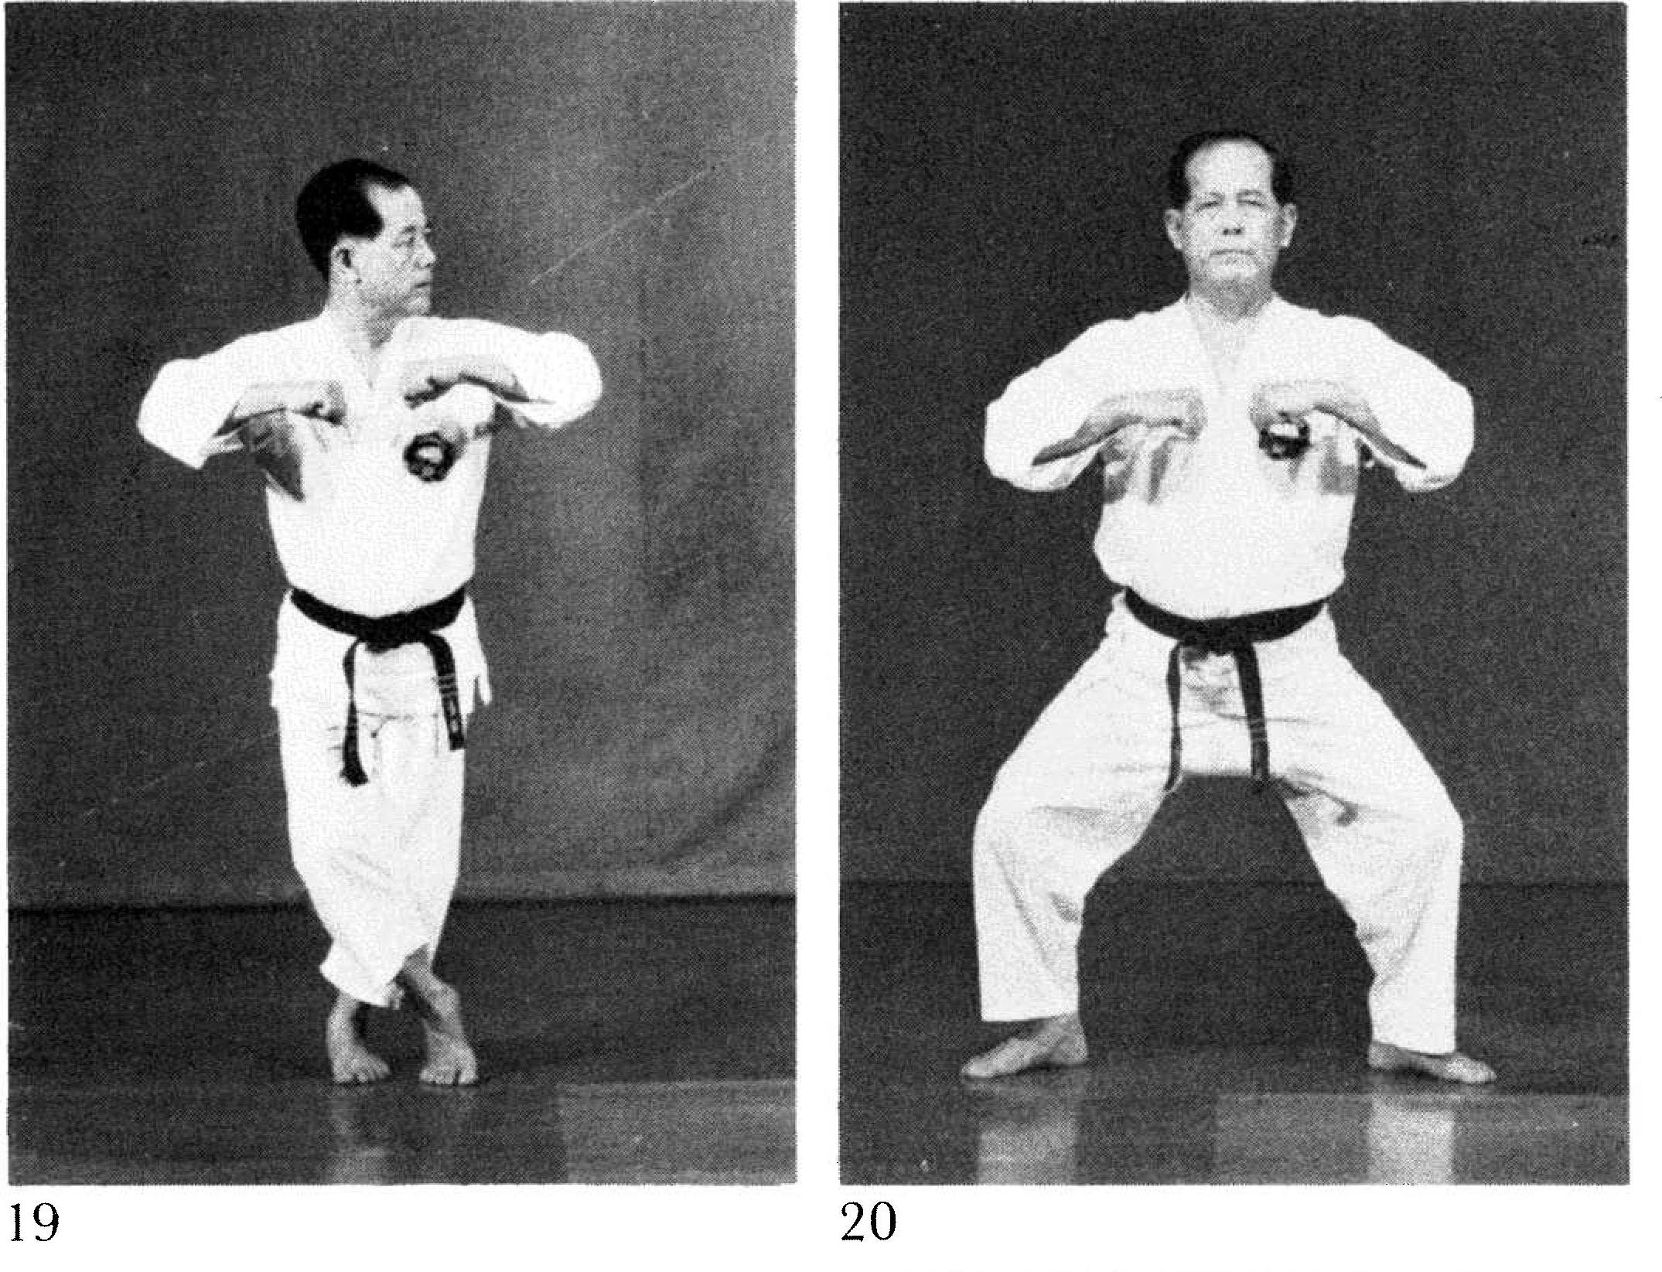

Photographs: 88(19, 20)

Nihanchi ni: 153(4), 155(10)

Gojushiho: 213(35)

Nihanchi ni 153(4)  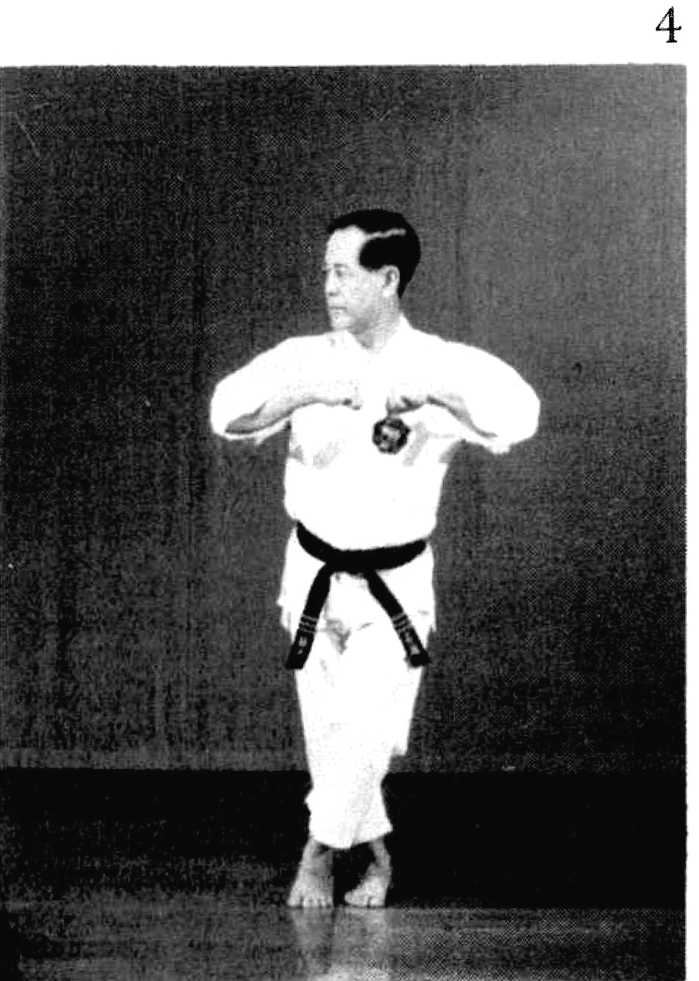 | Nihanchi ni 155(10)  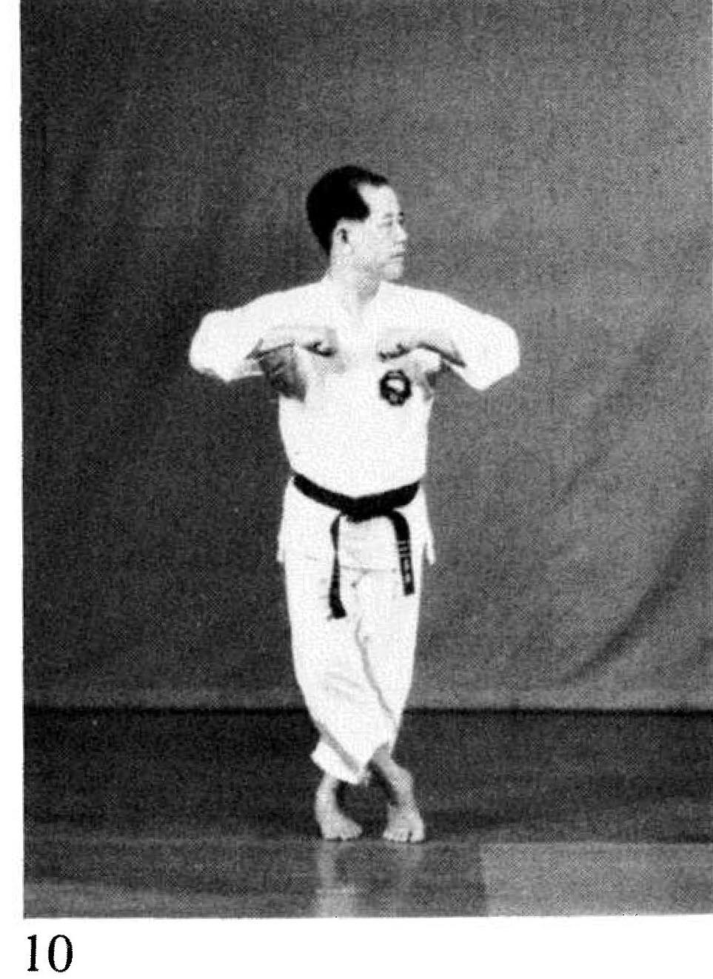
Gojushiho 213(35)
