Spec. number: 25
Technique: Dropping downward block (Otoshi-uke)
Kata: P5, Passai
Page number: 88
Description: “The arm is dropped down from the height of the ear to block a kicking leg.”
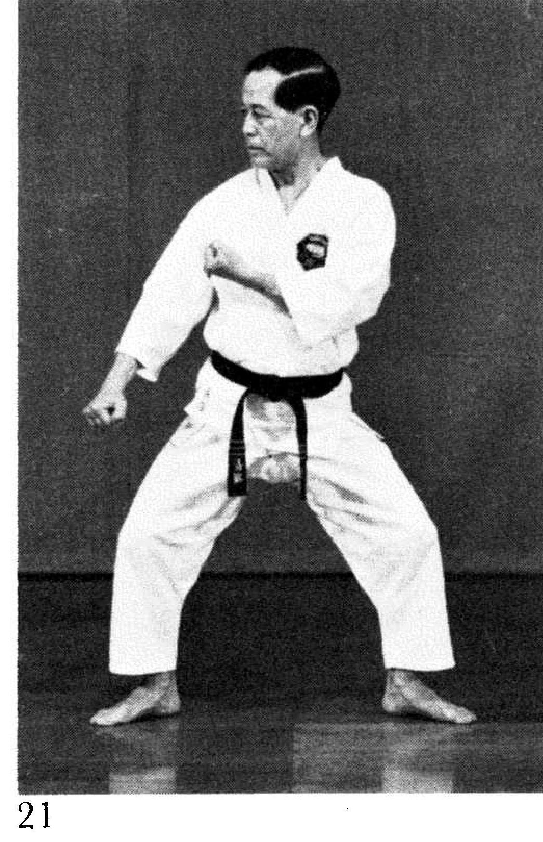
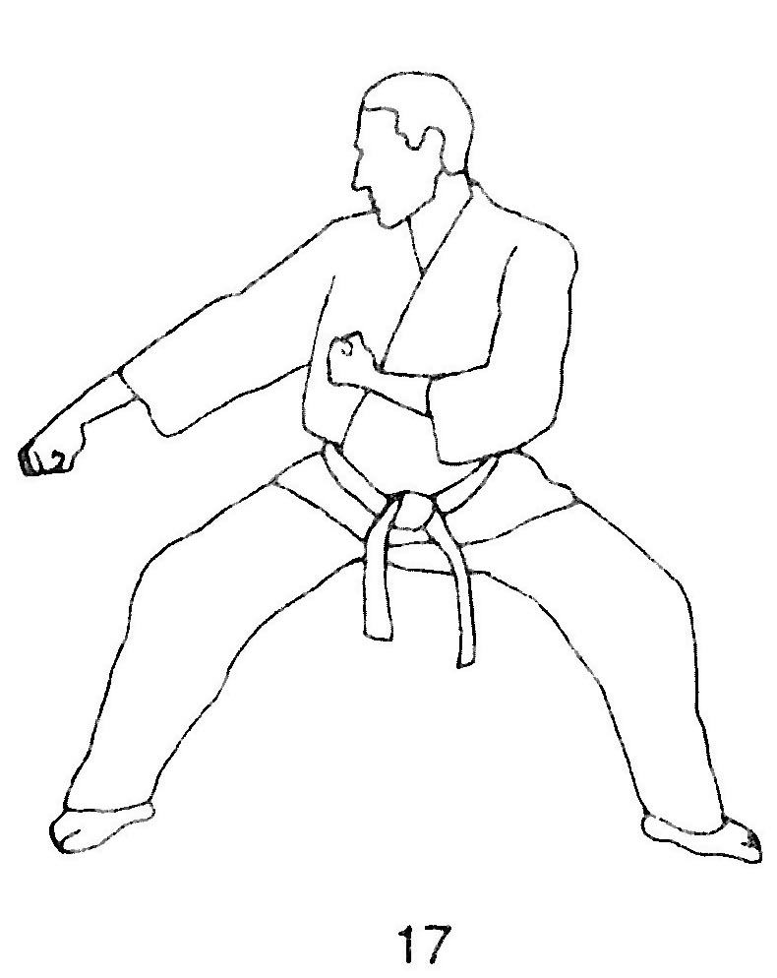
Comments: Fig. 21 shows the complementary arm angled upwards to protect the solar plexis. The fist is about arm pit height. Many students have this arm angling downwards, as in the lower knife-hand blocks in P2 and Rohai. This is incorrect. See Spec sheet # 21.

Photographs: 88(21)
Pinan godan: 144(21)
Passai: 199(21, 22, 23), 202(35)

Pinan godan 144(21)  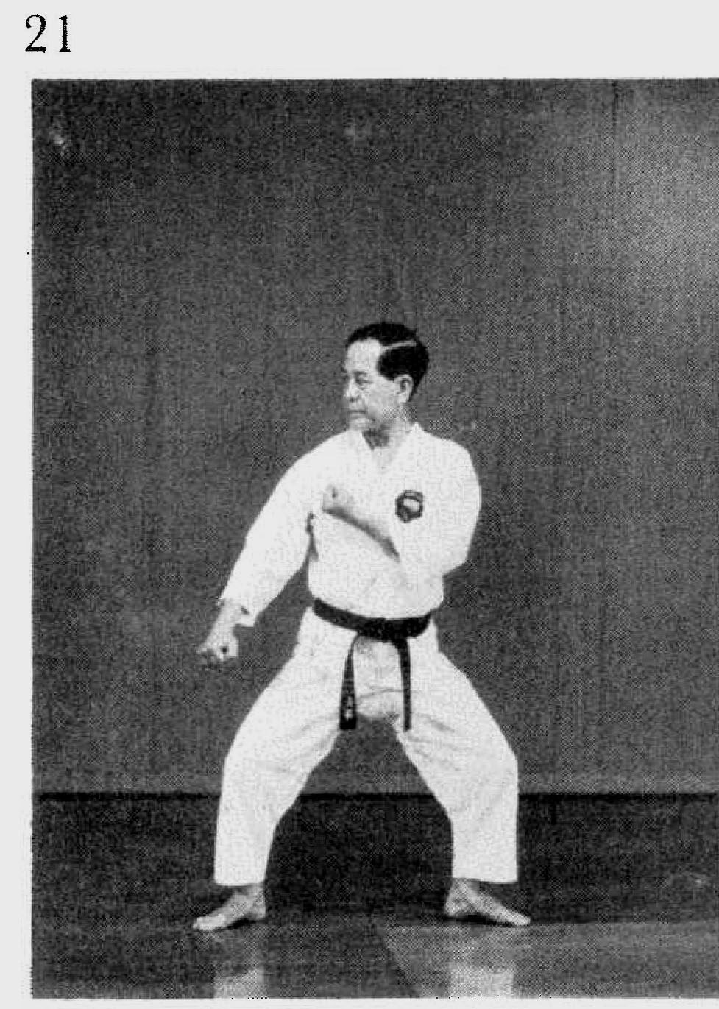 | Passai 199(21)  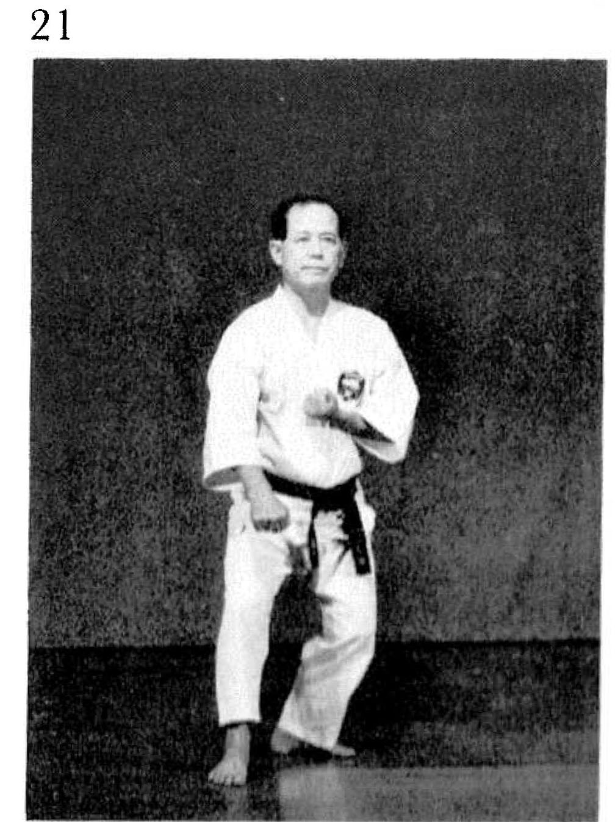
Passai 199(22)  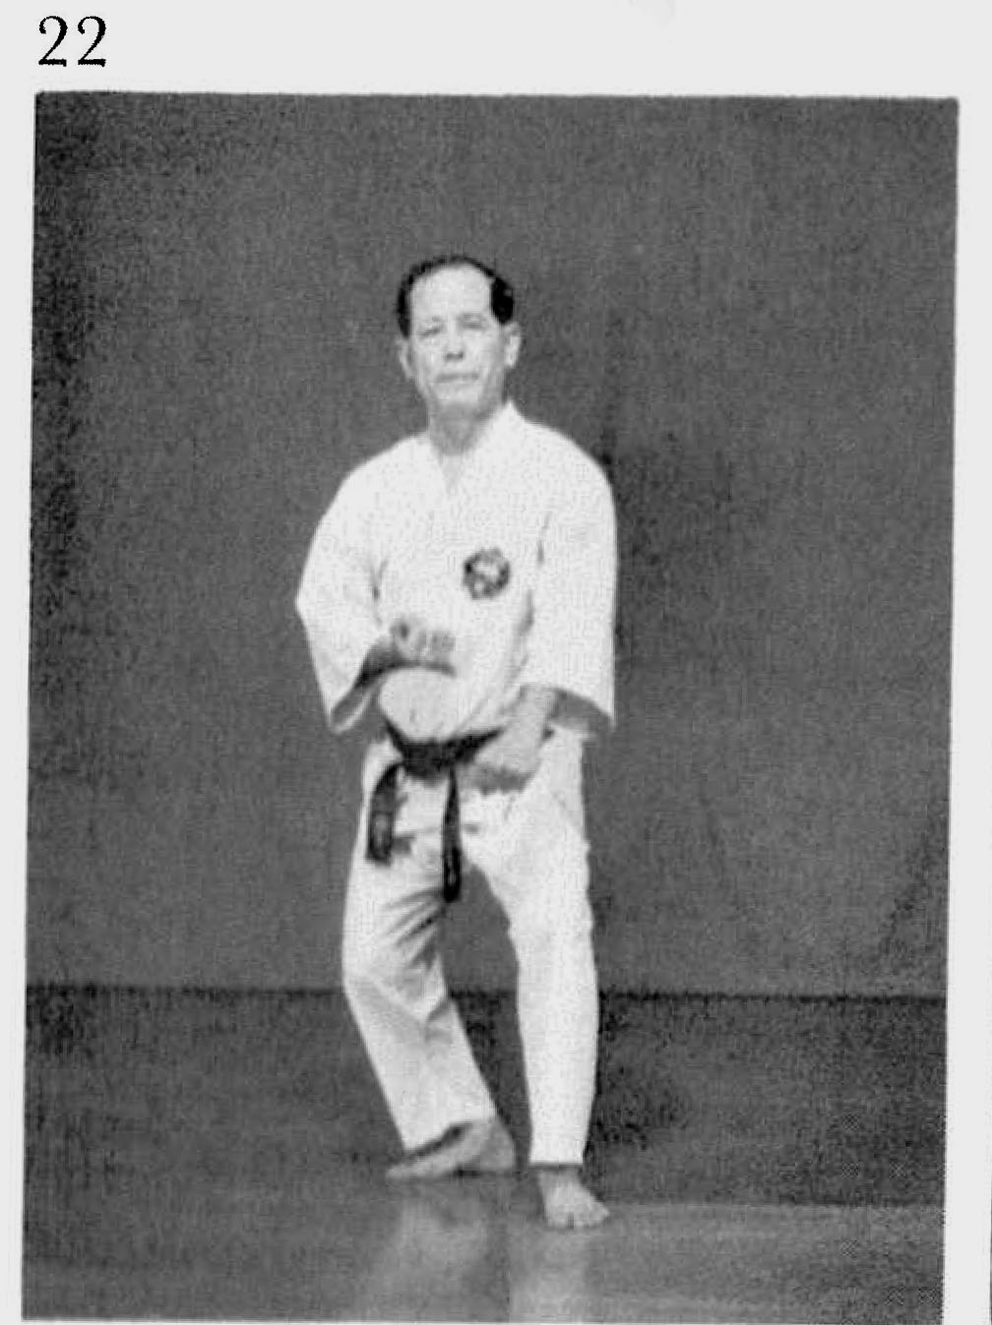 | Passai 199(23)  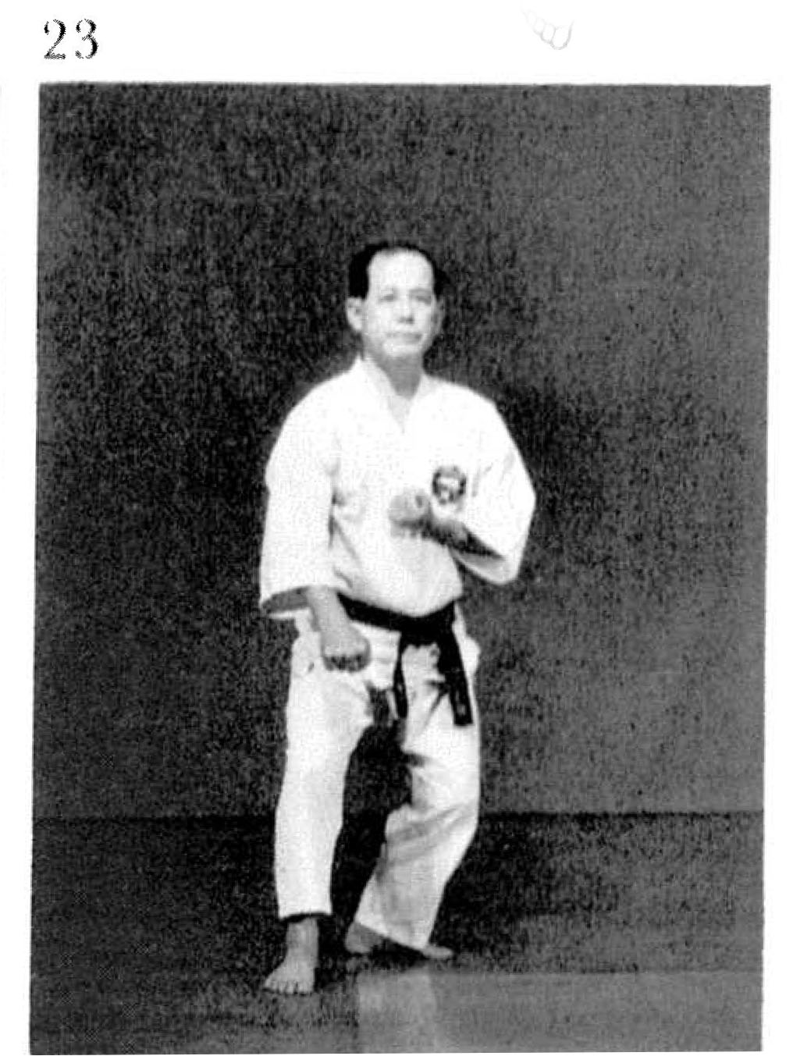

Passai 202(35)
